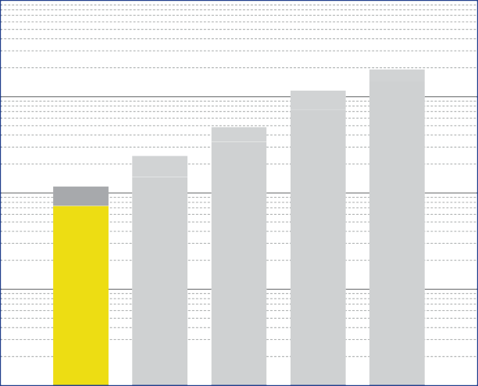
10

1
speciic load [N/mm²]

0.1

0.01

0.001
Diepolast dyn series

Working range

S 75

S 150

S 350
S 750
S 1500
Diepolast dyn type

Recommendations for elastic bearing:

Static load: up to [N/mm²]
0.075
Dynamic load: up to [N/mm²]
0.120
Load peaks: up to [N/mm²]
2.0
Values depending on form factor and apply to form factor q = 3

Material closed cellular polyether-urethane
Colour yellow
Delivery specifications Thickness: 12.5 mm and 25 mm
Mats: 0.5 m wide, 2.0 m long
Stripes: max. 2.0 m long

Other dimensions on request (also stamping and moulded parts).

Properties | Value | Test method | Comment
Mechanical loss factor (1) | 0.06 | DIN 53513 (2) | guide value
Static E-modulus (1) | 0.63 N/mm² | DIN 53513 (2)
Dynamic E-modulus (1) | 0.92 N/mm² | DIN 53513 (2)
Static shear modulus (1) | 0.16 N/mm² | DIN 53513 (2) | preload 0.075 N/mm²
Dynamic shear modulus (1) | 0.27 N/mm² | DIN 53513 (2) | preload 0.075 N/mm², 10 Hz
Resistance to strain | 0.083 N/mm² |  | at 10% deformation
Residual compression set | < 5 % | DIN EN ISO 1856 | 50%, 23°C, 70 h, 30 min after unloading
Tensile strength | > 1.5 N/mm2 | DIN 53455-6-4 | minimum
Elongation at break | > 500 % | DIN 53455-6-4 | minimum
Tear resistance | > 1.6 N/mm | DIN ISO 34-1/A
Rebound elasticity | 70 % | DIN EN ISO 8307 | ± 10%
Speciic volume resistance | >1011 Ω·cm | DIN IEC 93 | dry
Thermal conductivity | 0.06 W/[m·K] | DIN 52612-1
Operating temperature | -30 up to +70 °C
Temperature peak | +120 °C
Inlammability | Class E / EN 13501-1 | EN ISO 11925-1 | normal lammable

(1) measured at maximum limit of static application range
(2) test according to DIN 53513
All information and data is based on our current knowledge. The data are subject to typical manufacturing tolerances and are not guaranteed. We reserve the right to amend the data.

Load deflection curve

0.15

0.10
Specific load [N/mm²]

0.05

0.00

0 2 4 6 8 10 12

Recording of the 3rd loading; testing between steel plates at room temperature measured with a delection rate of 1% of the thickness per second
Form factor q = 3

Deflection [mm]

Modulus of elasticity

1.4

1.2

1.0
Mo d u l u s of elasticity [N/mm²]

0.8

0.6

0.4

0.2

0.0

0.00 0.05 0.10 0.15

Dynamic test: sinusoidal excitation with an oscilla- ting range of ± 0.11 mm at 10 Hz and ± 0.04 mm at 30 Hz
Quasistatic modulus of elasticity:
tangent modulus taken from the load delection curve
Test according to DIN 53513 Form factor q = 3

Specific load [N/mm²]

Natural frequency

0.15

0.10
Specific load [N/mm²]

0.05

0.00

0 5 10 15 20 25

Natural frequency of a single-degree-of-freedom system consisting of a ixed mass and an elastic bearing consisting of Diepolast dyn S 75 on
a stiff subgrade. Form factor q = 3

Natural frequency [Hz]

Correction values varying form factors

s p eciic load 0.075 N/mm², form factor q = 3

Static load range Deflection

0.080

0.075
Specific load [N/mm²]

0.070

0.065

0.060
0.3 1 3 10

F orm factor

Dynamic modulus of elasticity at 10 Hz Natural frequency

DISCLAIMER:
The information provided is intended only as a summary and general overview on matters of interest. The information is not intended to be comprehensive nor does it constitute expert advice. P+S Polyurethan-Elastomere GmbH Co.KG shall not be liable for incidental and/or consequential damages directly or indirectly sustained, nor any loss caused by not complying with relevant industry/product standards and improper use of any Diepolast dyn products. Due to varying construction methods, any other circumstances not stated above should be brought to the attention of P+S Polyurethan-Elastomere GmbH Co.KG for review. For suitability to the prevailing site conditions, it is advised that certiied testing should be conducted. It is recommended to seek further advice on your application with our technical staff prior to use.

The data sheet is not subject to any change service! All information is without guarantee. Latest version of this document available on www.pus-polyurethan.de

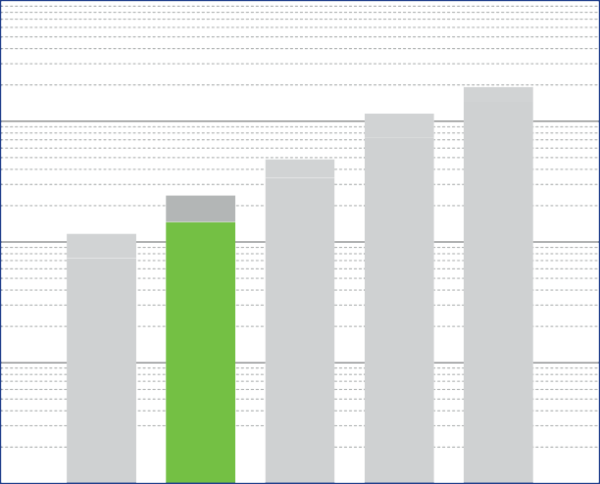
10

1
speciic load [N/mm²]

0.1

0.01

0.001
Diepolast dyn series

Working range

S 75

S 150

S 350
S 750
S 1500
Diepolast dyn type

Recommendations for elastic bearing:

Static load: up to [N/mm²]
0.150
Dynamic load: up to [N/mm²]
0.250
Load peaks: up to [N/mm²]
3.0
Values depending on form factor and apply to form factor q = 3

Material closed cellular polyether-urethane
Colour green
Delivery specifications Thickness: 12.5 mm and 25 mm
Mats: 0.5 m wide, 2.0 m long
Stripes: max. 2.0 m long

Other dimensions on request (also stamping and moulded parts).

Properties | Value | Test method | Comment
Mechanical loss factor (1) | 0.03 | DIN 53513 (2) | guide value
Static E-modulus (1) | 1.25 N/mm² | DIN 53513 (2)
Dynamic E-modulus (1) | 1.65 N/mm² | DIN 53513 (2)
Static shear modulus (1) | 0.22 N/mm² | DIN 53513 (2) | preload 0.15 N/mm²
Dynamic shear modulus (1) | 0.35 N/mm² | DIN 53513 (2) | preload 0.15 N/mm², 10 Hz
Resistance to strain | 0.16 N/mm² |  | at 10% deformation
Residual compression set | < 5 % | DIN EN ISO 1856 | 50%, 23°C, 70 h, 30 min after unloading
Tensile strength | > 2.0 N/mm2 | DIN 53455-6-4 | minimum
Elongation at break | > 500 % | DIN 53455-6-4 | minimum
Tear resistance | > 2.1 N/mm | DIN ISO 34-1/A
Rebound elasticity | 70 % | DIN EN ISO 8307 | ± 10%
Speciic volume resistance | >1011 Ω·cm | DIN IEC 93 | dry
Thermal conductivity | 0.075 W/[m·K] | DIN 52612-1
Operating temperature | -30 up to +70 °C
Temperature peak | +120 °C
Inlammability | Class E / EN 13501-1 | EN ISO 11925-1 | normal lammable

(1) measured at maximum limit of static application range
(2) test according to DIN 53513
All information and data is based on our current knowledge. The data are subject to typical manufacturing tolerances and are not guaranteed. We reserve the right to amend the data.

Load deflection curve

0.30

0.25

0.20
Specific load [N/mm²]

0.15

0.10

0.05

0.00

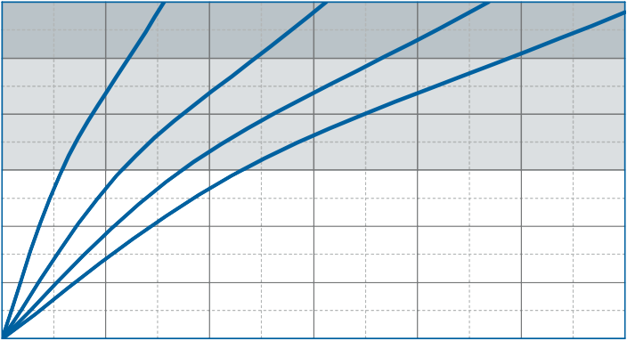
0 2 4 6 8 10 12

Recording of the 3rd loading; testing between steel plates at room temperature measured with a delection rate of 1% of the thickness per second
Form factor q = 3

Deflection [mm]

Modulus of elasticity

3.0

2.5
M o d u l u s of elasticity [N/mm²]

2.0

1.5

1.0

0.5

0.0

0.00 0.05 0.10 0.15 0.20 0.25 0.30

Dynamic test: sinusoidal excitation with an oscilla- ting range of ± 0.11 mm at 10 Hz and ± 0.04 mm at 30 Hz
Quasistatic modulus of elasticity:
tangent modulus taken from the load delection curve
Test according to DIN 53513 Form factor q = 3

Specific load [N/mm²]

Natural frequency

0.30

0.25

0.20
S p e c ific load [N/mm²]

0.15

0.10

0.05

0.00

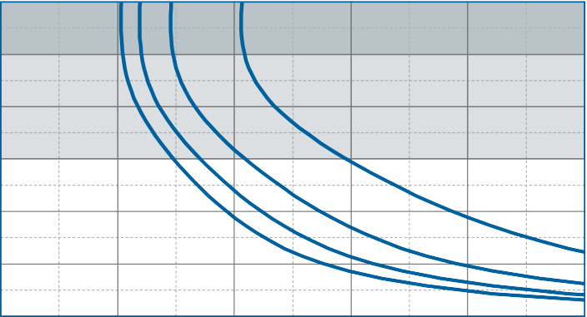
0 5 10 15 20 25
50 mm
37.5 mm
25 mm
12.5 mm

Natural frequency of a single-degree-of-freedom system consisting of a ixed mass and an elastic bearing consisting of Diepolast dyn S 150 on
a stiff subgrade. Form factor q = 3

Natural frequency [Hz]

Correction values varying form factors

speciic load 0.15 N/mm², form factor q = 3

Static load range Deflection

0.17

0.16

0.15
Specific load [N/mm²]

0.14

0.13

0.12
50

40

30
V ariation of deflection [ %

20

10

0

- 10

0.11

0.3 1 3
- 20
10

0. 3 1 3 10

For m f actor F orm factor

Dynamic modulus of elasticity at 10 Hz Natural frequency

10
n of the dynamic modulus of elasticity [%]

5

0

- 5

- 10

- 15

- 20

- 25
V ariatio
5

0
Variation of th e natural frequency [%]

- 5

- 10

- 30

0.3 1 3
- 15
10

0.3 1 3 10

F or m factor F orm factor

DISCLAIMER:
The information provided is intended only as a summary and general overview on matters of interest. The information is not intended to be comprehensive nor does it constitute expert advice. P+S Polyurethan-Elastomere GmbH Co.KG shall not be liable for incidental and/or consequential damages directly or indirectly sustained, nor any loss caused by not complying with relevant industry/product standards and improper use of any Diepolast dyn products. Due to varying construction methods, any other circumstances not stated above should be brought to the attention of P+S Polyurethan-Elastomere GmbH Co.KG for review. For suitability to the prevailing site conditions, it is advised that certiied testing should be conducted. It is recommended to seek further advice on your application with our technical staff prior to use.

The data sheet is not subject to any change service! All information is without guarantee. Latest version of this document available on www.pus-polyurethan.de

10

1
speciic load [N/mm²]

0.1

0.01

0.001
Diepolast dyn series

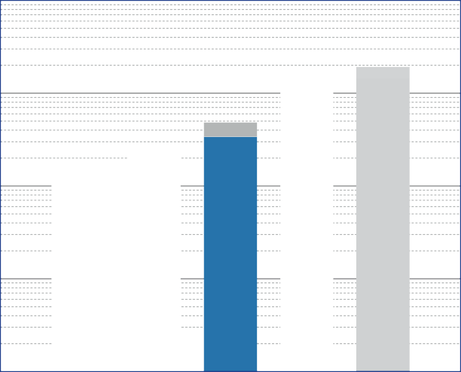Working range

S 150

S 750

S
350

S 75

Diepolast dyn type

Recommendations for elastic bearing:

Static load: up to [N/mm²]
0.350
Dynamic load: up to [N/mm²]
0.500
Load peaks: up to [N/mm²]
4.0
Values depending on form factor and apply to form factor q = 3

Material closed cellular polyether-urethane
Colour blue
S
1500
Delivery specifications Thickness: 12.5 mm and 25 mm
Mats: 0.5 m wide, 2.0 m long
Stripes: max. 2.0 m long

Other dimensions on request (also stamping and moulded parts).

Properties | Value | Test method | Comment
Mechanical loss factor (1) | 0.03 | DIN 53513 (2) | guide value
Static E-modulus (1) | 2.53 N/mm² | DIN 53513 (2)
Dynamic E-modulus (1) | 3.25 N/mm² | DIN 53513 (2)
Static shear modulus (1) | 0,35 N/mm² | DIN 53513 (2) | preload 0.35 N/mm²
Dynamic shear modulus (1) | 0,52 N/mm² | DIN 53513 (2) | preload 0.35 N/mm², 10 Hz
Resistance to strain | 0.32 N/mm² |  | at 10% deformation
Residual compression set | < 5 % | DIN EN ISO 1856 | 50%, 23°C, 70 h, 30 min after unloading
Tensile strength | > 3.5 N/mm2 | DIN 53455-6-4 | minimum
Elongation at break | > 500 % | DIN 53455-6-4 | minimum
Tear resistance | > 2.5 N/mm | DIN ISO 34-1/A
Rebound elasticity | 70 % | DIN EN ISO 8307 | ± 10%
Speciic volume resistance | >1011 Ω·cm | DIN IEC 93 | dry
Thermal conductivity | 0.09 W/[m·K] | DIN 52612-1
Operating temperature | -30 up to +70 °C
Temperature peak | +120 °C
Inlammability | Class E / EN 13501-1 | EN ISO 11925-1 | normal lammable

(1) measured at maximum limit of static application range
(2) test according to DIN 53513
All information and data is based on our current knowledge. The data are subject to typical manufacturing tolerances and are not guaranteed. We reserve the right to amend the data.

Load deflection curve

0.8

0.6
Specific load [N/mm²]

0.4

0.2

0.0

0 2 4 6 8 10 12

Recording of the 3rd loading; testing between steel plates at room temperature measured with a delection rate of 1% of the thickness per second
Form factor q = 3

Deflection [mm]

Modulus of elasticity

6

4
Mo d u l u s of elasticity [N/mm²]

2

0
0. 0 0.2 0.4 0.6 0.8

Dynamic test: sinusoidal excitation with an oscilla- ting range of ± 0.11 mm at 10 Hz and ± 0.04 mm at 30 Hz
Quasistatic modulus of elasticity:
tangent modulus taken from the load delection curve
Test according to DIN 53513 Form factor q = 3

Spe c i f i c load [N/mm²]

Natural frequency

0.8

0.6
Specific load [N/mm²]

0.4

0.2

0.0

0 5 10 15 20 25

Natural frequency of a single-degree-of-freedom system consisting of a ixed mass and an elastic bearing consisting of Diepolast dyn S 350 on
a stiff subgrade. Form factor q = 3

Natural frequency [Hz]

Correction values varying form factors

speciic load 0.35 N/mm², form factor q = 3

Static load range Deflection

0.38

0.36

0.34
Specific load [N/mm²]

0.32

0.30

0.28
50

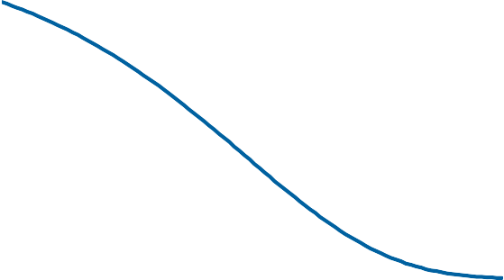
40

30
Variation of deflection [ %

20

10

0

-10

0.26

0.3

1 3

For m facto
-20
10

0.3

1 3 10

Form factor

Dynamic modulus of elasticity at 10 Hz Natural frequency

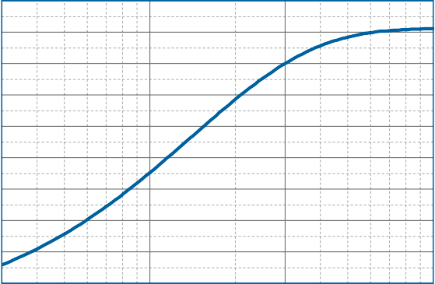
10
Variation of the dynamic modulus of elasticity [%]

5

0

-5

-10

- 15

- 20

- 25

- 3 0
5

0
Variation of the n a t ural frequency [%]

-5

-10

-15

- 35

0.3 1 3

-20
10

0.3 1 3 10

Form factor Fo r m factor

DISCLAIMER:
The information provided is intended only as a summary and general overview on matters of interest. The information is not intended to be comprehensive nor does it constitute expert advice. P+S Polyurethan-Elastomere GmbH Co.KG shall not be liable for incidental and/or consequential damages directly or indirectly sustained, nor any loss caused by not complying with relevant industry/product standards and improper use of any Diepolast dyn products. Due to varying construction methods, any other circumstances not stated above should be brought to the attention of P+S Polyurethan-Elastomere GmbH Co.KG for review. For suitability to the prevailing site conditions, it is advised that certiied testing should be conducted. It is recommended to seek further advice on your application with our technical staff prior to use.

The data sheet is not subject to any change service! All information is without guarantee. Latest version of this document available on www.pus-polyurethan.de

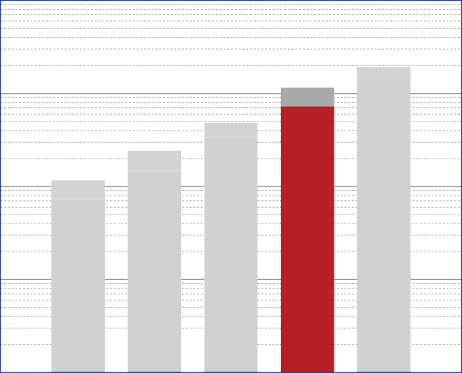
10

1
speciic load [N/mm²]

0.1

0.01

0.001
Diepolast dyn series

Working range

S
75

S
150

S
350
S
750
S
1500

Diepolast dyn type

Recommendations for elastic bearing:

Static load: up to [N/mm²]
0.750
Dynamic load: up to [N/mm²]
1.200
Load peaks: up to [N/mm²]
6.0
Values depending on form factor and apply to form factor q = 3

Material closed cellular polyether-urethane
Colour red
Delivery specifications Thickness: 12.5 mm and 25 mm
Mats: 0.5 m wide, 2.0 m long
Stripes: max. 2.0 m long

Other dimensions on request (also stamping and moulded parts).

Properties | Value | Test method | Comment
Mechanical loss factor (1) | 0.04 | DIN 53513 (2) | guide value
Static E-modulus (1) | 5.21 N/mm² | DIN 53513 (2)
Dynamic E-modulus (1) | 8.88 N/mm² | DIN 53513 (2)
Static shear modulus (1) | 0.80 N/mm² | DIN 53513 (2) | preload 0.75 N/mm²
Dynamic shear modulus (1) | 1.22 N/mm² | DIN 53513 (2) | preload 0.75 N/mm², 10 Hz
Resistance to strain | 0.59 N/mm² |  | at 10% deformation
Residual compression set | < 6 % | DIN EN ISO 1856 | 50%, 23°C, 70 h, 30 min after unloading
Tensile strength | > 5.0 N/mm2 | DIN 53455-6-4 | minimum
Elongation at break | > 500 % | DIN 53455-6-4 | minimum
Tear resistance | > 4.3 N/mm | DIN ISO 34-1/A
Rebound elasticity | 70 % | DIN EN ISO 8307 | ± 10%
Speciic volume resistance | >1011 Ω·cm | DIN IEC 93 | dry
Thermal conductivity | 0.10 W/[m·K] | DIN 52612-1
Operating temperature | -30 up to +70 °C
Temperature peak | +120 °C
Inlammability | Class E / EN 13501-1 | EN ISO 11925-1 | normal lammable

(1) measured at maximum limit of static application range
(2) test according to DIN 53513
All information and data is based on our current knowledge. The data are subject to typical manufacturing tolerances and are not guaranteed. We reserve the right to amend the data.

Load deflection curve

1.6

1.2
Speciic load [N/mm2]

0.8

0.4

0.0

Recording of the 3rd loading; testing between steel plates at room temperature measured with a delection rate of 1% of the thickness per second
Form factor q = 3

0 2 4 6 8 10 12

Delection [mm]

Modulus of elasticity

15

10
Modulus of elasticity [N/mm2]

5

0
0.0 0.4 0.8 1.2 1.6

Dynamic test: sinusoidal excitation with an oscilla- ting range of ± 0.11 mm at 10 Hz and ± 0.04 mm at 30 Hz
Quasistatic modulus of elasticity:
tangent modulus taken from the load delection curve
Test according to DIN 53513 Form factor q = 3

Speciic load [N/mm²]

Natural frequency

1.6

1.2
Speciic load [N/mm2]

0.8

0.4

0.0

0 5 10 15 20 25

Natural frequency of a single-degree-of-freedom system consisting of a ixed mass and an elastic bearing consisting of Diepolast dyn S 750 on
a stiff subgrade. Form factor q = 3

Natural frequency [Hz]

Diepolast dyn S
750

Prod t ata eet

Correction values varying form factors

peciic load 0.75 N/mm², form factor q = 3

Static load range Deflection

Dynamic modulus of elasticity at 10 Hz Natural frequency

DISCLAIMER:
The information provided is intended only as a summary and general overview on matters of interest. The information is not intended to be comprehensive nor does it constitute expert advice. P+S Polyurethan-Elastomere GmbH Co.KG shall not be liable for incidental and/or consequential damages directly or indirectly sustained, nor any loss caused by not complying with relevant industry/product standards and improper use of any Diepolast dyn products. Due to varying construction methods, any other circumstances not stated above should be brought to the attention of P+S Polyurethan-Elastomere GmbH Co.KG for review. For suitability to the prevailing site conditions, it is advised that certiied testing should be conducted. It is recommended to seek further advice on your application with our technical staff prior to use.

The data sheet is not subject to any change service! All information is without guarantee. Latest version of this document available on www.pus-polyurethan.de

P+S oly ethan-Ela tomere Kielwe
Gmb o KG 49356 ephol
Telefo 4 0 44 980-0 E-Mail: nfo@p -poly rethan de
Telefa 4 0 44 980-80 Internet: w w p -poly ethan de

10

1
speciic load [N/mm²]

0.1

0.01

0.001
Diepolast dyn series

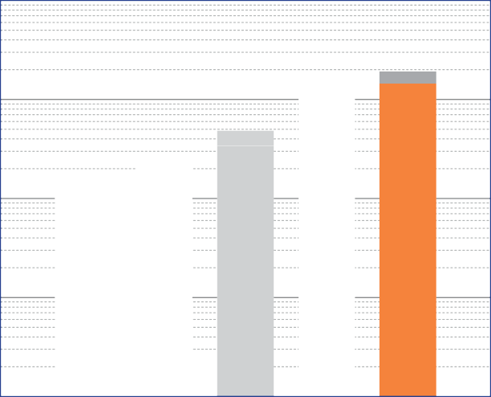Working range

S 150

S 750

S
350

S 75

Diepolast dyn type

Recommendations for elastic bearing:

Static load: up to [N/mm²]
1.500
Dynamic load: up to [N/mm²]
2.000
Load peaks: up to [N/mm²]
8.0
Values depending on form factor and apply to form factor q = 3

Material closed cellular polyether-urethane
Colour orange
S
1500
Delivery specifications Thickness: 12.5 mm and 25 mm
Mats: 0.5 m wide, 2.0 m long
Stripes: max. 2.0 m long

Other dimensions on request (also stamping and moulded parts).

Properties | Value | Test method | Comment
Mechanical loss factor (1) | 0.05 | DIN 53513 (2) | guide value
Static E-modulus (1) | 9.21 N/mm² | DIN 53513 (2)
Dynamic E-modulus (1) | 16.66 N/mm² | DIN 53513 (2)
Static shear modulus (1) | 1.15 N/mm² | DIN 53513 (2) | preload 1.5 N/mm²
Dynamic shear modulus (1) | 1.69 N/mm² | DIN 53513 (2) | preload 1.5 N/mm², 10 Hz
Resistance to strain | 0.94 N/mm² |  | at 10% deformation
Residual compression set | < 8 % | DIN EN ISO 1856 | 50%, 23°C, 70 h, 30 min after unloading
Tensile strength | > 7.0 N/mm2 | DIN 53455-6-4 | minimum
Elongation at break | > 500 % | DIN 53455-6-4 | minimum
Tear resistance | > 5.6 N/mm | DIN ISO 34-1/A
Rebound elasticity | 70 % | DIN EN ISO 8307 | ± 10%
Speciic volume resistance | >1011 Ω·cm | DIN IEC 93 | dry
Thermal conductivity | 0.11 W/[m·K] | DIN 52612-1
Operating temperature | -30 up to +70 °C
Temperature peak | +120 °C
Inlammability | Class E / EN 13501-1 | EN ISO 11925-1 | normal lammable

(1) measured at maximum limit of static application range
(2) test according to DIN 53513
All information and data is based on our current knowledge. The data are subject to typical manufacturing tolerances and are not guaranteed. We reserve the right to amend the data.

Load deflection curve

2.5

2.0
Speciic load [N/mm2]

1.5

1.0

0.5

0.0

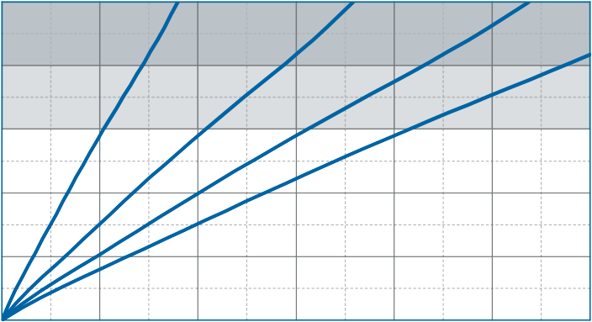
0 2 4 6 8 10 12

Recording of the 3rd loading; testing between steel plates at room temperature measured with a delection rate of 1% of the thickness per second
Form factor q = 3

Delection [mm]

Modulus of elasticity

30

20
Modulus of elasticity [N/mm2]

10

0
0.0 0.5 1.0 1.5 2.0 2.5

Dynamic test: sinusoidal excitation with an oscilla- ting range of ± 0.11 mm at 10 Hz and ± 0.04 mm at 30 Hz
Quasistatic modulus of elasticity:
tangent modulus taken from the load delection curve
Test according to DIN 53513 Form factor q = 3

Speciic load [N/mm²]

Natural frequency

2.5

2.0
Speciic load [N/mm2]

1.5

1.0

0.5

0.0

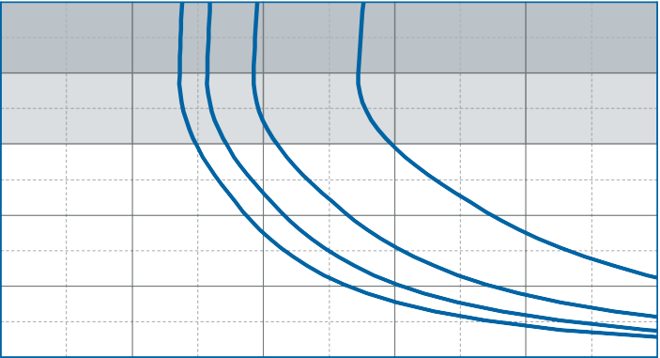
0 5 10 15 20 25

Natural frequency of a single-degree-of-freedom system consisting of a ixed mass and an elastic bearing consisting of Diepolast dyn S 1500 on
a stiff subgrade. Form factor q = 3

Natural frequency [Hz]

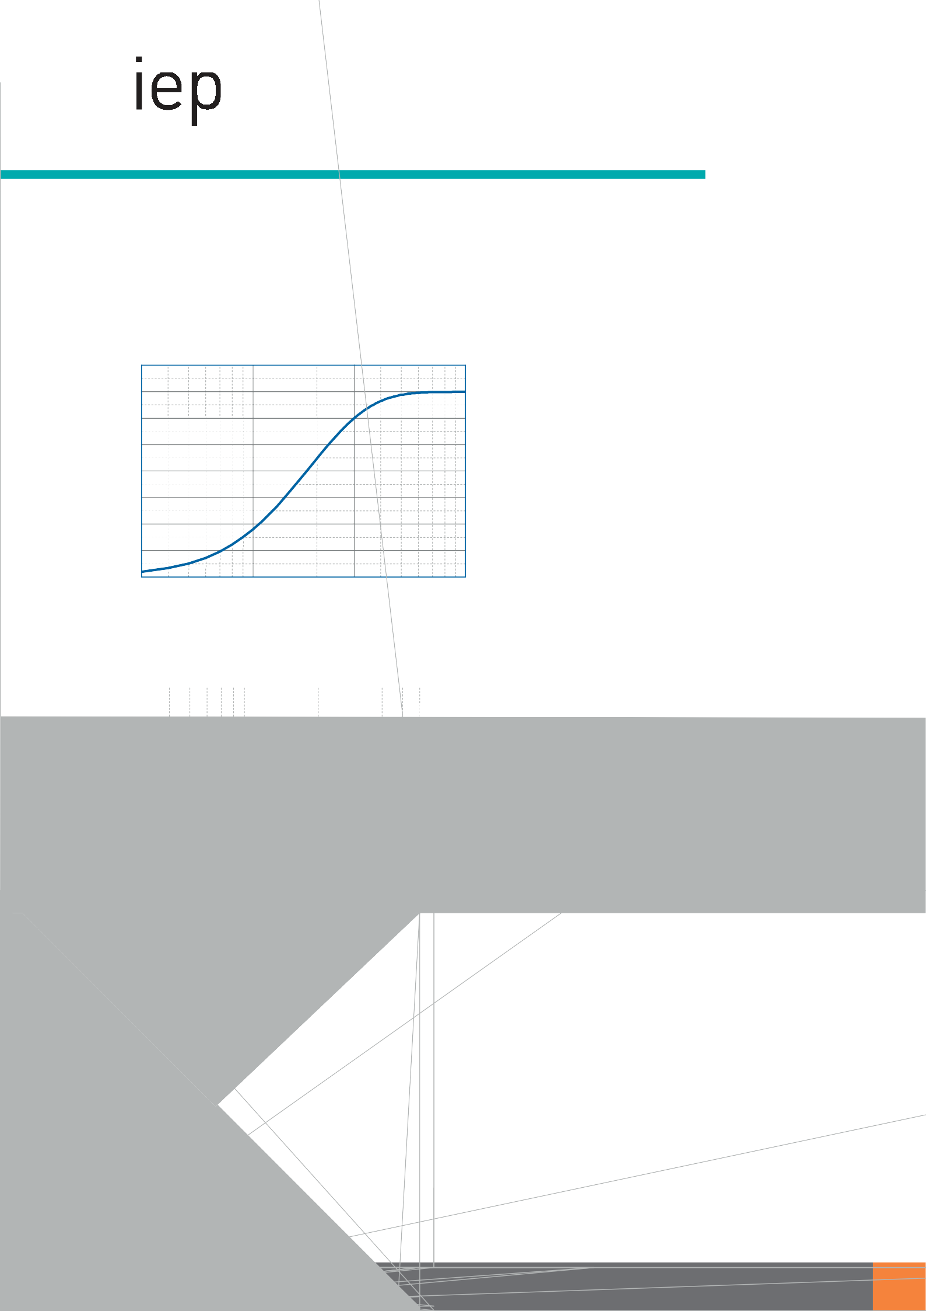D olast dyn S
1500

Prod t t eet

Correction values varying form factors

pec ic load 1.50 N/mm², form factor q = 3

Static load range Deflection

1.7

1.6

1.5

1.4

1.3

1.2

1.1

1.0

0.9
0.3 1 3 10

Dynamic modulus of elasticity at 10 Hz Natural frequency

DISCLAIMER:
The information provided is intended only as a summary and general overview on matters of interest. The information is not intended to be comprehensive nor does it constitute expert advice. P+S Polyurethan-Elastomere GmbH Co.KG shall not be liable for incidental and/or consequential damages directly or indirectly sustained, nor any loss caused by not complying with relevant industry/product standards and improper use of any Diepolast dyn products. Due to varying construction methods, any other circumstances not stated above should be brought to the attention of P+S Polyurethan-Elastomere GmbH Co.KG for review. For suitability to the prevailing site conditions, it is advised that certiied testing should be conducted. It is recommended to seek further advice on your application with our technical staff prior to use.

The data sheet is not subject to any change service! All information is without guarantee. Latest version of this document available on www.pus-polyurethan.de

P+S oly eth n-El tomere | K elwe | Telefo | 4 0 44 980-0 | E-M l: nfo@p -poly ret n de
Gmb o KG | 49356 ephol | Telef | 4 0 44 980-80 | Internet: w w p -poly eth n de

