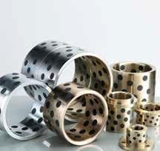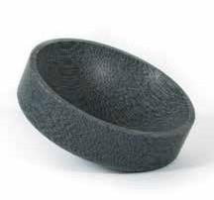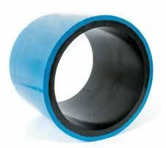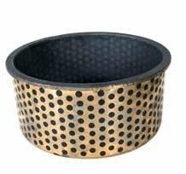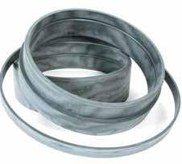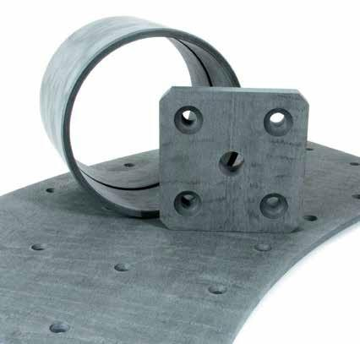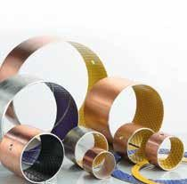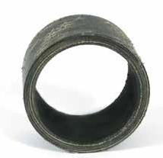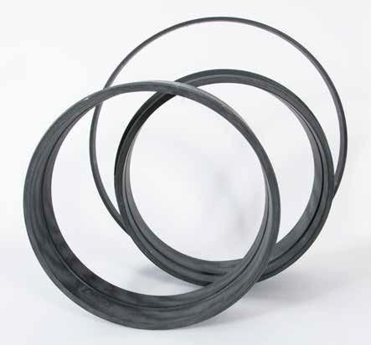

A leading manufacturer of low friction bearing materials to the marine, offshore and onshore industries

Norden Maritime AS
A leading manufacturer of low friction bearing materials to the marine, offshore and onshore industries

Norden Maritime AS was established in 1997. The company is based in Os, just 30 km outside Bergen on Norway`s west coast.

Norden Maritime’s main activity is the manufacture of low friction bearing materials supplied to the marine, offshore

Content

Unique personal experience 4 MRP Quality Management System 5 Design and manufacturing 5 On Line Design Program 6 Research and development 6 Response and delivery 6 Norden Materials 8 Cutter head bearings/Water lubricated stern tube system 13 Norden Bronze 14 Rubber Buffer 15 Norden DU Bearings 16

and onshore industries. Our composite material has been proved to have the best quality in the market.

As a leading supplier Norden Maritime has within its range a number of products which represent some of the most skilful manufacturers fromaround the world.
Norden Maritime
is certified with
ISO 9001-2008
Norden DX Bearings 16
Polyurethane 17 Plastic 17 Water Jet Cutting 18 Contact 20

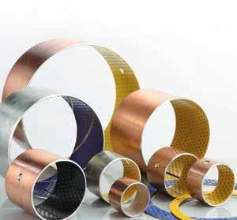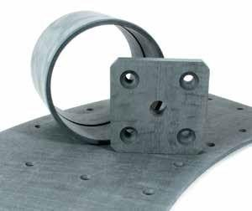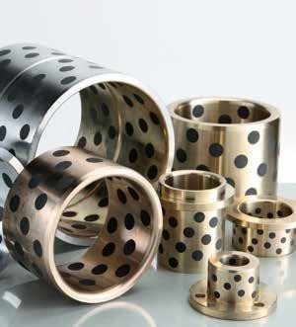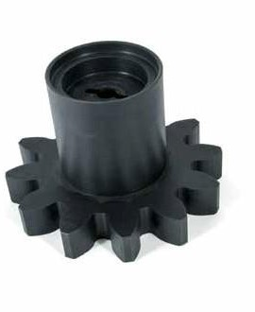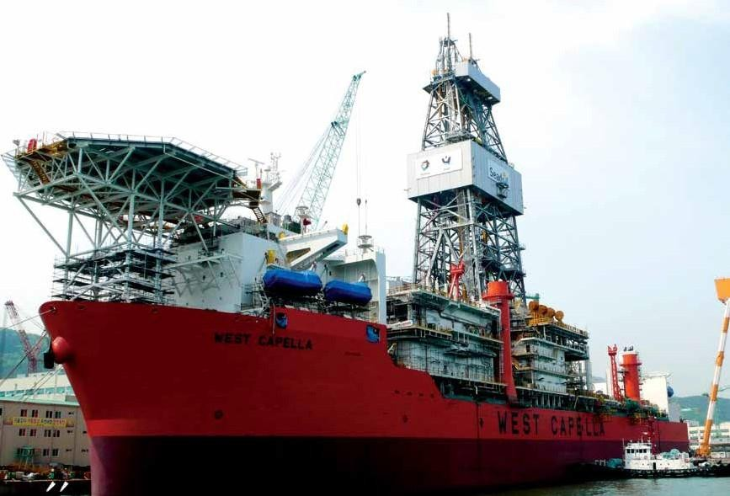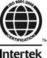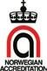

2 www.norden-maritime.no 3

Technical Director Bob Birchley

MRP Quality
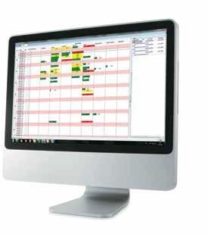
Management System

Our in house activities including, customer service, design, production and documentation are followed up and controlled with our bespoke quality management system.

This system is our guarantee for delivery of products with the exact
specification and quality to our customers’ orders and needs.
The quality management system also produces and stores all the relevant documentation for control and maintenance needed for our QA system.

Unique personal experience

Our technical director has more than 35 years’ experience in the design and development of low friction bearing materials for our customers around the world.

Including developing a number of different composite materials for both general qualities and specials to suit customer’s specific needs.

Our highly skilled CNC engineers and workforce operate the newest software and machinery in the industry.
We are always available to meet our customers’ needs with the optimum design and materials.

Design and manufacturing

Our experience, knowledge and high end production facilities with the latest CNC machinery guarantee delivery of the best low friction products in the market.

In cooperation with our customers, our highly qualified staff will detect needs and possibilities in design and choice of materials to maximize quality and minimize needs for maintenance.

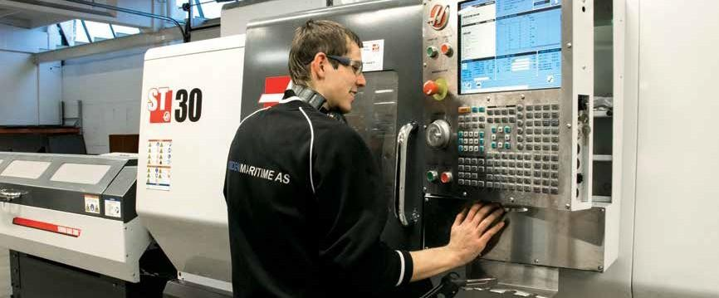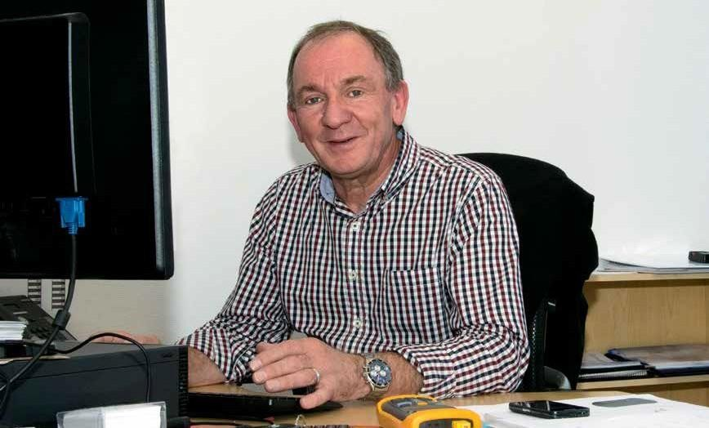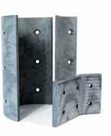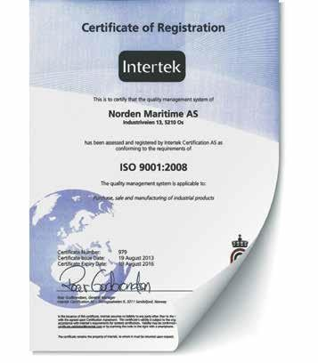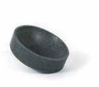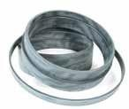

4 www.norden-maritime.no 5

Bearing Design Program
On Line design tool, specially developed for our customers.

Our special design program has been developed over a number of years and has been subjected to frequent updates to reflect the use of new materials and production methods in our development strategy.

The design program is available for our customers and engineers to use on line and provides an effective tool for in house design.

Try our online

Bearing Calculation Program
An effective tool for inhouse design
www.norden-maritime.no

Research and development

Norden Maritime is constantly testing all new materials, design and products.

Our production line includes test facilities to test bearings wear and friction.

In cooperation with the leading technical university in Norway, The NTNU in Trondheim,
Norden Maritime also runs test programs for innovation and testing.

The composite materials developed and manufactured by Norden Maritime has been proved to have the best quality in themarket

Response and delivery

Norden Maritime isorganisedfor quick response to our customers’ needs.

Together with our staff our procedures and production lines can accommodate quick changes for fast delivery.

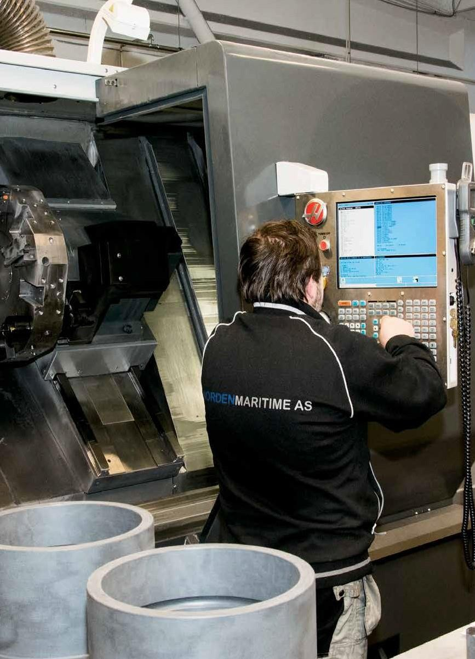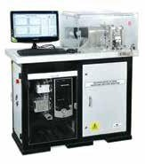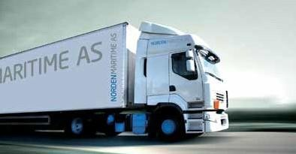

6
www.norden-maritime.no

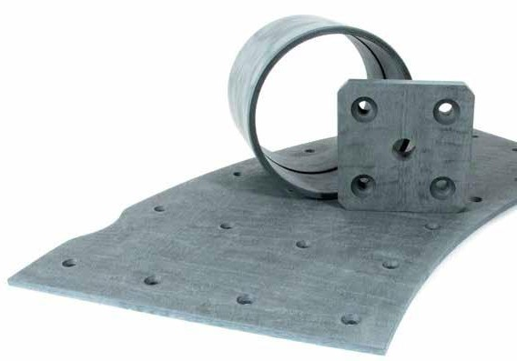
Norden 788
Norden 788 is a high load composite bearing material.
Norden988
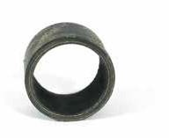
Norden 988 composite bearing material is produced using a specially manufactured Aramid fabric reinforcement andincorporates a unique low friction bearing surface.
The material is impregnated with a thermosetting resin incorporating solid lubricant fillers.
Norden 988 has been formulated particularly for dry running high load applications.

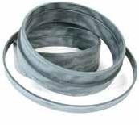
Norden701
Norden701 is a high load composite bearing material manufactured from synthetic fabric reinforcement which is impregnated with a thermosetting resin, solid lubricant fillers are added forreduced friction andimproved dryrunning capability.

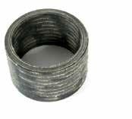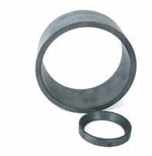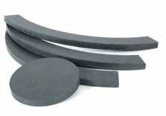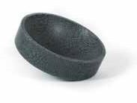Norden901
Norden 901 composite bearing material is produced using specially manufactured Aramid fabric reinforcement which is impregnated with a thermosetting resin,
solid lubricant fillers are added for reduced friction and improved dry running capability.

Made with a specially manufactured synthetic fabric reinforcement using a composite construction process and impregnated with thermosetting resin. Solid lubricant fillers are added to make
itsuitable fordryrunningapplications.

Reference

Kongsberg Oil & Gas (KOGT) has tested Norden Maritime material 788 as part of its
testing program also involving other similar commonly used friction materials.

• The performance of the subject Norden material Norden 788 satisfied all pre-defined KOGT requirements

• Thematerialhasbeenapprovedforuseforthedefinedpurposes

• The cooperation with the representatives from Norden Maritime throughout testing has been
Norden RA5
Norden RA5 composite bearing material is made of a specially manufactured synthetic fabric reinforcement incorporating PTFE. The material impregnated with a thermosetting resin containing solid lubricant fillers for enhanced dry running capability.

Norden AM8
Norden AM8 is a high load composite bearing material made of specially manufactured synthetic fabric reinforcement using a special composite construction process,
the material is impregnated with a thermosetting resin and solid lubricant fillers making
itsuitable fordryrunningapplications.

Norden NNF
Norden NNF is a specially constructed composite bearing material incorporating a needle felt fibre reinforcing which is impregnated with a thermosetting resin. Solid lubricant fillers are added to the resin to lower friction and improve wear resistance.

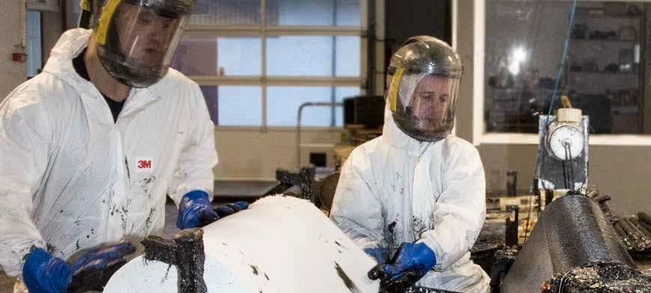
value adding and recommendable

8 www.norden-maritime.no 9

Outstanding quality
Bearings from Norden Maritime are subject to unique quality control and meets the international standard BS EN ISO 9001:2008.

This standard includes the choice of raw material, component traceability, manufacturing and delivery. Our high- end test programs ensure the best
quality and performance. If required testing can be supported by specific certification of products for customers.

Hatch Cover Pads

All bearings manufactured by Norden Maritime are designed from our range of thermoset composite materials. Using advanced polymer technologies and technical fabrics impregnated with thermosetting resins incorporating solid lubricants, these bearings provide engineers with solutions to satisfy many diverse engineering applications.
Based on a number of test results Norden 788 is ideally suited for use in hatch cover pad applications.

Norden 788 exhibits the lowest coefficient of friction coupled with exceptionally low wear rates, a typical dry sliding friction value of 7% against stainless steel with no stick slip or noise generation offers owners a long term maintenance free service life

Norden Materials have many advantages over more traditional metallic bearing materials and other polymeric bearings including:

- Low coefficient of friction
- High load capacity
- Dry running
- Good chemical resistance
- Operates in fresh or salt water without lubrication
- Damping of vibration
- Accommodation of shaft misalignment
- Ease of machining
- Fitting by pressing, freezing, adhesives and mechanical methods
- Dimensional stability
- Minimal thermal softening
- Does not encourage galvanic corrosion
- Norden contains no asbestos or environmentally hazardous/toxic substances
Many successful applications for Norden involve highly loaded bearings or pads operating with intermittent or oscillating movements. Norden bearings have been fitted and used in a diverse range of applications including:

- Off-road vehicles
- Process equipment
- Pumps and valves
- Lifting and handling equipment
- Hydropower
- Ports and Harbour equipment
- Shipbuilding
- Hatch cover pads
- Fairleads
- Moring sheaves
- Winches

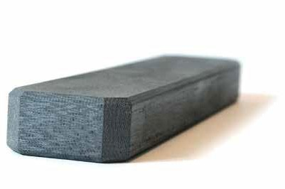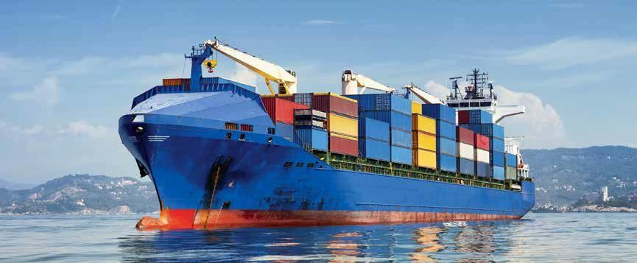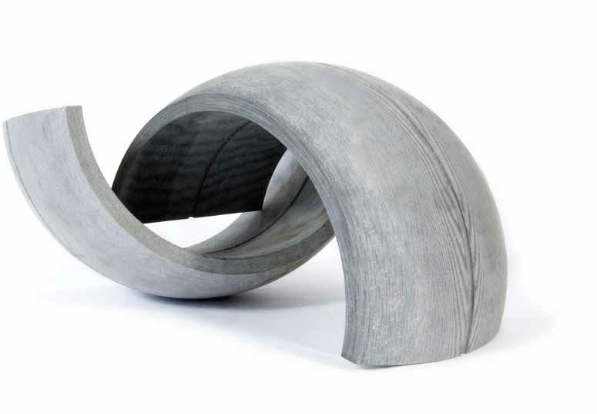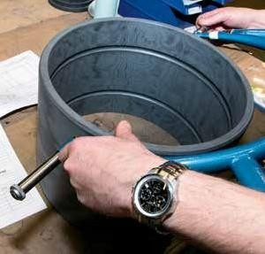

10 www.norden-maritime.no 11

Cutter Head Bearings

Cutter head bearings are one of the most abrasive applications for bearings in the marine industry.

The cutter head which is at the end of a ladder is dropped to the sea bed and rotates and cuts through sand and rock. The head swings through an arc as it cuts through the sand and rock and mixes with the water, it is then sucked up and pumped to land. The cutter head which rotates is supported by a bearing operating in this abrasive environment.
To optimize the life of both the cutter bearing and the cutter shaft (or sleeve on the shaft) there must be a constant flow of relatively clean water through the bearing in order to keep the abrasives away from the cutter bearing. However this is the ideal and sometimes abrasives do get into the bearing. When this happens the selection of bearing and sleeve Materials must be as abrasive resistant as possible.

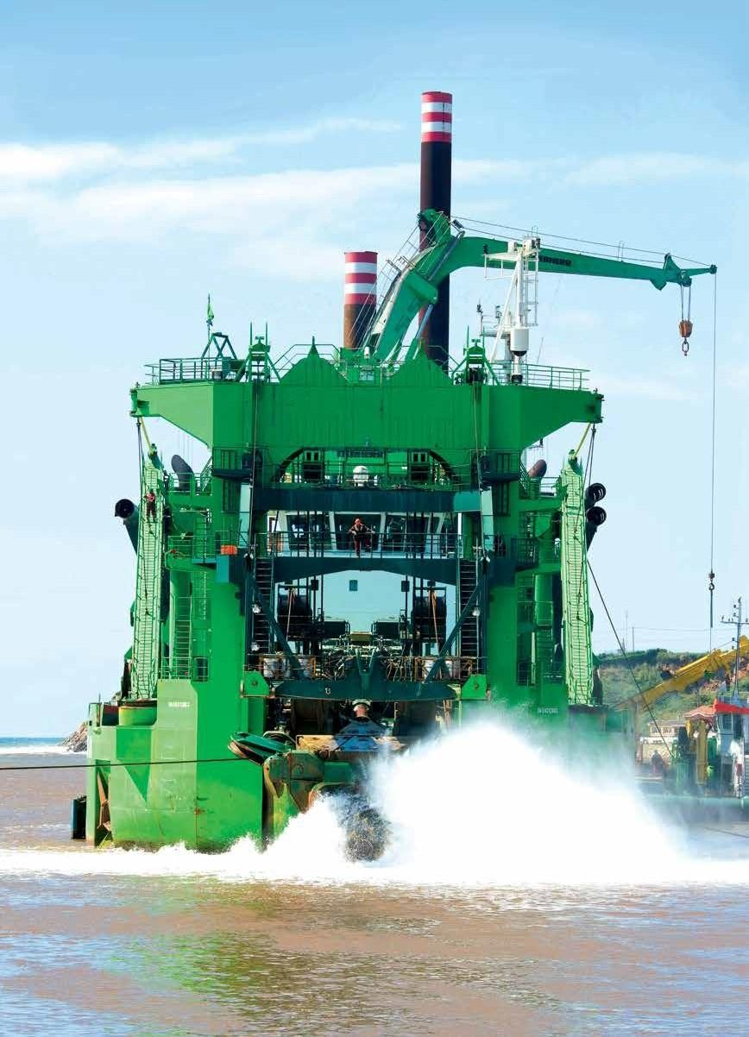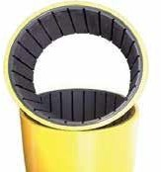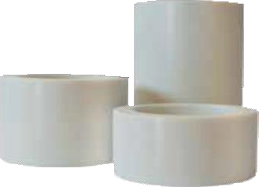
Norden Composite (CM77)
The Norden Composite Bearing was developed for use specifically for Cutter Suction Dredges. It is a combination of two highly developed thermosetting cross-linked polymers that optimize different characteristics in the design of these elastomeric bearings.
The outside polymer, Blue or yelow in colour is tough, hard material with high load bearing capacity, resistant to impact and compression. The inside polymer black in color
is a softer rubber like material with good flexibility and the ability to resist tearing from abrasive particles.

While it is very difficult to obtain meaningful laboratory abrasive test values, this material
has often proven to be better than the rubber and plastic materials by a factor of 8:1.

Water lubricated stern tube bearings

Norden CM7 / Norden 605 marine / Norden NNF
Norden CM7 elastomeric bearings offer a very good combination of strength/stiffness and flexibility/elasticity. Bearing length 2:1 for AFT bearing and 1:1 for FWD bearing.
Norden propeller system will consist of Norden CM7/Norden 605 or Norden NNF bearings, shaft liners and water Quality Package.

www.norden-maritime.no

Norden Bronze
Copper-aluminium alloys, Copper-zink alloys, Copper-lead-nickel alloys, Copper-tin alloys

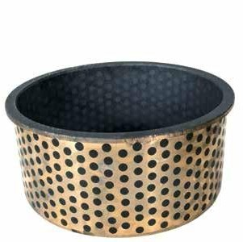
500 Oilies
500 Oiles series bearings incorporate high quality copper alloy based metals with engineered solid lubricant plugs. (ptfe/graphite) These bearings are designed to accommodate a wide variety of application requirements demanded by today’s equipment. Precise tolerances utilizing strategic plug location and plug compounds ensure performance
delivery and lubrication free service..

500 series bearings provide extreme temperature limits and high load capacity performance. Available as plain bearings, flanges bearing and flat pads.

Norden Alm Bz 220

For the very highest loads when well lubricated. Load up to 200 N/mm2

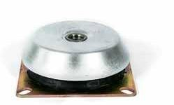
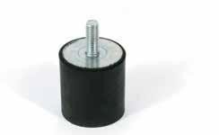
Rubber Buffers

Norden SL-4

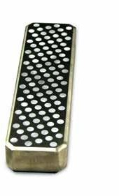
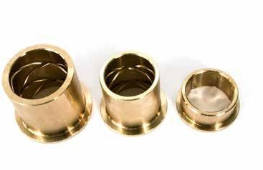Hatch Cover Pads with PTFT plugs

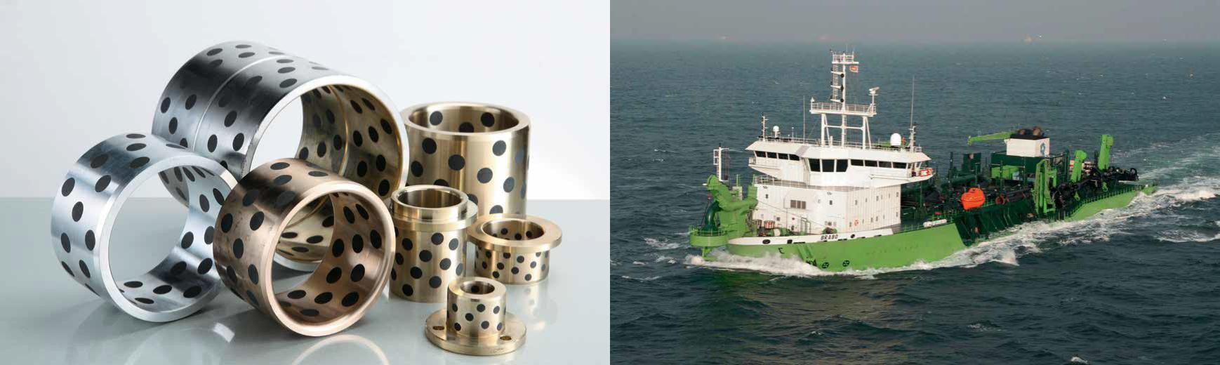

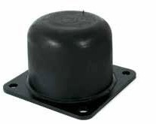
14 www.norden-maritime.no 15

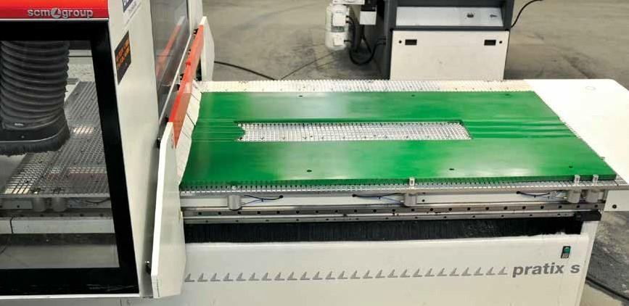
Norden
DU Bearings
PTFE coated bushings

PTFE lined self-lubricating bearings. This type of bushing has a ptfe layer on the inside to enable dry running, giving low friction and good wear properties over a range of temperatures speeds and loads.

Norden
DX Bearings

POM coated bushings

Acetyl lined bearings suitable for oil or grease lubricated applications. The surface indentations retain lubricant providing boundary lubrication suitable for low speed
atrelativelyhighloads.

Polyurethane

Specifications
Material: Casting polyurethane elastomer
Thickness: 0.5 to 500mm
Sizes: 1,000 x 4,000mm / 1,500 x 3,000mm and 1000 x 2000mm
Hardness: Shore 5A-80D
Colors: Red, green, black, yellow, transparent, gray or customized

Special features
Lightweight and flexible:
Only 1/7th the weight of steel for easier installations

Excellent resistance to abrasion and impact:
NORDEN polyurethane sheets outwear mild steel 10 to 1

Plastic

- PA6G
- PA6G+mos
- PA6G+oil
- POM
- PET
- PTFE
- HMWPN
- PP
- PVC
- PEEK
- PVDF
- PDHD 500
- PDHD 1000

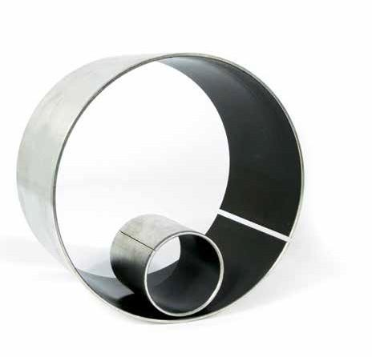
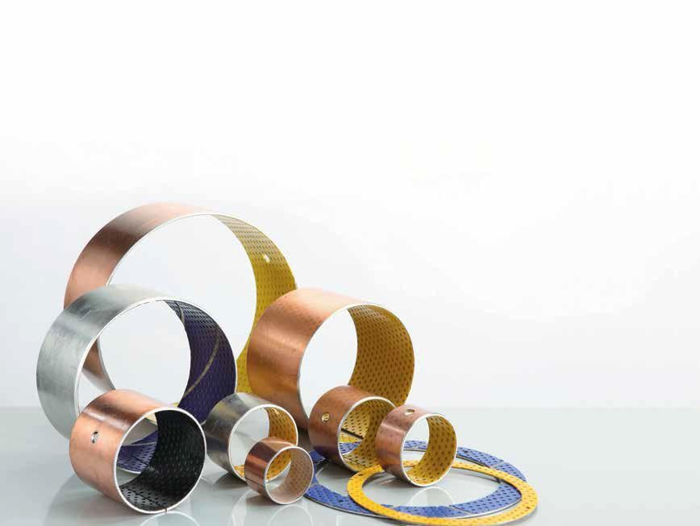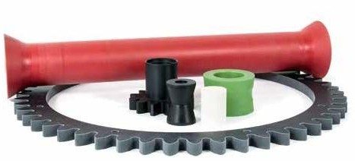

16 www.norden-maritime.no 17

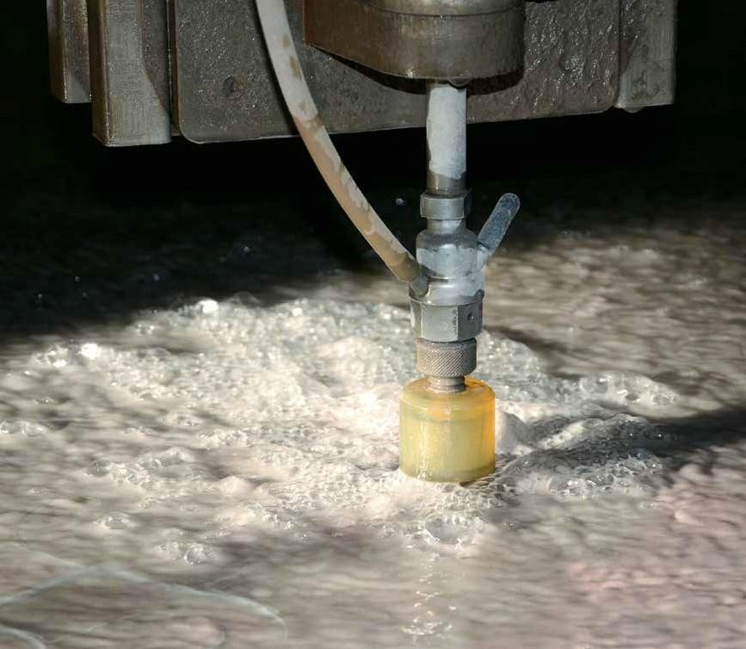
Water cutting
Abrasive water cutting is an advanced method for cutting different materials.

Our machine is fitted with two cutting heads, but when equired, the full power of 35kW pump capacity can be channelled through one nozzle. Nearly all materials can be cut by this method. Up to 110mm thick steel can be cut with a precision of better than 0,1 mm.
The table is 2000mm x 3000mm and maximum weight is 1000 kg/m². The cut itself is very fine and no thermal effects appear in the material.

18

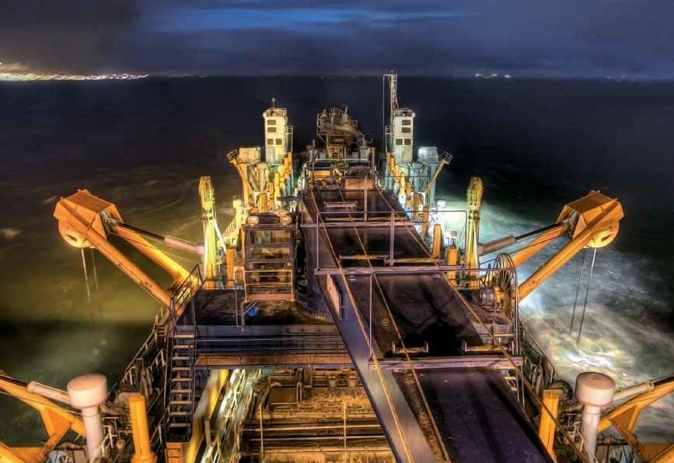
T23095 | www.creato.no

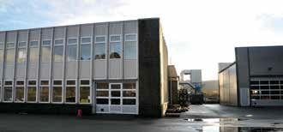

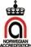
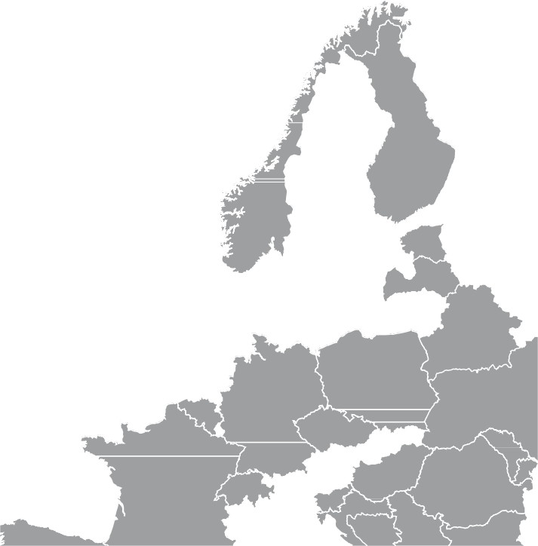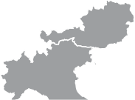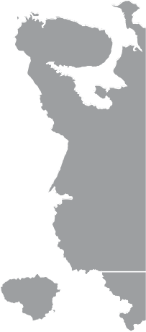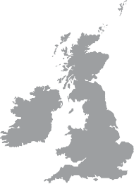Industriveien 13 | 5210 Os | Norway
Phone: +47 5656 5570 | TL@norden-maritime.no | www.norden-maritime.no

