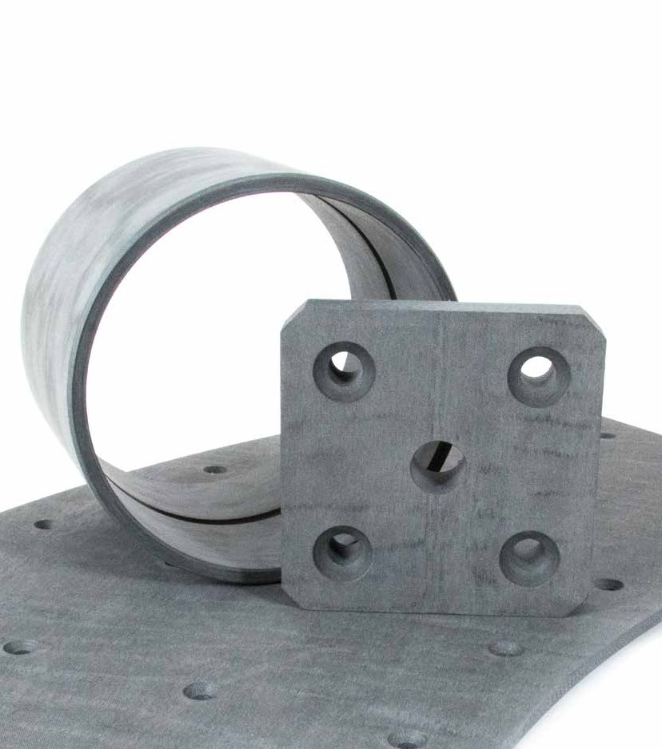

A leading manufacturer of low friction bearing materials to the marine, offshore and onshore industries

Engineering Manual

Essential information to establish
- Housing diameter and tolerance
- Shaft diameter and tolerance
- Shaft material and hardness
- Maximum operating speed
- Maximum operating load

- Maximum operating temperature
- Minimum operating temperature
- Operating environment
- Lubrication medium
Content
Bearing Design Method 4

Bearing Design
The purpose of this manual is to offer a guide to the design of composite bearings manufactured from Norden Composite materials, and to outline the importance of establishing the correct data required to ensure optimum performance of such bearings.
Machining 4
Maching Speeds and Feeds 5
Feed rates 5
Grooving 6
Drilling 6
Installation 7
Running Clearance 8
Recommended Interference Fit 8
PV Correction Factor 9
Typical PV Values 9
Bearing Freeze Fitting Procedure 10 Transfer of Interference Chart 12 Stress/Strain curve 13 Norden 788, Technical Specifications 15
Norden 701, Technical Specifications 16
Norden 901, Technical Specifications 17
Norden 988, Technical Specifications 18 Norden AM8, Technical Specifications 19 Norden NNF, Technical Specifications 20

The above information is essential not only for the design of the bearings but also to ensure the correct grade of material is selected.
Norden RA5, Technical Specifications 21
Contact Norden Maritime AS 24

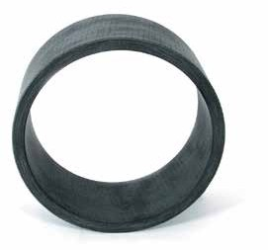

2 www.norden-maritime.no 3

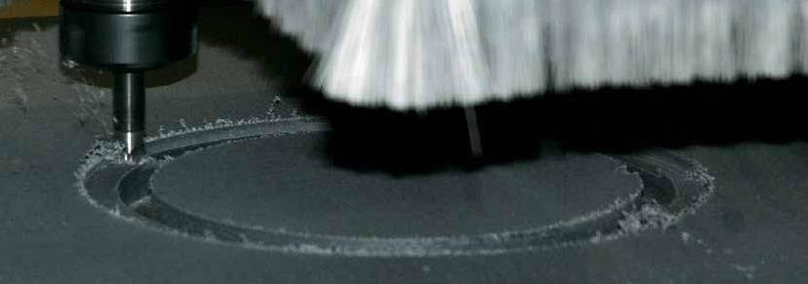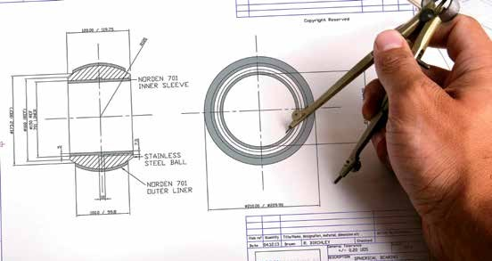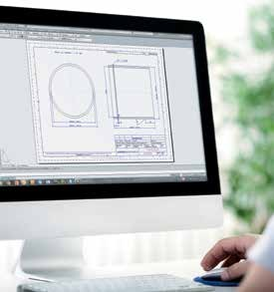Bearing Design Method
To calculate bearing od for machining purposes 1: Housing id max + interference fit = Bearing od min
2: Bearing od min + M/C tolerance = Bearing od max
Subtract min bearing housing diameter from max bearing od, this will give the maximum interference fit value. This value is necessary when calculating machining dimensions for the bearing id due to transfer of interference fit in NORDEN composite bearings.

To calculate bearing id for machining purposes 3: Shaft dia max + “Running clearance” + % transfer value of max
interference fit from chart on page 5 (relevant to the wall thickness of the bearing and shaft diameter) = Min bearing id

4: Min bearing id + M/C tolerance = Max bearing id.

Machining

Visit

www.norden-maritime.no
for Bearing Calculation

An effective tool for inhouse design
Machining Speeds and Feeds

Dia mm
0 – 50 50 – 100 100 – 150 150 – 200 200 – 300 300 – 400

RPM.
2100 1000 700 550 350 250
Dia mm
400 – 500 500 – 600 600 – 700 700 – 800 800 – 900 900 –1000

RPM
200 175 150 130 120 100

Feed Rates

4
www.norden-maritime.no
5

The material is readily machined using conventional machine tooling. It is advisable that the material is machined in a dry condition using the suggested feeds and speeds, Surface speed 300 to 350 m/min with a feed of 0.1 mm/rev for finishing cuts. 0.25mm feed can be used for roughing cuts.
Turning | Roughing 0,7 | Finishing 0.25 mm per rev
Boring | 0.5 | 0.20 mm per rev
Parting | 0.4 | 0.20 mm per rev

Tungsten Carbide tipped tools with positive rake geometry of between 3 & 5 degrees top, side and front have been found to give best results.

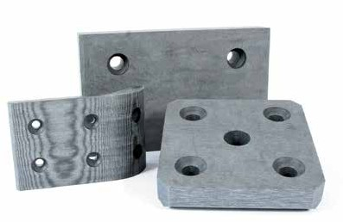

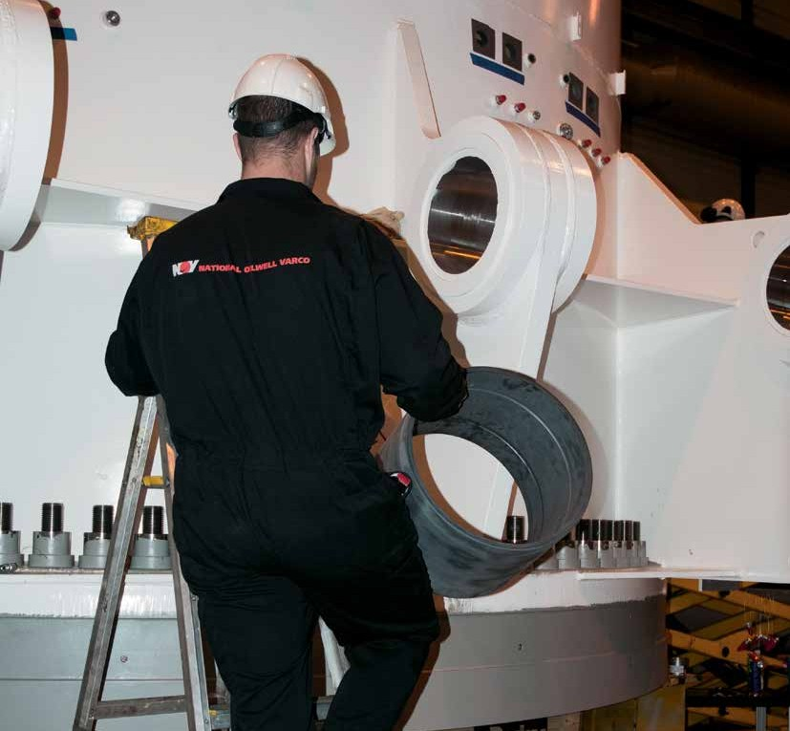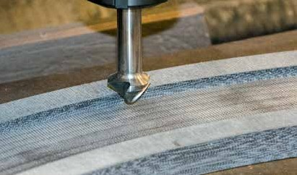Grooving
NORDEN composites can be readily grooved on a lathe, shaping, milling or boring machine with
a 90 degree machining head. For most situations a lathe will be adequate. A sharp tool made from high speed steel ground to the correct form should be clamped to a boring bar with at least 3 degrees clearance ground on the sides of the tool. No top clearance is required

The chuck should be marked with the correctly spaced number of grooves, each groove should be shaped in turn. A depth of 0.2mm should be used for each subsequent cut until the recommended groove depth is reached, the machines fast traverse with the spindle locked should be used for the power. Linear speeds of up to 20 metres per minute can be achieved.
For long bearings a steady may be required.

Drilling
NORDEN composites are easily drilled using either high speed steel or Carbide tipped drills.

The following feeds and speeds are suggested

Installation
Drill DIA Speed RPM Feed MM/MIN
5 | 1000 | 300
10 | 800 | 400
15 | 600 | 400
20 | 400 | 400
25 | 350 | 400
30 | 300 | 400

6
www.norden-maritime.no
7

No asbestos is used in the manufacture of NORDEN material, the material is completely non toxic, the material should be machined dry no cutting or cooling fluids should be used.
Dust extraction is recommended when machining NORDEN material, if not available then it is suggested the operator should wear a non toxic particle mask to avoid inhalation of dust particles.
The bearings can either be pressed into the housing
or freeze-fitted. For recommendations for freeze fitting
see the relevant data sheet.

Care must be taken at all times not to damage the bush during the fitting process. The use of lead in chamfers on the bearing and housing are recommended.

Bore sizes must be checked along all axes at ambient temperature to ensure the minimum bearing running clearance has been achieved.
Bearings can also be bonded into housings with the use of a number of types of adhesives possible.Typically toughened acrylic adhesives have been found to give the best results.

Consult our technical department for recommendations on this procedure.

Running Clearance

Slow Speed Dry
High Speed Lubricated Slow Speed Lubricated
PV Correction Factor

2

1,8

1,6

1,4
Running Clearanc (mm)

1,2

1

0,8

0,6

0,4

0,2
1.4
1.2
1
Correction Factor
0.8
0.6
0.4
0.2
0
0

50 100

Temperature C

150

200

0
0 100 200 300 400 500 600 700 800 900 1000
Shaft Diameter (mm)

Typical PV Values Norden 701 Norden RA5 Norden 901
Norden 788 / 988

Recommended Interference Fit

Interference Fit

100

8
www.norden-maritime.no
9
3,5

3
10
Pressure (N/mm2)

2,5
Interferende Fit mm

2

1,5 1

1

0,5

0 0
0 | 50 | 100 | 150 | 200 | 250 | 300 | 350 | 400 450 500 550 600 650 | 700 | 750 | 800 | 850 | 900 | 950 1000 1050 1100 | 0.00 | 0.01 | 0.10 | 1.00
 |  |  |  |  |  |  |  | Housing Diameter mm |  |  |  |  |  |  |  |  | Velocity (m/s)

10.00

Bearing Freeze Fitting Procedure

Most NORDEN composite bearing materials are capable of being freeze fitted using Liquid Nitrogen, a guide for this process is as follows.

1: Select or manufacture a thin wall steel container which can be clad with insulating material around its outside diameter, the container should be just large enough to hold the bearing and allow it to be completely immersed in the liquid nitrogen.

2: Place the bearing into the container then start to pour in the nitrogen.
For the first few moments the nitrogen will boil off as soon as it contacts the steel surface. Once the steel surface has cooled sufficiently the nitrogen will start to fill the container.

3: Due to the extreme temperature differential the liquid nitrogen will continue to boil off for some time during this period it will be necessary to keep topping up the container ensuring the bearing is completely covered by the nitrogen.

4: When the boiling has subsided, the bearing should be left to stand in the nitrogen for a further period of time. This will be dependant upon the bearing size and can vary from a minimum
of 10 minutes for small bearings, up to 90 minutes for large bearings.

Handling and Safety

When working with liquid nitrogen operators should ensure they are fully conversant with the necessary precautions for its handling and use, as prescribed by the liquid nitrogen supplier. The correct protective
clothing and eye protection should be used at all times.

Thermal contraction coefficient of most NORDEN
materials is 3.5 x 10-5 / °C.
It should be noted that Dry Ice typically will not give
sufficient shrinkage of the bearing to allow freeze fitting
additional mechanical force to press fit may also be required. Consult Norden Maritime for advice on fitting with Dry Ice.

Liquid nitrogen is oxygen depleting
and must not be used in confined spaces

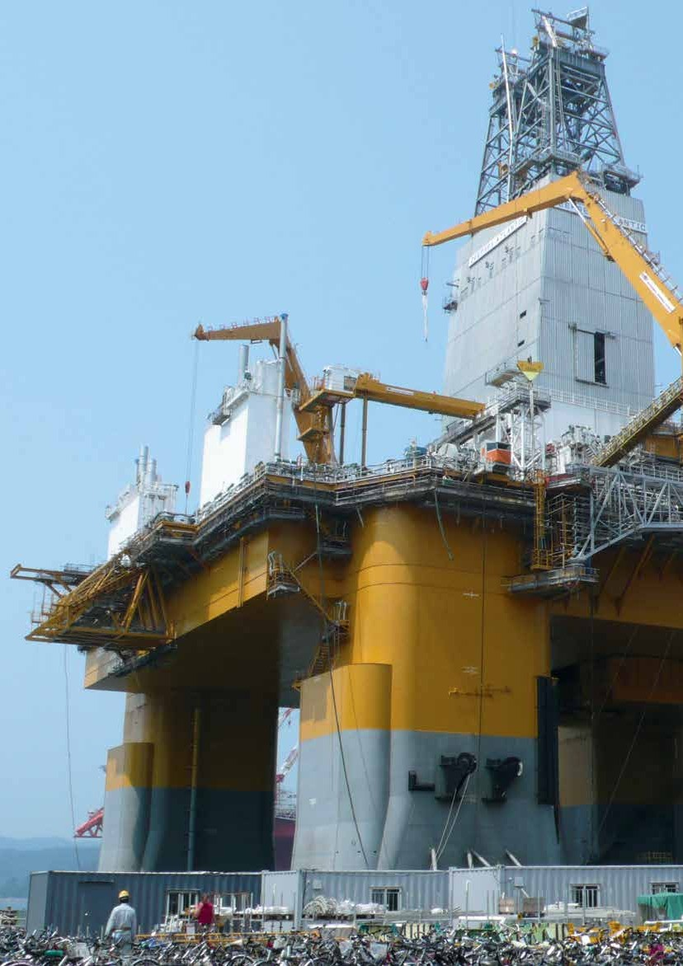

10
www.norden-maritime.no 11

Transfer of Interference Chart Typical Stress/Strain curve

450
100% 90%
80%
70%
60%
50%

40%

400

350
Shaft Diameter (mm)

300

250

200

150

100

50
2.50 5.00 7.50 10.00 12.50 15.00 17.50 20.00 22.50 25.00 27.50 30.00 32.50 35.00 37.50 40.00

Wall Thickness (mm)
500

450

400

350

300
Stress N/mm2

250

200

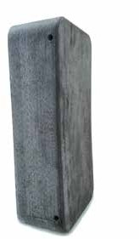
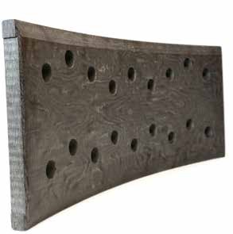
Norden 788 Turret Bearing Norden 788 Turret Bearing Segment
12
www.norden-maritime.no
13

150

100

50

0

0 2,85 5,7 8,57 11,43 14,29 15,71 17,14 20 22,86 25,71 28,57 31,43 34,29 37,14 40

% Strain

NORDEN 788

Technical Specifications

Description
Norden 788 material is intended for use in high load bushings and bearings applications.

Material
Norden 788 is a high load composite bearing material made of specially manufactured synthetic fabric reinforcement using a composite construction process which is impregnated with thermosetting resins, solid lubricant fillers are added which make it suitable for dry running applications. The product is dark grey in colour.

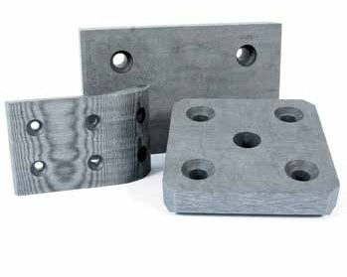

Manufacture
The material is manufactured to documented procedures and standards. Full manufacturing traceability records are kept for the material.

Certificates
Certificates of conformity can be issued that material supplied conforms to the grade standard for a particular order.

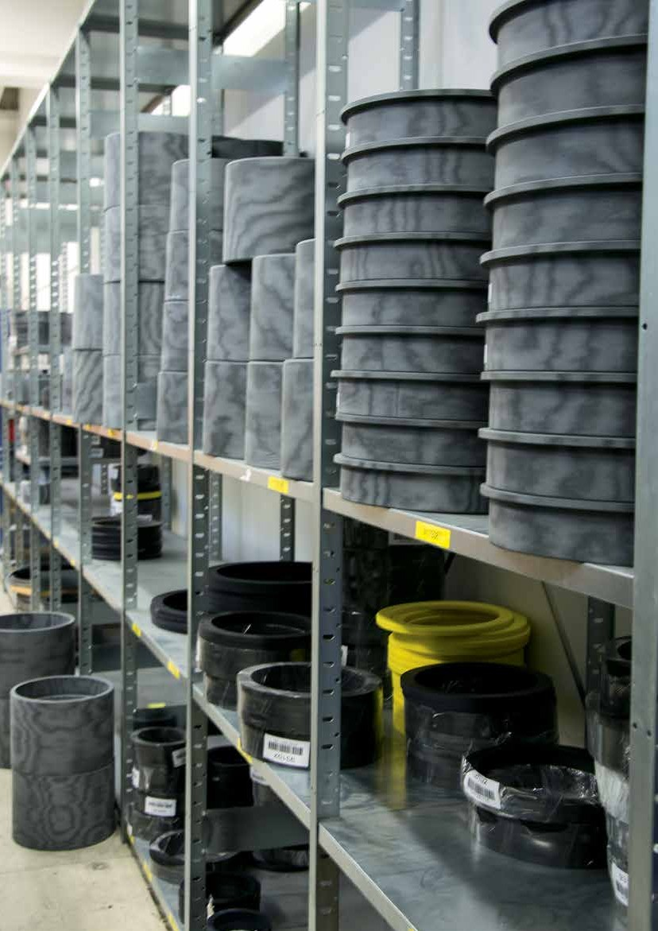

Properties | Value | Unit
Ultimate tensile strength | 60 | N/mm2
Ultimate Flatwise compressive strength | 414 | N/mm2
Ultimate Edgewise compressive strength | 160 | N/mm2
Safe Maximum Static Load | 140 | N/mm2
Safe Maximum Dynamic Load | 60 | N/mm2
Flexural Strength | 69 | N/mm2
Ultimate shear strength | 100 | N/mm2
Impact strength (flatwise) | >20 | IZOD
Density | 1.30/1.35 | gms/cc
Coefficient of friction (dry) | 0.08 | (typical)
Water adsorption to saturation | <0.15% | Volumetric
Maximum temperature range | cryogenic to 120 | oC
Linear expansion coefficients
Parallel to laminate | 5 | 10-5 oC
Normal to laminate | 10 | 10-5 oC
Typical Elongation | 10%

www.norden-maritime.no 15
14

NORDEN 701

Technical Specifications

Description
Norden701 material is intended for use in high load bushings and bearings applications.

Material
Norden701 is a high load composite bearing material manufactured from synthetic fabric reinforcement which is impregnated with a thermosetting resin, solid lubricant fillers are added for reduced friction and improved dry running capability. The product is dark grey in colour.

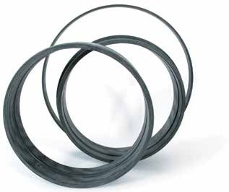

Manufacture
The material is manufactured to documented procedures and standards. Full manufacturing traceability records are kept for the material.

Certificates
Certificates of conformity can be issued that material supplied conforms to the grade standard for a particular order.
NORDEN 901

Technical Specifications

Description
Norden 901 is intended for use in exceptionally high loaded bushings and bearings applications.

Material
Norden 901 composite bearing material is produced using specially manufactured Aramid fabric reinforcement which is impregnated with a thermo- setting resin, solid lubricant fillers are added for reduced friction and improved dry running capability.
Norden 901 is dark grey in colour.

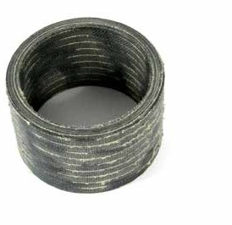

Manufacture
The material is manufactured to a documented formula- tion and procedure standard. Manufacturing traceability records are kept for the material batch.

Certificates
Certificates of conformity can be issued to confirm that the material supplied conforms to the grade standard for a particular order.

16
www.norden-maritime.no
17

Properties | Value | Unit
Ultimate tensile strength | 60 | N/mm2
Typical Elongation | 10%
Ultimate Flatwise compressive strength | 442 | N/mm2
Ultimate Edgewise compressive strength | 186 | N/mm2
Safe Maximum Static Load | 150 | N/mm2
Safe Maximum Dynamic Load | 70 | N/mm2
Flexural Strength | 69 | N/mm2
Ultimate shear strength | 100 | N/mm2
Impact strength (flatwise) | >20 | IZOD
Density | 1.35 | gms/cc
Coefficient of friction (dry) | 0.15 / 0.18
Water adsorption to saturation | <0.15% | Volumetric
Maximum temperature range | cryogenic to 120 | oC
Linear expansion coefficients
Parallel to laminate | 5 | 10-5 oC
Normal to laminate | 10 | 10-5 oC

Properties | Value | Unit
Ultimate tensile strength | 70 | N/mm2
Typical Elongation | <4%
Ultimate Flatwise compressive strength | 530 | N/mm2
Maximum Safe Static Load | 200 | N/mm2
Maximum Safe Dynamic Load | 90 | N/mm2
Ultimate Edgewise compressive strength | 186 | N/mm2
Impact strength (flatwise) | >20 | IZOD
Density | 1.30 / 1.35 | gms/cc
Coefficient of friction (dry) | 0.15 / 0.2 | (typical)
Water adsorption to saturation | <0. 5% | Volumetric
Maximum temperature range | cryogenic to 190 | oC
Linear expansion coefficients
Parallel to laminate | 3 | 10-5 oC
Normal to laminate | 5 | 10-5 oC

NORDEN 988

Technical Specifications

Description
Norden 988 is intended for use in exceptionally high loaded bushings and bearings applications.

Composition
Norden 988 composite bearing material is produced using a specially manufactured Aramid fabric reinforce- ment and incorporates a unique low friction bearing surface. The material is impregnated with a thermosetting resin incorporating solid lubricant fillers. Norden 988 has been formulated particularly for dry running high load applications. Norden 988 is dark grey in colour.

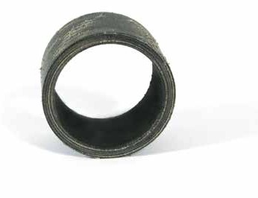

Manufacture
The material is manufactured to a documented formulation and procedure standard. Manufacturing traceability records are kept for the material batch.

Certificates
Certificates of conformity can be issued to confirm that the material supplied conforms to the grade standard for a particular order.
NORDEN AM8

Technical Specifications

Description
Norden AM8 material is intended for use in high load bushings and bearings applications.

Material
Norden AM8 is a high load composite bearing material made of specially manufactured synthetic fabric reinforcement using a special composite construction process, the material is impregnated with a thermosetting resin and solid lubricant fillers making it suitable for dry running applications. The product is dark grey in colour.

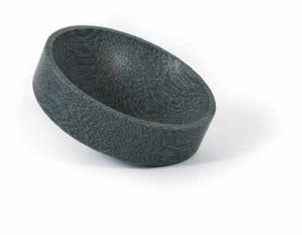

Manufacture
The material is manufactured to documented procedures and standards. Full manufacturing traceability records are kept for the material.

Certificates
Certificates of conformity can be issued that material supplied conforms to the grade standard for a particular order.

18
www.norden-maritime.no
19
Properties | Value | Unit
Ultimate tensile strength | 70 | N/mm2
Typical Elongation | <4%
Ultimate Flatwise compressive strength | 500 | N/mm2
Maximum Safe Static Load | 190 | N/mm2
Maximum Safe Dynamic Load | 80 | N/mm2
Ultimate Edgewise compressive strength | 186 | N/mm2
Impact strength (flatwise) | >20 | IZOD
Density | 1.30 / 1.35 | gms/cc
Coefficient of friction (dry) | 0.08 / 0.1 | (typical)
Water adsorption to saturation | <0. 5% | Volumetric
Maximum temperature range | cryogenic to 190 | oC
Linear expansion coefficients
Parallel to laminate | 3 | 10-5 oC
Normal to laminate | 5 | 10-5 oC

Properties | Value | Unit
Ultimate tensile strength | 60 | N/mm2
Ultimate Flatwise compressive strength | 400 | N/mm2
Maximum Safe Static Load | 120 | N/mm2
Maximum Safe Dynamic Load | 60 | N/mm2
Ultimate Edgewise compressive strength | 160 | N/mm2
Flexural Strength | 69 | N/mm2
Ultimate shear strength | 100 | N/mm2
Impact strength (flatwise) | >20 | IZOD
Density | 1.30/1.35 | gms/cc
Coefficient of friction (dry) | 0.08 | (typical)
Water adsorption to saturation | <0.15% | Volumetric
Maximum temperature range | cryogenic to 120 | oC
Linear expansion coefficients
Parallel to laminate | 5 | 10-5 oC
Normal to laminate | 10 | 10-5 oC
Typical Elongation | 10%

NORDEN NNF

Technical Specifications

Description
Norden NNF material is intended for use in medium load bushings and sliding bearing applications.

Material
Norden NNF is a specially constructed composite bearing material incorporating a needle felt fibre reinforcing which is impregnated with a thermosetting resin. Solid lubricant fillers are added to the resin to lower friction and improve wear resistance. The product is dark grey in colour.

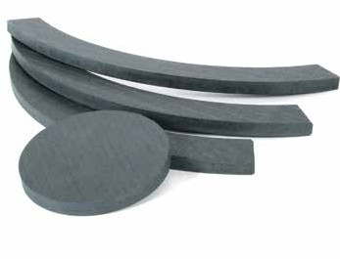

Manufacture
The material is manufactured to documented procedures and standards. Full manufacturing traceability records are kept for the material.

Certificates
Certificates of conformity can be issued that material supplied conforms to the grade standard for a particular order.
NORDEN RA5

Technical Specifications

Description
Norden RA5 is intended for use in high load bushings and bearings applications.

Material
Norden RA5 composite bearing material is made of
a specially manufactured synthetic fabric reinforcement incorporating PTFE. The material impregnated with
a thermosetting resin containing solid lubricant fillers for enhanced dry running capability. Norden RA5 is dark grey in colour.
Properties | Value | Unit
Ultimate tensile strength | 60 | N/mm2
Typical Elongation | 10%
Ultimate Flatwise compressive strength | 414 | N/mm2
Maximum Safe Static Load | 120 | N/mm2
Maximum Safe Dynamic Load | 60 | N/mm2
Ultimate Edgewise compressive strength | 186 | N/mm2
Flexural Strength | 69 | N/mm2
Ultimate shear strength | 100 | N/mm2
Impact strength (flatwise) | >20 | IZOD
Density | 1.30 / 1.35 | gms/cc
Coefficient of friction (dry) | 0.12 / 0.15 | (typical)
Water adsorption to saturation | <0.15% | Volumetric
Maximum temperature range | cryogenic to 120 | oC
Linear expansion coefficients
Parallel to laminate | 5 | 10-5 oC
Normal to laminate | 10 | 10-5 oC

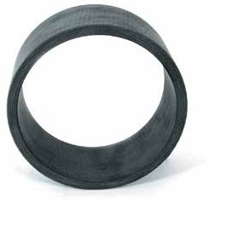

Manufacture
The material is manufactured to a documented formulation and procedure standard. Manufacturing traceability records are kept for the material batch.

Certificates
Certificates of conformity can be issued to confirm that the material supplied conforms to the grade standard for a particular order.

20
www.norden-maritime.no
21

Properties | Value | Unit
Ultimate tensile strength | 35 | N/mm2
Ultimate Flatwise compressive strength | 180 | N/mm2
Maximum Safe Static Load | 90 | N/mm2
Maximum Safe Dynamic load | 50 | N/mm2
Ultimate Edgewise compressive strength | 100 | N/mm2
Density | 1.40 / 1.45 | gms/cc
Coefficient of friction (dry) | 0.17 / 0.18
Water adsorption to saturation | <0.5% | Volumetric
Maximum temperature range | - 40 to 100 | oC
Linear expansion coefficients
Parallel to laminate | 4 | 10-5 oC
Normal to laminate | 6 | 10-5 oC

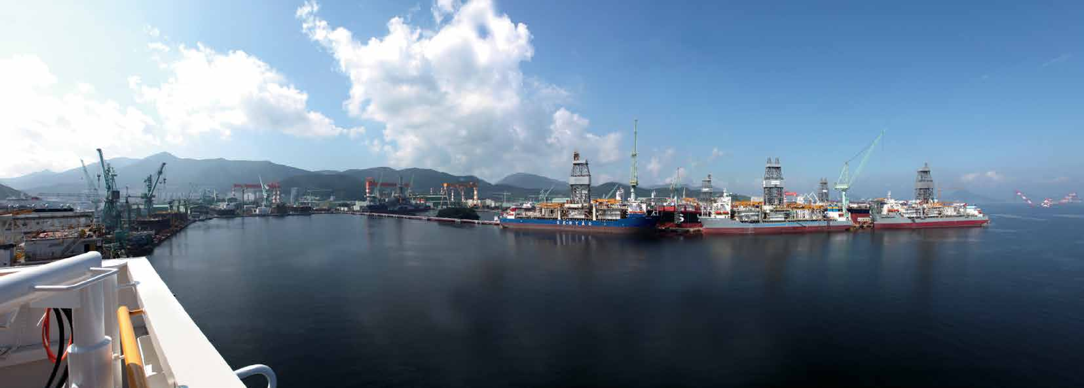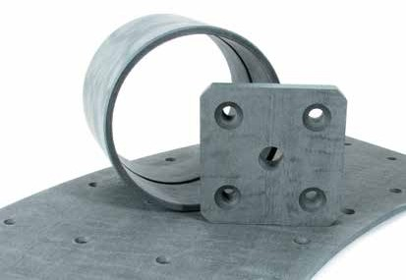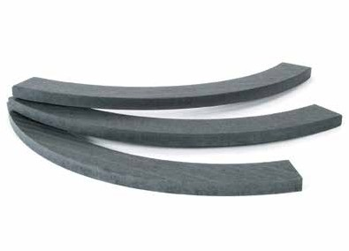
22 www.norden-maritime.no 23

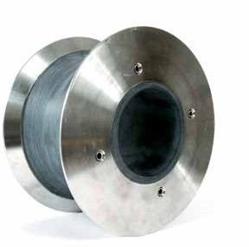
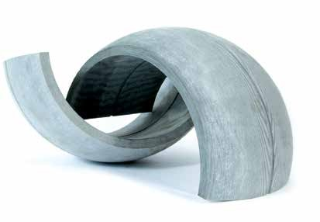
Availability

Norden Bearing materials are usually supplied as fully machined components to customers’ own drawings. Alternatively, semi-finished materials are supplied in the form of tube or sheet.

The following standard range of sizes is available with other sizes on request:

Tube
 | Minimum ID | 8 mm
 | Maximum OD | 2500
 | Standard lengts | 500 and 1000
Sheet
 | Minimum thickness | 1 mm
 | Maximum thickness | 100 mm
 | Maximum width | 1000 mm
 | Maximum length | 2000 mm

The composite materiel developed and manufactured by Norden Maritime has proven to hold the best quality in the market

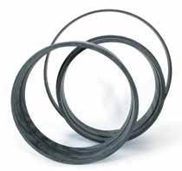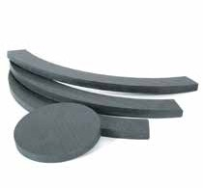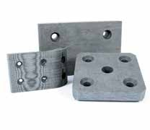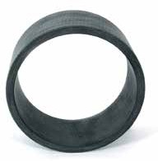
T23095 | www.creato.no

Engineering Manual

Industriveien 13 | 5210 Os | Norway
Phone: +47 5656 5570 | TL@norden-maritime.no | www.norden-maritime.no

