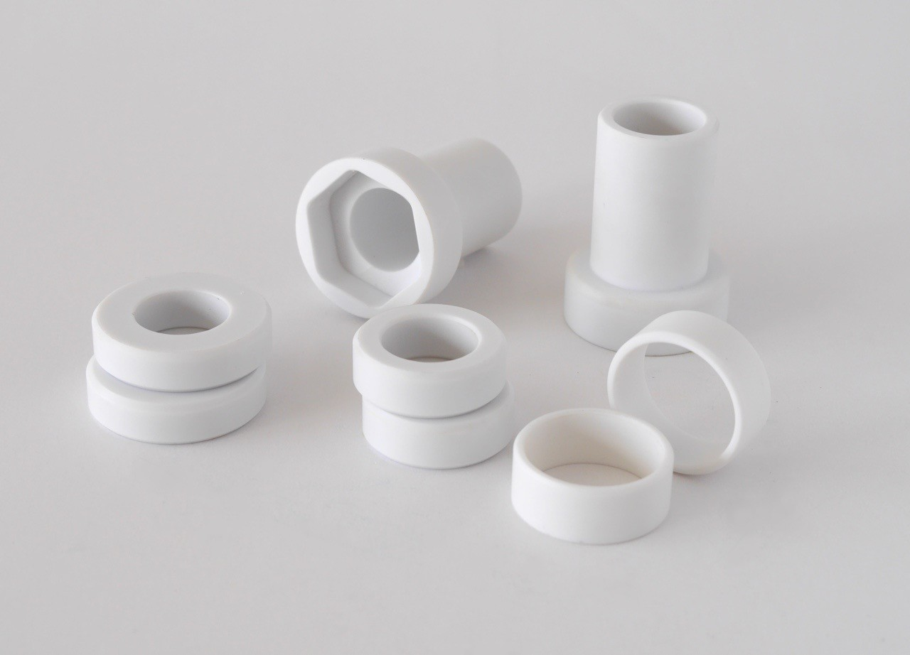
Norden CM8 – Data sheet

 | Metric
Density | 1.39 g.ml-1
Melting point | 255°C
Hardness (Shore D) | 82
Tensile strength at yield (D638) | 66 MPa
Tensile strength at break | 65 MPa
Tangent modulus of elasticity (D790) | 3726 MPa
Flexural yield strength | 113 MPa
Modulus of elasticity under compression | 2199 MPa
Compression strength at yield | 98 MPa
Shear strength | 50 MPa
Notched impact strength charpy (D256) | 26 J.m-1
Notched impact strength IZOD | 30 J.m-1
Abrasive Wear, dry mm 3 | 195
Coefficient of linear thermal expansion | 5,9x10-5mm.mm-  1.oC-1
Maximum moisture absorption in water at 20°C | 0.5%
Equilibrium moisture absorption in air at 23°C | 0.2%
Dynamic unlubricated friction coefficient on. | 0.10
Static friction coefficient dry (no lubrication) | 0.09
Dielectric strength | 14 kV.mm-1
Gamma ray resistance 50% loss of properties | 100 Mrads

NordenMaritime
5210 OS – Norway
www.norden-maritime.no
Phone +47 5656 5570 E:mail post@norden-maritime.no
3

