P+S

DURABLE
RESISTANT TO HYDROLYSIS

LIFE QUALITY
VIBRATION DECOUPLING
POLYURETHAN ELASTOMERS

HIGHLY RESILIENT

DYNAMIC

ACOUSTICS

COMFORT
DIEPOLAST

WORKING CLIMATE
PROTECTION
SUSPENSION
SOUNDPROOFING
THEATRE STAGE
VIBRATION ELASTIC
APPRECIATION
LIFESPAN

EXCELLENT MATERIAL
DIEPOLAST®
IDEAL FOR VIBRATION ISOLATION

Diepolast
Diepolast is a high-tech, mixed- cellular elastomer consisting of a special polyether-urethane.
The material is used for vibration decoupling in mechanical engineering as well as in construction industry. Our Diepolast has excellent properties both under compression and thrust loads. The 13 base types Diepolast SD10
– Diepolast SD1900 are available, enabling solutions for almost every application. The desired requirements can be fulfilled by the choice of the respective type, the supporting surface and the height.

In addition to the flat sheet material, it is also possible to produce technical moulded parts made of Diepolast.

If necessary, special types can be produced with precisely matching strength. The special properties of the material will be adjusted. Colour changes are possible. Such special
designs require a minimum production quantity, differing by type.

At a glance: the profile of properties
- large load ranges

- good vibration damping/-isolation

- for pressure and thrust loads

- good resistance to hydrolysis

- temperature range
of – 30°C bis + 70 °C

- low compression set

- good decoupling effect

- usable for isolation of source and/or recipient

- good resistance to mineral oils, greases and various solvents

In contrast to non-cellular elastomers, Diepolast has gas volumes enclosed in the fine-cell structure. Accordingly, the material is compressible both in static and dynamic stress. It is therefore also suitable for shallow construction sites in situ concrete way.

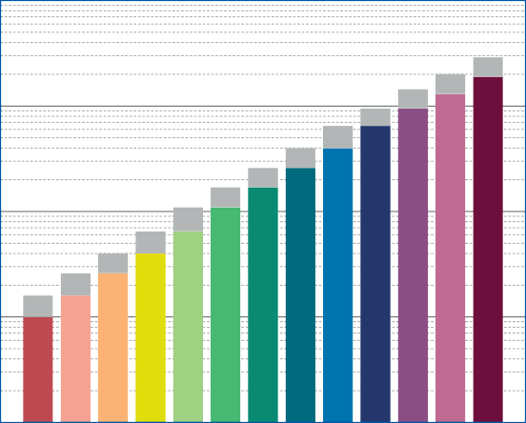
10

1
specific load [N/mm²]

0,1

SD 40

SD 65

SD 110

0,01

SD 10

SD 16

SD 26

0,001

SD 170
SD 260
SD 400
SD 650
SD 950
SD 1300
SD 1900

Diepolast type
Diepolast series Working range

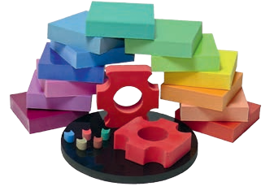
EXCELLENT MATERIAL
DIEPOLAST®

IDEAL FOR VIBRATION ISOLATION

Diepolast dyn

Applications overview:

- construction industry

- general engineering

- transport and conveyor technology

- civil engineering

- lift technology

- sanitary technology

- heating, air condition and ventilation systems

- medical technologies

- pre-fabricated house production
Diepolast dyn is a closed-cell high-tech elastomer and consists of a special polyether-urethane. Due to its strucutre, this material absorbs almost no fluids and can thus also be used in oppressive groundwater.

The 5 basic types Diepolast dyn S75
– Diepolast dyn S1500 are available, enabling solutions for almost every application. The desired requirements can be fulfilled by the choice of the respective type, the supporting surface and the height.

Due to its excellent dynamic
properties, Diepolast dyn is also suitable for difficult applications. Our product range offers special types for heavy load foundation bearer and dynamic loads up to 9 N/mm² (load peaks even up to 18 N/mm²). These types are called Diepolast dyn HL and are available upon request.

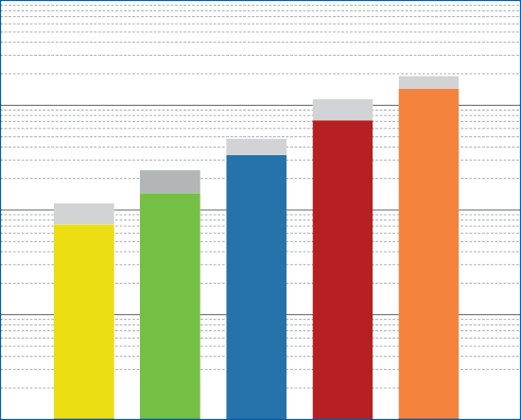
10

1

0,1
specific load [N/mm²]

0,01

0,001

S S
75 150

S 350

S 750

S
1500
Diepolast dyn series Working range

Diepolast dyn type

DIEPOLAST SD
SD SD
SD
SD SD SD SD
SD
SD SD SD SD SD

Properties | 10 | 16 | 26 | 40 | 65 | 110 | 170 | 260 | 400 | 650 | 950 | 1300 | 1900 | Test method
Colour | red | pink | orange | yellow | bright green | green | dark green | petrol | blue | dark blue | dark violet | violet | borde- aux red
Static loads [N/mm2] (1) | 0.010 | 0.016 | 0.026 | 0.040 | 0.065 | 0.110 | 0.170 | 0.260 | 0.400 | 0.650 | 0.950 | 1.300 | 1.900
Dynamic loads [N/mm2] (1) | 0.016 | 0.026 | 0.040 | 0.065 | 0.110 | 0.170 | 0.260 | 0.400 | 0.650 | 0.950 | 1.450 | 2.000 | 2.800
Load peaks [N/mm2] (1) | 0.5 | 0.7 | 1.0 | 2.0 | 2.5 | 3.0 | 3.5 | 4.0 | 4.5 | 5.5 | 6.0 | 6.5 | 7.0
Mechanical loss factor (2) | 0.25 | 0.24 | 0.22 | 0.15 | 0.18 | 0.12 | 0.13 | 0.11 | 0.10 | 0.10 | 0.10 | 0.09 | 0.09 | DIN 53513 (3)
Static E-modulus [N/mm2] (2) | 0.048 | 0.111 | 0.129 | 0.316 | 0.453 | 0.861 | 0.931 | 1.64 | 2.72 | 4.57 | 8.16 | 12.0 | 20.4 | DIN 53513 (3)
Dynamic E-modulus [N/mm2] (2) | 0.144 | 0.328 | 0.443 | 0.743 | 1.06 | 1.86 | 2.27 | 3.63 | 5.27 | 10.4 | 21.5 | 35.2 | 78.2 | DIN 53513 (3)
Resistance to strain at 10% deforma- tion [N/mm2] | 0.011 | 0.018 | 0.026 | 0.046 | 0.073 | 0.130 | 0.170 | 0.270 | 0.370 | 0.590 | 0.930 | 1.340 | 1.840
Residual compression set [%] | < 5 | < 5 | < 5 | < 5 | < 5 | < 5 | < 5 | < 5 | < 6 | < 7 | < 9 | < 9 | < 8 | DIN ISO 1856
Tensile strength [N/mm2] | > 0.35 | > 0.40 | > 0.45 | > 0.55 | > 0.70 | > 0.95 | > 1.25 | > 1.65 | > 2.25 | > 3.00 | > 3.80 | > 4.40 | > 5.00 | DIN 53455-6-4
Elongation at break [%] | > 400 | > 400 | > 400 | > 400 | > 400 | > 400 | > 400 | > 400 | > 400 | > 400 | > 400 | > 400 | > 400 | DIN 53455-6-4
Rebound elasticity [%] | 50 | 50 | 50 | 50 | 50 | 50 | 50 | 50 | 50 | 50 | 50 | 50 | 50 | DIN  EN ISO 8307
Specific volume resistance [Ω⋅cm] | > 1012 | > 1012 | > 1011 | > 1011 | > 1011 | > 1011 | > 1011 | > 1011 | > 1011 | > 1011 | > 1011 | > 1011 | > 1011 | DIN IEC 93
Thermal conductivity [W/m⋅K] | 0.05 | 0.05 | 0.06 | 0.07 | 0.07 | 0.08 | 0,08 | 0.08 | 0.10 | 0.10 | 0.11 | 0.11 | 0.11 | DIN 52612-1
Operating temperature [°C] | - 30 to + 70
Temperature peak [°C] | + 120
Inflammability | Class E / EN 13501-1 |  |  |  |  |  |  |  |  |  |  |  |  | EN ISO 11925-1

(1) Values apply to form factor q = 3

Product overview

- motor bearer

- foundation decoupling

- sound insulation in floors and ceilings

- vibration decoupling of components

- machine frame foundation

- elastical intermediate bearer

- wall decoupling

- spring elements

- plates and cuttings for individuell processing

- underwater installations

- shaft decoupling
(2) Measured at maximum limit of static application range
(3) Test according to respective standards

All information and data is based on our current knowledge. The data are subject to typical manufacturing tolerances and are not guaranteed. We reserve the right to amend the data.

DIEPOLAST DYN S

S

S

S

S

S

(1) Values apply to form factor q = 3
(2) Measured at maximum limit of static application range
(3) Test according to respective standards

All information and data is based on our current knowledge. The data are subject to typical manufacturing tolerances and are not guaran-
P+S Polyurethan-Elastomere GmbH & Co. KG

Kielweg 17 · D-49356 Diepholz
75 150 350 750 1500
Properties Test method
Colour | yellow | green | blue | red | orange
Static loads [N/mm2] (1) | 0.075 | 0.150 | 0.350 | 0.750 | 1.500
Dynamic loads [N/mm2] (1) | 0.120 | 0.250 | 0.500 | 1.200 | 2.000
Load peaks [N/mm2] (1) | 2.0 | 3.0 | 4.0 | 6.0 | 8.0
Mechanical loss factor (2) | 0.06 | 0.03 | 0.03 | 0.04 | 0.05 | DIN 53513 (3)
Static E-modulus [N/mm2] (2) | 0.63 | 1.25 | 2.53 | 5.21 | 9.21 | DIN 53513 (3)
Dynamic E-modulus [N/mm2] (2) | 0.92 | 1.65 | 3.25 | 8.88 | 16.66 | DIN 53513 (3)
Static shear modulus [N/mm²] (2) | 0.16 | 0.22 | 0.35 | 0.80 | 1.15 | DIN 53513 (3)
Dynamic shear modulus [N/ mm²] (2) | 0.27 | 0.35 | 0.52 | 1.22 | 1.69 | DIN 53513 (3)
Resistance to strain at 10% deforma- tion [N/mm2] | 0.083 | 0.16 | 0.32 | 0.59 | 0.94
Residual compression set [%] | < 5 | < 5 | < 5 | < 6 | < 8 | DIN ISO 1856
Tensile strength [N/mm2] | > 1.5 | > 2.0 | > 3.5 | > 5.0 | > 7.0 | DIN 53455-6-4
Elongation at break [%] | > 500 | > 500 | > 500 | > 500 | > 500 | DIN 53455-6-4
Tear resistance [N/mm] | > 1.6 | > 2.1 | > 2.5 | > 4.3 | > 5.6 | DIN ISO 34-1/A
Rebound elasticity [%] | 70 | 70 | 70 | 70 | 70 | DIN EN ISO 8307
Specific volume resistance [Ω⋅cm] | > 1011 | > 1011 | > 1011 | > 1011 | > 1011 | DIN IEC 93
Thermal conductivity [W/m⋅K] | 0.06 | 0.075 | 0.09 | 0.10 | 0.11 | DIN 52612-1
Operating temperature [°C] | - 30 up to + 70
Temperature peak [°C] | + 120
Inflammability | Class E / EN 13501-1 |  |  |  |  | EN ISO 11925-1

+

teed.
Telefon
49 (0) 5441 5980-0

We reserve the right to amend the data.
Telefax + 49 (0) 5441 5980-88
info@pus-polyurethan.de www.pus-polyurethan.de

