10

SD 1900
SD 1300
SD 950
SD 650
SD 400
SD 260
SD 170
SD 110
SD 65
SD 40
SD 26
SD 16
SD 10

1
specific load [N/mm²]

0.1

0.01

0.001
Diepolast series

Working range

Diepolast type

Recommendations for elastic bearing:

Static load: up to [N/mm²]
0.010
Dynamic load: up to [N/mm²]
0.016
Load peaks: up to [N/mm²]
0.5
Values depending on form factor and apply to form factor q = 3

Material mixed cellular polyether-urethane
Colour red
Delivery specifications Thickness: 12.5 mm and 25 mm
Mats: 0.5 m wide, 2.0 m long
Stripes: max. 2.0 m lang
Other dimensions on request (also stamping and moulded parts).

Properties | Value | Test method | Comment
Mechanical loss factor (1) | 0.25 | DIN 53513 (2) | guide value
Static E-modulus (1) | 0.048 N/mm² | DIN 53513 (2)
Dynamic E-modulus (1) | 0.144 N/mm² | DIN 53513 (2)
Resistance to strain | 0.011 N/mm² |  | at 10% deformation
Residual compression set | < 5 % | DIN EN ISO 1856 | 50%, 23°C, 70 h, 30 min after unloading
Tensile strength | > 0.35 N/mm2 | DIN 53455-6-4 | minimum
Elongation at break | > 400 % | DIN 53455-6-4 | minimum
Rebound elasticity | 50 % | DIN EN ISO 8307 | ± 10%
Specific volume resistance | >1012 Ω·cm | DIN IEC 93 | dry
Thermal conductivity | 0.05 W/[m·K] | DIN 52612-1
Operating temperature | -30 bis +70 °C
Temperature peak | +120 °C
Inflammability | Class E / EN 13501-1 | EN ISO 11925-1 | normal flammable

(1) measured at maximum limit of static application range
Version 1.0 from 01/04/2016
(2) test according to DIN 53513
All information and data is based on our current knowledge. The data are subject to typical manufacturing tolerances and are not guaranteed. We reserve the right to amend the data.

Load deflection curve

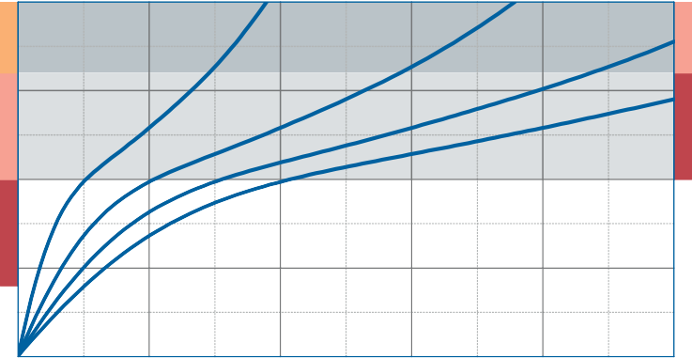
0.020
SD 16
Dynamic range of use

0.015
Specific load [N/mm²]
SD 16
SD 10

0.010
Static range of use SD 10

0.005

Recording of the 3rd loading; testing between steel plates at room temperature measured with a deflection rate of 1% of the thickness per second
Form factor q = 3

0.000
0

2 4 6

Deflection [mm]

8 10

Modulus of elasticity

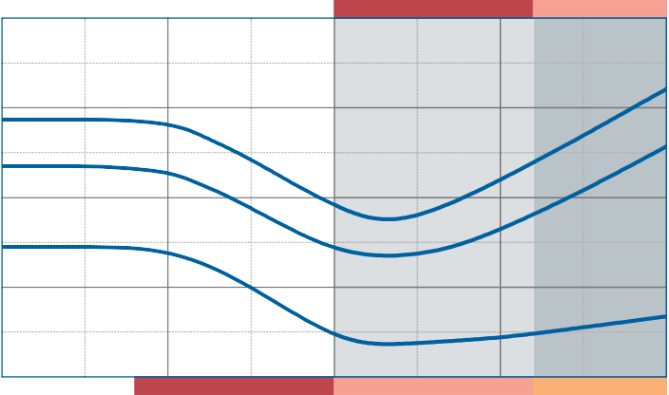0.4
SD 10
SD 16
SD 10
SD 16

0.3
Modulus of elasticity [N/mm²]

0.2

Dynamic range of use

Dynamic test: sinusoidal excitation with an oscillating range of ± 0.22 mm at 10 Hz and ± 0.08 mm at 30 Hz
Quasistatic modulus of elasticity: tangent modulus taken from the load deflection curve
Test according to DIN 53513 Form factor q = 3

0.1

0.0

0.000

Static range of use 0.005

0.010

0.015

0.020

Specific load [N/mm²]

Natural frequency

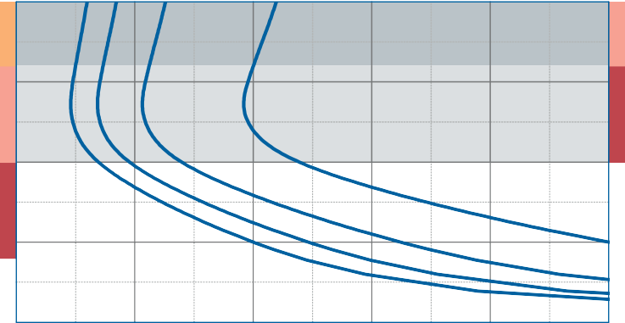
0.020
SD 16
Dynamic range of use

0.015
Specific load [N/mm²]
SD 16
SD 10

0.010
Static range of use SD 10

0.005

Natural frequency of a single-degree-of- freedom system consisting of a fixed mass and an elastic bearing consisting of Diepolast SD 10 on a stiff subgrade.
Form factor q = 3

0.000
5

10 15 20 25 30
Version 1.0 from 01/04/2016

Natural frequency [Hz]

Correction values varying form factors

specific load 0.01 N/mm², form factor q = 3

Static load range Deflection

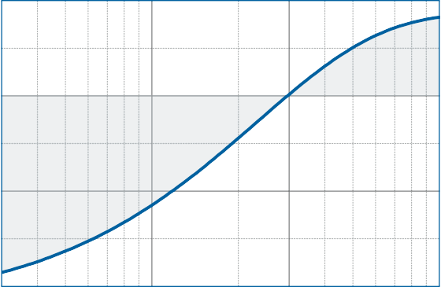
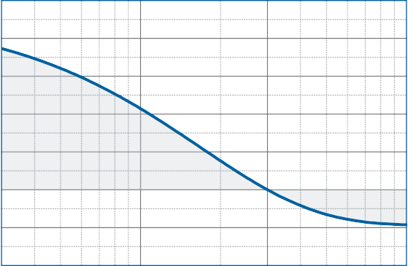
0.0105 10

8

6
Specific load [N/mm²]
Variation of deflection [%]
0.0100
4

2
0.0095
0

-2

0.0090

0.3

1 3
Form factor
-4
10 0.3

1 3 10
Form factor

Dynamic modulus of elasticity at 10 Hz Natural frequency

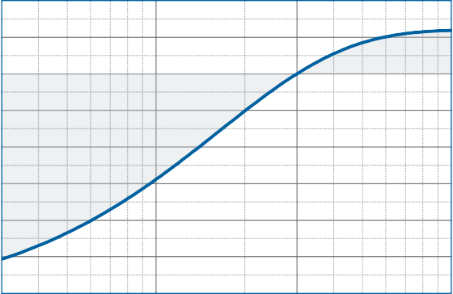
10
Variation of the dynamic modulus of elasticity [%]

5

0

-5

-10

-15

-20

-25

5

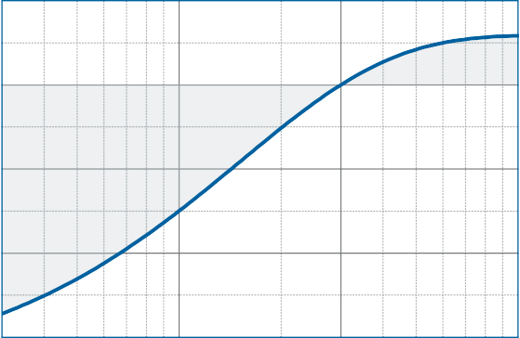
0
Variation of the natural frequency [%]

-5

-10

-30

0.3

1 3
Form factor

-15
10

0.3

1 3 10
Form factor

DISCLAIMER:
The information provided is intended only as a summary and general overview on matters of interest. The information is not intended to be comprehensive nor does it constitute expert advice. P+S Polyurethan-Elastomere GmbH Co.KG shall not be liable for incidental and/or consequential damages directly or indirectly sustained, nor any loss caused by not complying with relevant industry/product standards and improper use of any Diepolast products. Due to varying construction methods, any other circumstances not stated above should be brought to the attention of P+S Polyurethan-Elastomere GmbH Co.KG for review. For suitability to the prevailing site conditions, it is advised that certified testing should be conducted. It is recommended to seek further advice on your application with our technical staff prior to use.
Version 1.0 from 01/04/2016

The data sheet is not subject to any change service! All information is without guarantee. Latest version of this document available on www.pus-polyurethan.de

10

SD 1900
SD 1300
SD 950
SD 650
SD 400
SD 260
SD 170
SD 110
SD 65
SD 40
SD 26
SD 16
SD 10

1
specific load [N/mm²]

0.1

0.01

0.001
Diepolast series

Working range

Diepolast type

Recommendations for elastic bearing:

Static load: up to [N/mm²]
0.016
Dynamic load: up to [N/mm²]
0.026
Load peaks: up to [N/mm²]
0.7
Values depending on form factor and apply to form factor q = 3

Material mixed cellular polyether-urethane
Colour pink
Delivery specifications Thickness: 12.5 mm and 25 mm
Mats: 0.5 m wide, 2.0 m long
Stripes: max. 2.0 m lang
Other dimensions on request (also stamping and moulded parts).

Properties | Value | Test method | Comment
Mechanical loss factor (1) | 0.24 | DIN 53513 (2) | guide value
Static E-modulus (1) | 0.111 N/mm² | DIN 53513 (2)
Dynamic E-modulus (1) | 0.328 N/mm² | DIN 53513 (2)
Resistance to strain | 0.018 N/mm² |  | at 10% deformation
Residual compression set | < 5 % | DIN EN ISO 1856 | 50%, 23°C, 70 h, 30 min after unloading
Tensile strength | > 0.40 N/mm2 | DIN 53455-6-4 | minimum
Elongation at break | > 400 % | DIN 53455-6-4 | minimum
Rebound elasticity | 50 % | DIN EN ISO 8307 | ± 10%
Specific volume resistance | >1012 Ω·cm | DIN IEC 93 | dry
Thermal conductivity | 0.05 W/[m·K] | DIN 52612-1
Operating temperature | -30 bis +70 °C
Temperature peak | +120 °C
Inflammability | Class E / EN 13501-1 | EN ISO 11925-1 | normal flammable

(1) measured at maximum limit of static application range
Version 1.0 from 01/04/2016
(2) test according to DIN 53513
All information and data is based on our current knowledge. The data are subject to typical manufacturing tolerances and are not guaranteed. We reserve the right to amend the data.

Load deflection curve

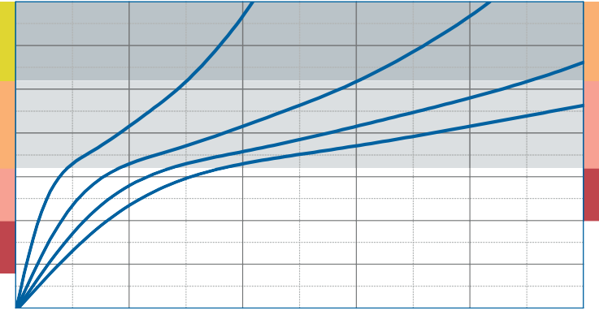
0.035

0.030
SD 26

0.025
Specific load [N/mm²]
SD 26
SD 16
Dynamic range of use

0.020

0.015
Static range of use SD 10 SD 16
SD 10

0.010

0.005

Recording of the 3rd loading; testing between steel plates at room temperature measured with a deflection rate of 1% of the thickness per second
Form factor q = 3

0.000
0

2 4 6

Deflection [mm]

8 10

Modulus of elasticity

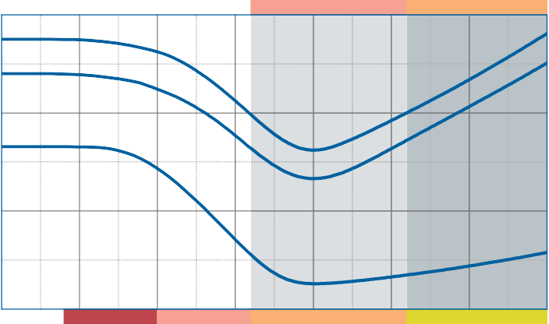0.6
SD 16
SD 26
SD 10
SD 16
SD 26
SD 10

0.4
Modulus of elasticity [N/mm²]

Dynamic range of use

Dynamic test: sinusoidal excitation with an oscillating range of ± 0.22 mm at 10 Hz and ± 0.08 mm at 30 Hz
Quasistatic modulus of elasticity: tangent modulus taken from the load deflection curve
Test according to DIN 53513 Form factor q = 3

0.2

0.0
Static range of use
0.000 0.005 0.010 0.015 0.020 0.025 0.030 0.035
Specific load [N/mm²]

Natural frequency

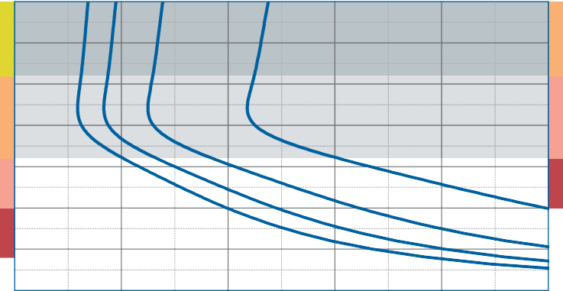
0.035

0.030
SD 26

0.025
Specific load [N/mm²]
SD 26
SD 16
Dynamic range of use

0.020

0.015
Static range of use SD 10 SD 16
SD 10

0.010

0.005

Natural frequency of a single-degree-of- freedom system consisting of a fixed mass and an elastic bearing consisting of Diepolast SD 16 on a stiff subgrade.
Form factor q = 3

0.000
5

10 15 20 25 30
Version 1.0 from 01/04/2016

Natural frequency [Hz]

Correction values varying form factors

specific load 0.016 N/mm², form factor q = 3

Static load range Deflection

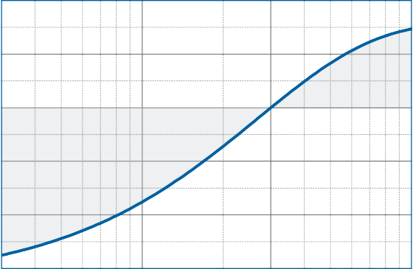
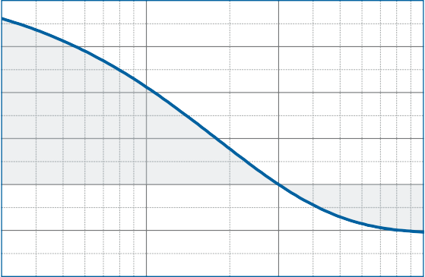
0.0170 20

0.0165 15
Variation of deflection [%]

10
Specific load [N/mm²]
0.0160
5
0.0155
0

0.0150 -5

0.0145

0.3

1 3
Form factor
-10
10

0.3

1 3 10
Form factor

Dynamic modulus of elasticity at 10 Hz Natural frequency

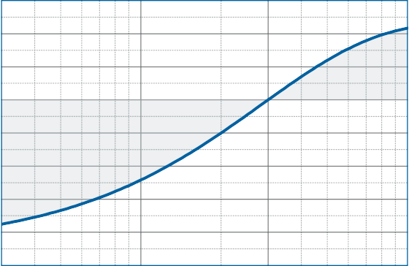
15
Variation of the dynamic modulus of elasticity [%]

10

5

0

-5

-10

-15

-20

10

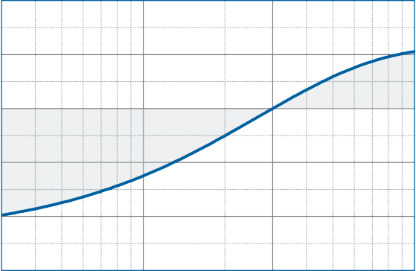
5
Variation of the natural frequency [%]

0

-5

-10

-25

0.3

1 3
Form factor

-15
10

0.3

1 3 10
Form factor

DISCLAIMER:
The information provided is intended only as a summary and general overview on matters of interest. The information is not intended to be comprehensive nor does it constitute expert advice. P+S Polyurethan-Elastomere GmbH Co.KG shall not be liable for incidental and/or consequential damages directly or indirectly sustained, nor any loss caused by not complying with relevant industry/product standards and improper use of any Diepolast products. Due to varying construction methods, any other circumstances not stated above should be brought to the attention of P+S Polyurethan-Elastomere GmbH Co.KG for review. For suitability to the prevailing site conditions, it is advised that certified testing should be conducted. It is recommended to seek further advice on your application with our technical staff prior to use.
Version 1.0 from 01/04/2016

The data sheet is not subject to any change service! All information is without guarantee. Latest version of this document available on www.pus-polyurethan.de

10

 |  |  |  |  |  |  |  |  |  |  |  |  | SD 1900
 |  |  |  |  |  |  |  |  |  |  |  | SD 1300
 |  |  |  |  |  |  |  |  |  |  | SD 950
 |  |  |  |  |  |  |  |  |  | SD 650
 |  |  |  |  |  |  |  |  | SD 400
 |  |  |  |  |  |  |  | SD 260
 |  |  |  |  |  |  | SD 170
 |  |  |  |  |  | SD 110
 |  |  |  |  | SD 65
 |  |  |  | SD 40
 |  | SD 16 | SD 26
 | SD 10

1
specific load [N/mm²]

0.1

0.01

0.001
Diepolast series

Working range

Diepolast type

Recommendations for elastic bearing:

Static load: up to [N/mm²]
0.026
Dynamic load: up to [N/mm²]
0.040
Load peaks: up to [N/mm²]
1.0
Values depending on form factor and apply to form factor q = 3

Material mixed cellular polyether-urethane
Colour orange
Delivery specifications Thickness: 12.5 mm and 25 mm
Mats: 0.5 m wide, 2.0 m long
Stripes: max. 2.0 m lang
Other dimensions on request (also stamping and moulded parts).

Properties | Value | Test method | Comment
Mechanical loss factor (1) | 0.22 | DIN 53513 (2) | guide value
Static E-modulus (1) | 0.129 N/mm² | DIN 53513 (2)
Dynamic E-modulus (1) | 0.443 N/mm² | DIN 53513 (2)
Resistance to strain | 0.026 N/mm² |  | at 10% deformation
Residual compression set | < 5 % | DIN EN ISO 1856 | 50%, 23°C, 70 h, 30 min after unloading
Tensile strength | > 0.45 N/mm2 | DIN 53455-6-4 | minimum
Elongation at break | > 400 % | DIN 53455-6-4 | minimum
Rebound elasticity | 50 % | DIN EN ISO 8307 | ± 10%
Specific volume resistance | >1011 Ω·cm | DIN IEC 93 | dry
Thermal conductivity | 0.06 W/[m·K] | DIN 52612-1
Operating temperature | -30 bis +70 °C
Temperature peak | +120 °C
Inflammability | Class E / EN 13501-1 | EN ISO 11925-1 | normal flammable

(1) measured at maximum limit of static application range
Version 1.0 from 01/04/2016
(2) test according to DIN 53513
All information and data is based on our current knowledge. The data are subject to typical manufacturing tolerances and are not guaranteed. We reserve the right to amend the data.

Load deflection curve

0.05
 |  |  |  |  |  |  |  |  |  |  | 40
 |  |  |  |  |  |  |  |  |  |  | SD
0
SD 4 |  |  |  |  |  |  |  |  |  |  | SD 26
D 26 |  |  |  |  |  |  |  |  |  |  | D 16
6 S |  |  |  |  |  |  |  |  |  |  | S
SD 1

0.04
Specific load [N/mm²]

0.03
Dynamic range of use

0.02
Static range of use

0.01

Recording of the 3rd loading; testing between steel plates at room temperature measured with a deflection rate of 1% of the thickness per second
Form factor q = 3

0.00
0

2 4 6

Deflection [mm]

8 10

Modulus of elasticity

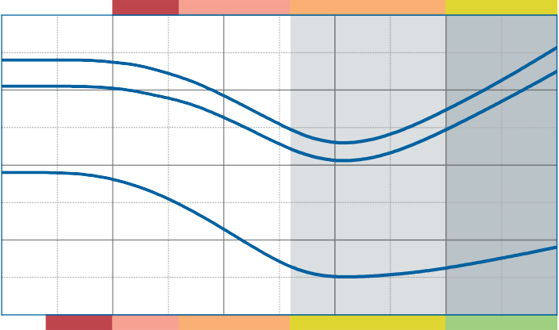0.8
SD 16
SD 26
SD 40
SD 16
SD 26
SD 40

0.6
Modulus of elasticity [N/mm²]

0.4

Dynamic range of use

Dynamic test: sinusoidal excitation with an oscillating range of ± 0.22 mm at 10 Hz and ± 0.08 mm at 30 Hz
Quasistatic modulus of elasticity: tangent modulus taken from the load deflection curve
Test according to DIN 53513 Form factor q = 3

0.2

0.0

0.00

Static range of use
0.01

0.02

0.03

0.04

0.05

Specific load [N/mm²]

Natural frequency

0.05
S
 |  |  |  |  |  |  |  |  |  |  | 40
 |  |  |  |  |  |  |  |  |  |  | SD
0
SD 4 |  |  |  |  |  |  |  |  |  |  | SD 26
D 26 |  |  |  |  |  |  |  |  |  |  | D 16
6 S |  |  |  |  |  |  |  |  |  |  | S
SD 1

0.04
Specific load [N/mm²]

0.03
Dynamic range of use

0.02
Static range of use

0.01

Natural frequency of a single-degree-of- freedom system consisting of a fixed mass and an elastic bearing consisting of Diepolast SD 26 on a stiff subgrade.
Form factor q = 3

0.00
5

10 15 20 25 30
Version 1.0 from 01/04/2016

Natural frequency [Hz]

Correction values varying form factors

specific load 0.026 N/mm², form factor q = 3

Static load range Deflection

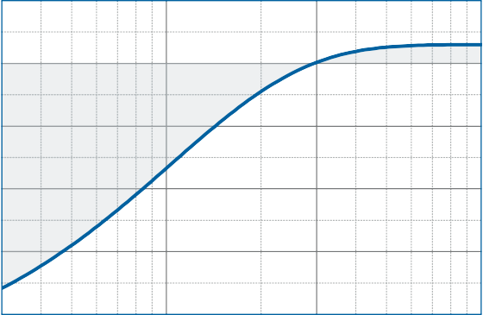
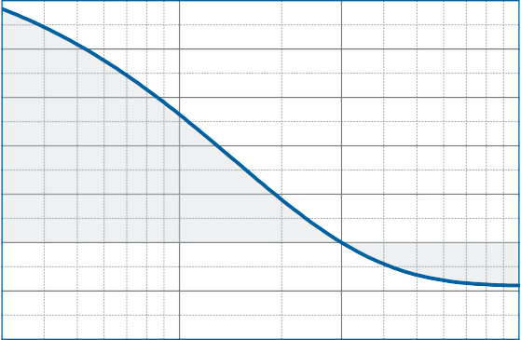
0.028 25

20
0.026
15
Specific load [N/mm²]
Variation of deflection [%]

0.024 10

0.022 5
0
0.020
-5

0.018

0.3

1 3
Form factor
-10
10

0.3

1 3 10
Form factor

Dynamic modulus of elasticity at 10 Hz Natural frequency

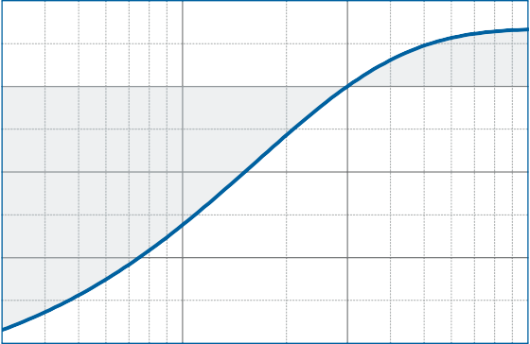
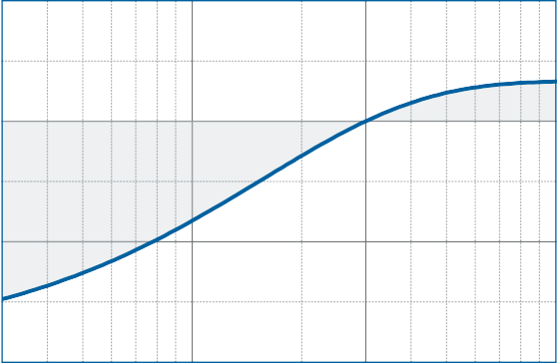
5 5
Variation of the dynamic modulus of elasticity [%]

0
Variation of the natural frequency [%]
0

-5

-5
-10

-15

0.3

1 3
Form factor
-10
10

0.3

1 3 10
Form factor

DISCLAIMER:
The information provided is intended only as a summary and general overview on matters of interest. The information is not intended to be comprehensive nor does it constitute expert advice. P+S Polyurethan-Elastomere GmbH Co.KG shall not be liable for incidental and/or consequential damages directly or indirectly sustained, nor any loss caused by not complying with relevant industry/product standards and improper use of any Diepolast products. Due to varying construction methods, any other circumstances not stated above should be brought to the attention of P+S Polyurethan-Elastomere GmbH Co.KG for review. For suitability to the prevailing site conditions, it is advised that certified testing should be conducted. It is recommended to seek further advice on your application with our technical staff prior to use.
Version 1.0 from 01/04/2016

The data sheet is not subject to any change service! All information is without guarantee. Latest version of this document available on www.pus-polyurethan.de

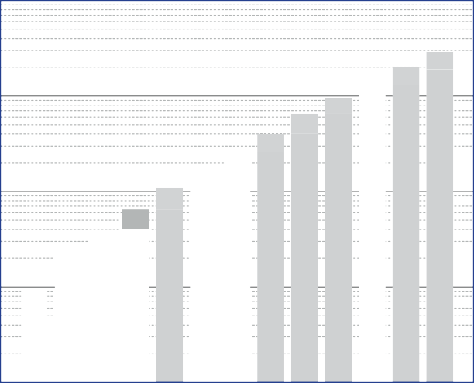10

SD 40

SD 26
SD 65
SD 260
SD 400
SD 650
SD 1300
SD 1900

SD 10

SD 16

SD 110

SD 170

SD 950

1
specific load [N/mm²]

0.1

0.01

0.001
Diepolast series

Working range

Diepolast type

Recommendations for elastic bearing:

Static load: up to [N/mm²]
0.040
Dynamic load: up to [N/mm²]
0.065
Load peaks: up to [N/mm²]
2.0
Values depending on form factor and apply to form factor q = 3

Material mixed cellular polyether-urethane
Colour yellow
Delivery specifications Thickness: 12.5 mm and 25 mm
Mats: 0.5 m wide, 2.0 m long
Stripes: max. 2.0 m lang
Other dimensions on request (also stamping and moulded parts).

Properties | Value | Test method | Comment
Mechanical loss factor (1) | 0.15 | DIN 53513 (2) | guide value
Static E-modulus (1) | 0.316 N/mm² | DIN 53513 (2)
Dynamic E-modulus (1) | 0.743 N/mm² | DIN 53513 (2)
Resistance to strain | 0.046 N/mm² |  | at 10% deformation
Residual compression set | < 5 % | DIN EN ISO 1856 | 50%, 23°C, 70 h, 30 min after unloading
Tensile strength | > 0.55 N/mm2 | DIN 53455-6-4 | minimum
Elongation at break | > 400 % | DIN 53455-6-4 | minimum
Rebound elasticity | 50 % | DIN EN ISO 8307 | ± 10%
Specific volume resistance | >1011 Ω·cm | DIN IEC 93 | dry
Thermal conductivity | 0.07 W/[m·K] | DIN 52612-1
Operating temperature | -30 bis +70 °C
Temperature peak | +120 °C
Inflammability | Class E / EN 13501-1 | EN ISO 11925-1 | normal flammable

(1) measured at maximum limit of static application range
Version 1.0 from 01/04/2016
(2) test according to DIN 53513
All information and data is based on our current knowledge. The data are subject to typical manufacturing tolerances and are not guaranteed. We reserve the right to amend the data.

Load deflection curve

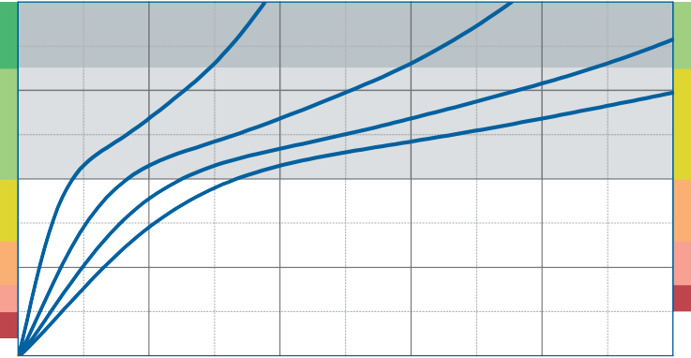
0.08
SD 65

0.06
Specific load [N/mm²]
SD 65
SD 40

0.04
Static range of use
SD 26 SD 40
SD 26
Dynamic range of use

0.02

Recording of the 3rd loading; testing between steel plates at room temperature measured with a deflection rate of 1% of the thickness per second
Form factor q = 3

0.00
0

2 4 6

Deflection [mm]

8 10

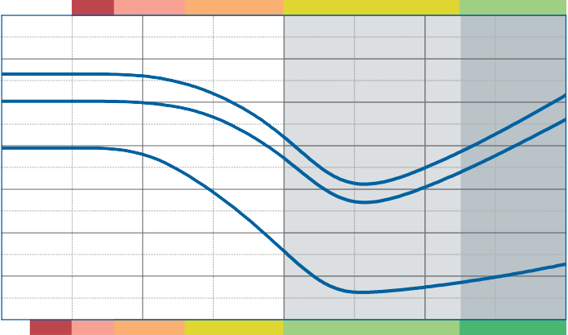Modulus of elasticity
Dynamic range of use
SD 26
SD 40
SD 65
SD 26
SD 40
SD 65

1.4

1.2

1.0
Modulus of elasticity [N/mm²]

0.8

0.6

Dynamic test: sinusoidal excitation with an oscillating range of ± 0.22 mm at 10 Hz and ± 0.08 mm at 30 Hz
Quasistatic modulus of elasticity: tangent modulus taken from the load deflection curve
Test according to DIN 53513 Form factor q = 3

0.4

0.2

0.0

0.00

Static range of use
0.02

0.04
Specific load [N/mm²]

0.06

0.08

Natural frequency

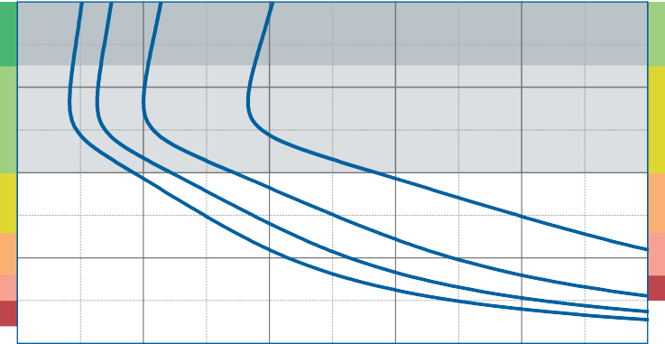
0.08
SD 65

0.06
Specific load [N/mm²]
SD 65
SD 40

0.04
Static range of use
SD 26 SD 40
SD 26
Dynamic range of use

0.02

Natural frequency of a single-degree-of- freedom system consisting of a fixed mass and an elastic bearing consisting of Diepolast SD 40 on a stiff subgrade.
Form factor q = 3

0.00
5

10 15 20 25 30
Version 1.0 from 01/04/2016

Natural frequency [Hz]

Correction values varying form factors

specific load 0.04 N/mm², form factor q = 3

Static load range Deflection

0.042

0.041
Specific load [N/mm²]

0.040

0.039

0.038

0.037

0.3

1 3
Form factor

35

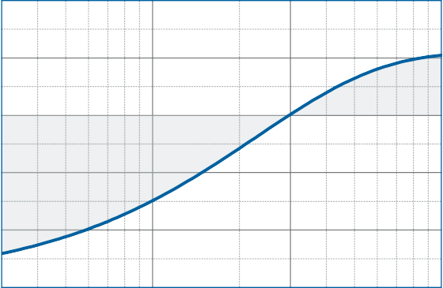
30

25
Variation of deflection [%]

20

15

10

5

0

-5

-10
10

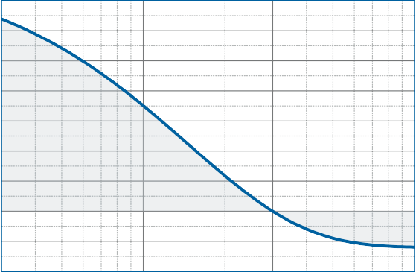
0.3

1 3 10
Form factor

Dynamic modulus of elasticity at 10 Hz Natural frequency

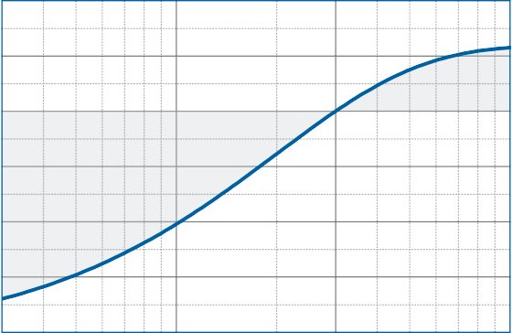
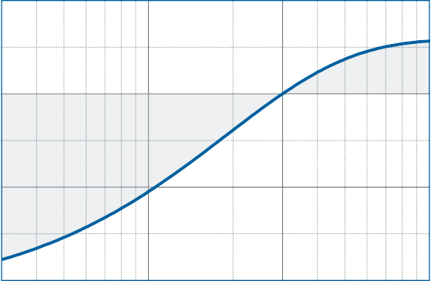
10 5
Variation of the dynamic modulus of elasticity [%]

5
Variation of the natural frequency [%]

0 0

-5

-10 -5

-15

-20

0.3

1 3
Form factor
-10
10

0.3

1 3 10
Form factor

DISCLAIMER:
The information provided is intended only as a summary and general overview on matters of interest. The information is not intended to be comprehensive nor does it constitute expert advice. P+S Polyurethan-Elastomere GmbH Co.KG shall not be liable for incidental and/or consequential damages directly or indirectly sustained, nor any loss caused by not complying with relevant industry/product standards and improper use of any Diepolast products. Due to varying construction methods, any other circumstances not stated above should be brought to the attention of P+S Polyurethan-Elastomere GmbH Co.KG for review. For suitability to the prevailing site conditions, it is advised that certified testing should be conducted. It is recommended to seek further advice on your application with our technical staff prior to use.
Version 1.0 from 01/04/2016

The data sheet is not subject to any change service! All information is without guarantee. Latest version of this document available on www.pus-polyurethan.de

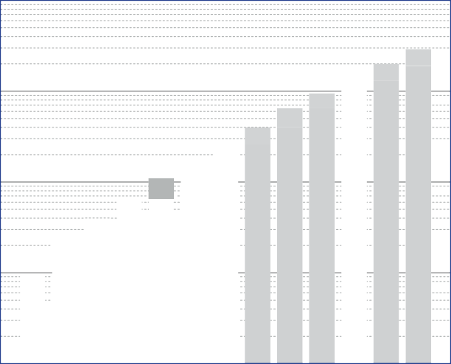10

SD 26

SD 65

SD 40
SD 260
SD 400
SD 650
SD 1300
SD 1900

SD 10

SD 16

SD 110

SD 170

SD 950

1
specific load [N/mm²]

0.1

0.01

0.001
Diepolast series

Working range

Diepolast type

Recommendations for elastic bearing:

Static load: up to [N/mm²]
0.065
Dynamic load: up to [N/mm²]
0.110
Load peaks: up to [N/mm²]
2.5
Values depending on form factor and apply to form factor q = 3

Material mixed cellular polyether-urethane
Colour bright green
Delivery specifications Thickness: 12.5 mm and 25 mm
Mats: 0.5 m wide, 2.0 m long
Stripes: max. 2.0 m lang
Other dimensions on request (also stamping and moulded parts).

Properties | Value | Test method | Comment
Mechanical loss factor (1) | 0.18 | DIN 53513 (2) | guide value
Static E-modulus (1) | 0.453 N/mm² | DIN 53513 (2)
Dynamic E-modulus (1) | 1.06 N/mm² | DIN 53513 (2)
Resistance to strain | 0.073 N/mm² |  | at 10% deformation
Residual compression set | < 5 % | DIN EN ISO 1856 | 50%, 23°C, 70 h, 30 min after unloading
Tensile strength | > 0.70 N/mm2 | DIN 53455-6-4 | minimum
Elongation at break | > 400 % | DIN 53455-6-4 | minimum
Rebound elasticity | 50 % | DIN EN ISO 8307 | ± 10%
Specific volume resistance | >1011 Ω·cm | DIN IEC 93 | dry
Thermal conductivity | 0.07 W/[m·K] | DIN 52612-1
Operating temperature | -30 bis +70 °C
Temperature peak | +120 °C
Inflammability | Class E / EN 13501-1 | EN ISO 11925-1 | normal flammable

(1) measured at maximum limit of static application range
Version 1.0 from 01/04/2016
(2) test according to DIN 53513
All information and data is based on our current knowledge. The data are subject to typical manufacturing tolerances and are not guaranteed. We reserve the right to amend the data.

Load deflection curve

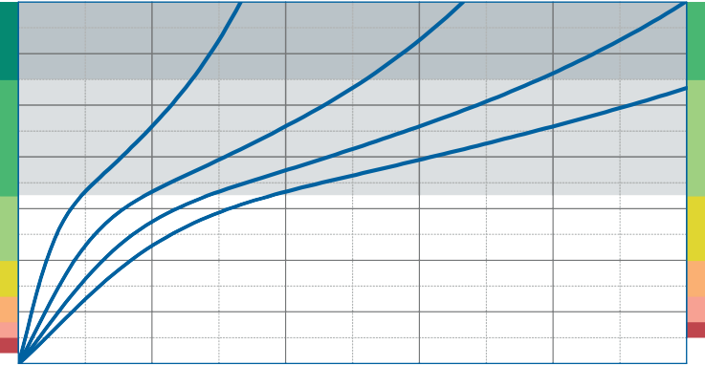
0.14
SD 110

0.12

0.10
Specific load [N/mm²]
SD 110
SD 65

0.08

0.06
Static range of use
SD 40 SD 65
SD 40
Dynamic range of use

0.04

0.02

Recording of the 3rd loading; testing between steel plates at room temperature measured with a deflection rate of 1% of the thickness per second
Form factor q = 3

0.00
0

2 4 6

Deflection [mm]

8 10

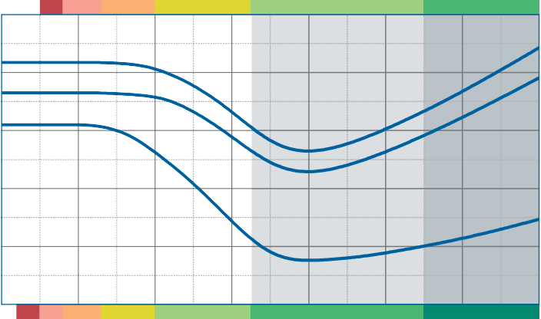Modulus of elasticity
Dynamic range of use
SD 40
SD 65
SD 110
SD 40
SD 65
SD 110

2.0

1.6
Modulus of elasticity [N/mm²]

1.2

0.8

Dynamic test: sinusoidal excitation with an oscillating range of ± 0.22 mm at 10 Hz and ± 0.08 mm at 30 Hz
Quasistatic modulus of elasticity: tangent modulus taken from the load deflection curve
Test according to DIN 53513 Form factor q = 3

0.4

0.0

0.00

Static range of use
0.02

0.04

0.06

0.08

0.10

0.12

0.14

Specific load [N/mm²]

Natural frequency

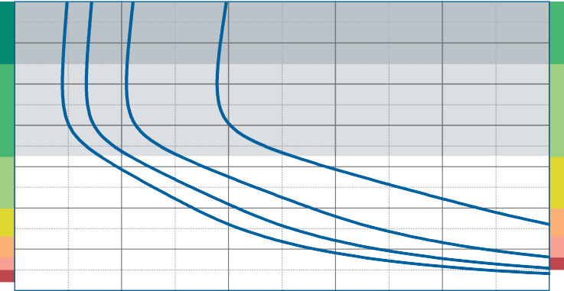
0.14
SD 110

0.12

0.10
Specific load [N/mm²]
SD 110
SD 65

0.08

0.06
Static range of use
SD 40 SD 65
SD 40
Dynamic range of use

0.04

0.02

Natural frequency of a single-degree-of- freedom system consisting of a fixed mass and an elastic bearing consisting of Diepolast SD 65 on a stiff subgrade.
Form factor q = 3

0.00
5

10 15 20 25 30
Version 1.0 from 01/04/2016

Natural frequency [Hz]

Correction values varying form factors

specific load 0.065 N/mm², form factor q = 3

Static load range Deflection

0.070

0.065
Specific load [N/mm²]

0.060

0.055

0.050

0.3

1 3
Form factor

40
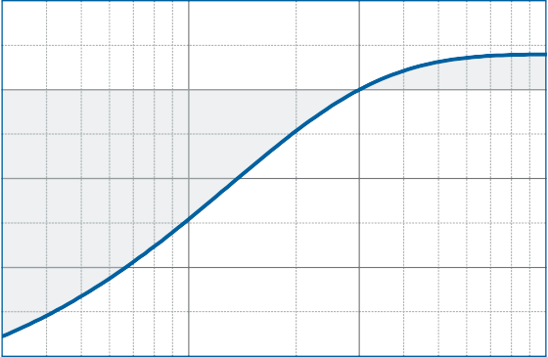
35

30
Variation of deflection [%]
25

20

15
10

5
0

-5
-10
10

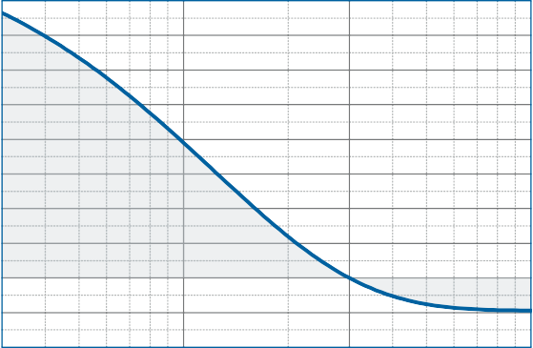
0.3

1 3 10
Form factor

Dynamic modulus of elasticity at 10 Hz Natural frequency

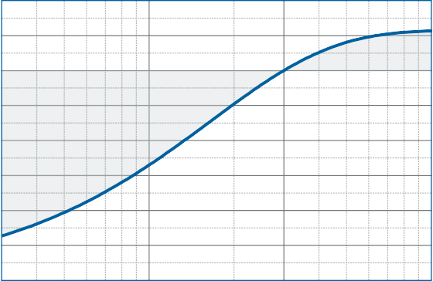
10
Variation of the dynamic modulus of elasticity [%]

5

0

-5

-10

-15

-20

-25

5

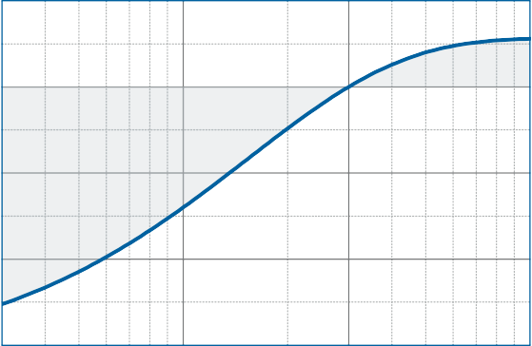
0
Variation of the natural frequency [%]

-5

-10

-30

0.3

1 3
Form factor

-15
10

0.3

1 3 10
Form factor

DISCLAIMER:
The information provided is intended only as a summary and general overview on matters of interest. The information is not intended to be comprehensive nor does it constitute expert advice. P+S Polyurethan-Elastomere GmbH Co.KG shall not be liable for incidental and/or consequential damages directly or indirectly sustained, nor any loss caused by not complying with relevant industry/product standards and improper use of any Diepolast products. Due to varying construction methods, any other circumstances not stated above should be brought to the attention of P+S Polyurethan-Elastomere GmbH Co.KG for review. For suitability to the prevailing site conditions, it is advised that certified testing should be conducted. It is recommended to seek further advice on your application with our technical staff prior to use.
Version 1.0 from 01/04/2016

The data sheet is not subject to any change service! All information is without guarantee. Latest version of this document available on www.pus-polyurethan.de

10

 |  |  |  |  |  |  |  |  |  |  |  |  | SD 1900
 |  |  |  |  |  |  |  |  |  |  |  | SD 1300
 |  |  |  |  |  |  |  |  |  |  | SD 950
 |  |  |  |  |  |  |  |  |  | SD 650
 |  |  |  |  |  |  |  |  | SD 400
 |  |  |  |  |  |  |  | SD 260
 |  |  |  |  |  |  | SD 170
 |  |  |  |  | SD 65 | SD 110
 |  |  |  | SD 40
 |  |  | SD 26
 |  | SD 16
 | SD 10

1
specific load [N/mm²]

0.1

0.01

0.001
Diepolast series

Working range

Diepolast type

Recommendations for elastic bearing:

Static load: up to [N/mm²]
0.110
Dynamic load: up to [N/mm²]
0.170
Load peaks: up to [N/mm²]
3.0
Values depending on form factor and apply to form factor q = 3

Material mixed cellular polyether-urethane
Colour green
Delivery specifications Thickness: 12.5 mm and 25 mm
Mats: 0.5 m wide, 2.0 m long
Stripes: max. 2.0 m lang
Other dimensions on request (also stamping and moulded parts).

Properties | Value | Test method | Comment
Mechanical loss factor (1) | 0.12 | DIN 53513 (2) | guide value
Static E-modulus (1) | 0.861 N/mm² | DIN 53513 (2)
Dynamic E-modulus (1) | 1.86 N/mm² | DIN 53513 (2)
Resistance to strain | 0.130 N/mm² |  | at 10% deformation
Residual compression set | < 5 % | DIN EN ISO 1856 | 50%, 23°C, 70 h, 30 min after unloading
Tensile strength | > 0.95 N/mm2 | DIN 53455-6-4 | minimum
Elongation at break | > 400 % | DIN 53455-6-4 | minimum
Rebound elasticity | 50 % | DIN EN ISO 8307 | ± 10%
Specific volume resistance | >1011 Ω·cm | DIN IEC 93 | dry
Thermal conductivity | 0.08 W/[m·K] | DIN 52612-1
Operating temperature | -30 bis +70 °C
Temperature peak | +120 °C
Inflammability | Class E / EN 13501-1 | EN ISO 11925-1 | normal flammable

(1) measured at maximum limit of static application range
Version 1.0 from 01/04/2016
(2) test according to DIN 53513
All information and data is based on our current knowledge. The data are subject to typical manufacturing tolerances and are not guaranteed. We reserve the right to amend the data.

Load deflection curve

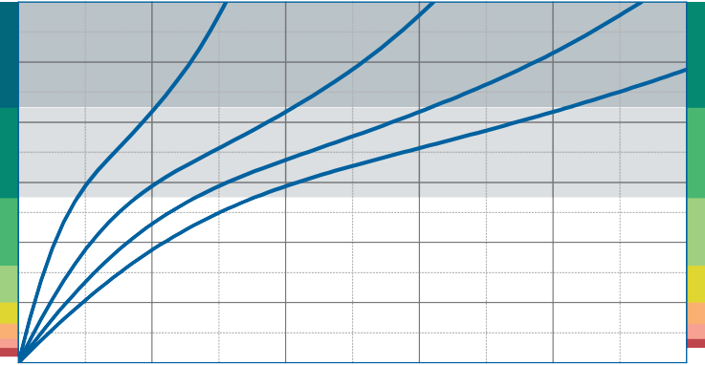
0.24
SD 170

0.20

0.16
Specific load [N/mm²]
SD 170
SD 110

0.12
Static range of use
SD 65 SD 110
SD 65
Dynamic range of use

0.08

0.04

Recording of the 3rd loading; testing between steel plates at room temperature measured with a deflection rate of 1% of the thickness per second
Form factor q = 3

0.00
0

2 4 6

Deflection [mm]

8 10

Modulus of elasticity
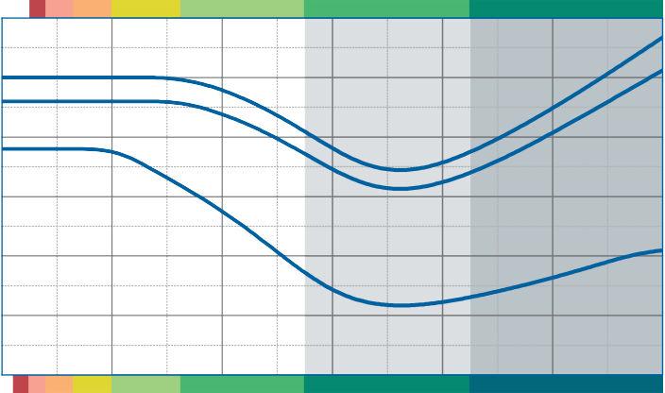Dynamic range of use
SD 65
SD 110
SD 170
SD 65
SD 110
SD 170
3.0

2.5
Modulus of elasticity [N/mm²]

2.0

1.5

Dynamic test: sinusoidal excitation with an oscillating range of ± 0.22 mm at 10 Hz and ± 0.08 mm at 30 Hz
Quasistatic modulus of elasticity: tangent modulus taken from the load deflection curve
Test according to DIN 53513 Form factor q = 3

1.0

0.5

0.0
Static range of use
0.00 0.04 0.08 0.12 0.16 0.20 0.24
Specific load [N/mm²]

Natural frequency

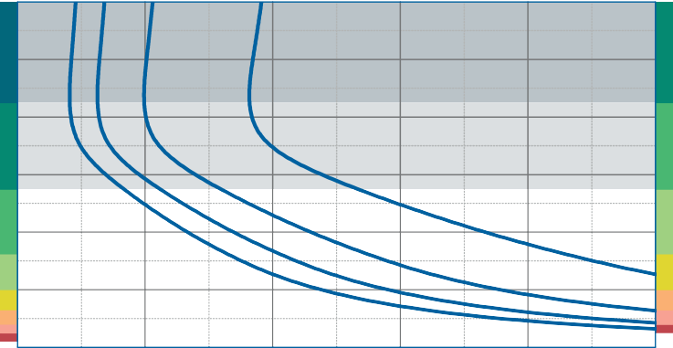
0.24
SD 170

0.20

0.16
Specific load [N/mm²]
SD 170
SD 110

0.12
Static range of use
SD 65 SD 110
SD 65
Dynamic range of use

0.08

0.04

Natural frequency of a single-degree-of- freedom system consisting of a fixed mass and an elastic bearing consisting of Diepolast SD 110 on a stiff subgrade.
Form factor q = 3

0.00
5

10 15 20 25 30
Version 1.0 from 01/04/2016

Natural frequency [Hz]

Correction values varying form factors

specific load 0.11 N/mm², form factor q = 3

Static load range Deflection

0.120

0.115

0.110

0.105
Specific load [N/mm²]

0.100

0.095

0.090

0.085

0.080

0.075

0.3

1 3
Form factor

50

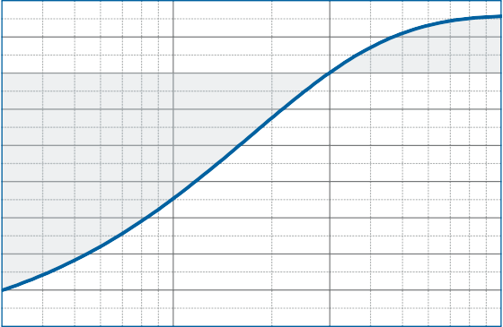
40
Variation of deflection [%]

30

20

10

0

-10
10

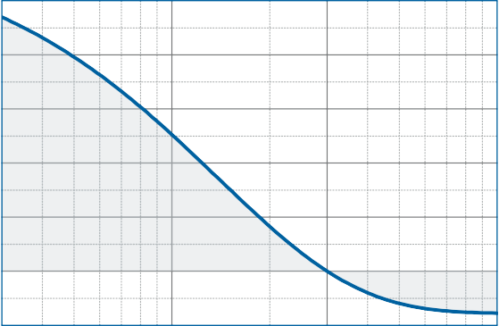
0.3

1 3 10
Form factor

Dynamic modulus of elasticity at 10 Hz Natural frequency

10
Variation of the dynamic modulus of elasticity [%]

5

0

-5

-10

-15

-20

-25

-30

-35

0.3

1 3
Form factor

5

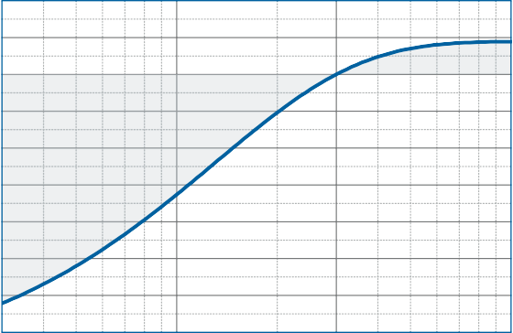
0
Variation of the natural frequency [%]

-5

-10

-15

-20
10

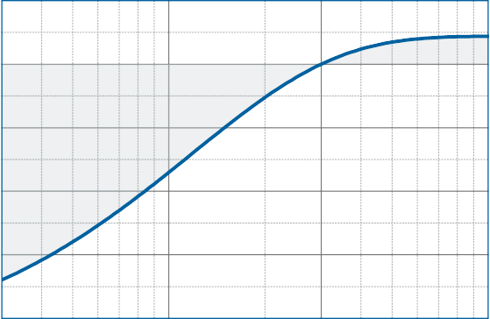
0.3

1 3 10
Form factor

DISCLAIMER:
The information provided is intended only as a summary and general overview on matters of interest. The information is not intended to be comprehensive nor does it constitute expert advice. P+S Polyurethan-Elastomere GmbH Co.KG shall not be liable for incidental and/or consequential damages directly or indirectly sustained, nor any loss caused by not complying with relevant industry/product standards and improper use of any Diepolast products. Due to varying construction methods, any other circumstances not stated above should be brought to the attention of P+S Polyurethan-Elastomere GmbH Co.KG for review. For suitability to the prevailing site conditions, it is advised that certified testing should be conducted. It is recommended to seek further advice on your application with our technical staff prior to use.
Version 1.0 from 01/04/2016

The data sheet is not subject to any change service! All information is without guarantee. Latest version of this document available on www.pus-polyurethan.de

10

 |  |  |  |  |  |  |  |  |  |  |  |  | SD 1900
 |  |  |  |  |  |  |  |  |  |  |  | SD 1300
 |  |  |  |  |  |  |  |  |  |  | SD 950
 |  |  |  |  |  |  |  |  |  | SD 650
 |  |  |  |  |  |  |  |  | SD 400
 |  |  |  |  |  |  |  | SD 260
 |  |  |  |  |  | SD 110 | SD 170
 |  |  |  |  | SD 65
 |  |  |  | SD 40
 |  |  | SD 26
 |  | SD 16
 | SD 10

1
specific load [N/mm²]

0.1

0.01

0.001
Diepolast series

Working range

Diepolast type

Recommendations for elastic bearing:

Static load: up to [N/mm²]
0.170
Dynamic load: up to [N/mm²]
0.260
Load peaks: up to [N/mm²]
3.5
Values depending on form factor and apply to form factor q = 3

Material mixed cellular polyether-urethane
Colour dark green
Delivery specifications Thickness: 12.5 mm and 25 mm
Mats: 0.5 m wide, 2.0 m long
Stripes: max. 2.0 m lang
Other dimensions on request (also stamping and moulded parts).

Properties | Value | Test method | Comment
Mechanical loss factor (1) | 0.13 | DIN 53513 (2) | guide value
Static E-modulus (1) | 0.931 N/mm² | DIN 53513 (2)
Dynamic E-modulus (1) | 2.27 N/mm² | DIN 53513 (2)
Resistance to strain | 0.170 N/mm² |  | at 10% deformation
Residual compression set | < 5 % | DIN EN ISO 1856 | 50%, 23°C, 70 h, 30 min after unloading
Tensile strength | > 1.25 N/mm2 | DIN 53455-6-4 | minimum
Elongation at break | > 400 % | DIN 53455-6-4 | minimum
Rebound elasticity | 50 % | DIN EN ISO 8307 | ± 10%
Specific volume resistance | >1011 Ω·cm | DIN IEC 93 | dry
Thermal conductivity | 0.08 W/[m·K] | DIN 52612-1
Operating temperature | -30 bis +70 °C
Temperature peak | +120 °C
Inflammability | Class E / EN 13501-1 | EN ISO 11925-1 | normal flammable

(1) measured at maximum limit of static application range
Version 1.0 from 01/04/2016
(2) test according to DIN 53513
All information and data is based on our current knowledge. The data are subject to typical manufacturing tolerances and are not guaranteed. We reserve the right to amend the data.

Load deflection curve

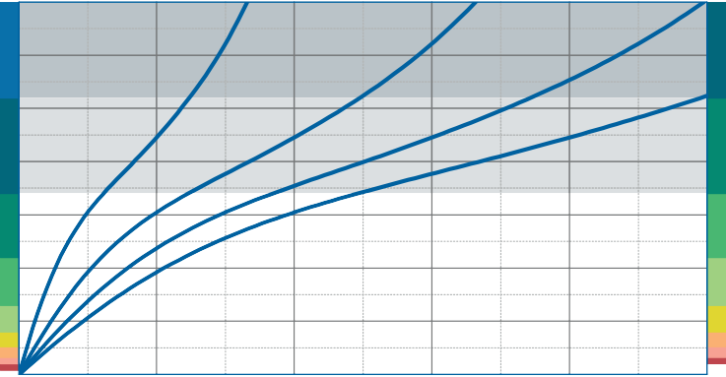
0.35
SD 260

0.30

0.25
Specific load [N/mm²]
SD 260
SD 170

0.20

0.15
Static range of use
SD 110 SD 170
SD 110
Dynamic range of use

0.10

0.05

Recording of the 3rd loading; testing between steel plates at room temperature measured with a deflection rate of 1% of the thickness per second
Form factor q = 3

0.00
0

2 4 6

Deflection [mm]

8 10

Modulus of elasticity
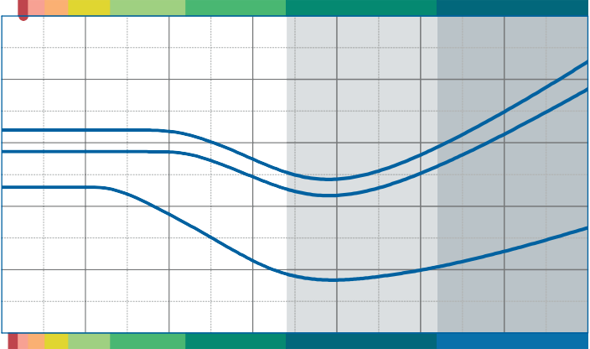Dynamic range of use
SD 110
SD 170
SD 260
SD 110
SD 170
SD 260
5

4
Modulus of elasticity [N/mm²]

3

2

Dynamic test: sinusoidal excitation with an oscillating range of ± 0.22 mm at 10 Hz and ± 0.08 mm at 30 Hz
Quasistatic modulus of elasticity: tangent modulus taken from the load deflection curve
Test according to DIN 53513 Form factor q = 3

1

0
Static range of use
0.00 0.05 0.10 0.15 0.20 0.25 0.30 0.35
Specific load [N/mm²]

Natural frequency

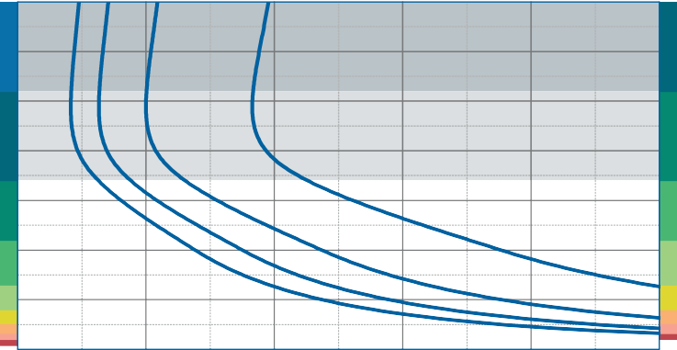
0.35
SD 260

0.30

0.25
Specific load [N/mm²]
SD 260
SD 170

0.20

0.15
Static range of use
SD 110 SD 170
SD 110
Dynamic range of use

0.10

0.05

Natural frequency of a single-degree-of- freedom system consisting of a fixed mass and an elastic bearing consisting of Diepolast SD 170 on a stiff subgrade.
Form factor q = 3

0.00
5

10 15 20 25 30
Version 1.0 from 01/04/2016

Natural frequency [Hz]

Correction values varying form factors

specific load 0.17 N/mm², form factor q = 3

Static load range Deflection

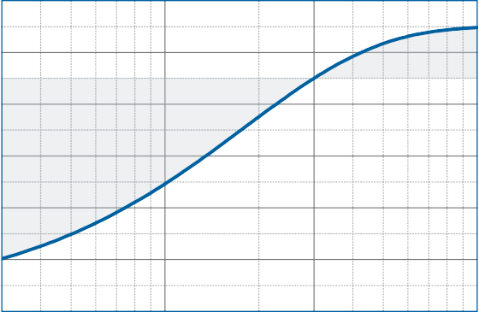
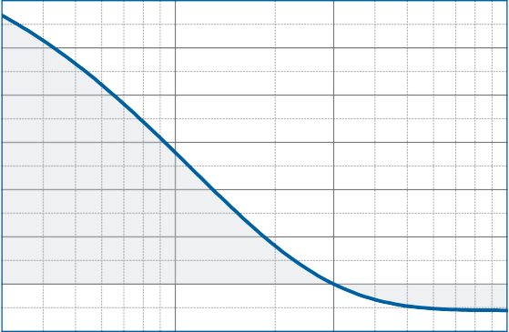
0.20 60

0.18 50
40
Specific load [N/mm²]
Variation of deflection [%]
0.16
30
0.14
20
0.12
10

0.10 0

0.08

0.3

1 3
Form factor
-10
10

0.3

1 3 10
Form factor

Dynamic modulus of elasticity at 10 Hz Natural frequency

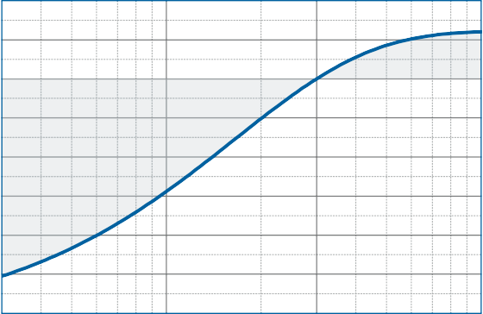
10
Variation of the dynamic modulus of elasticity [%]

5

0

-5

-10

-15

-20

-25

5

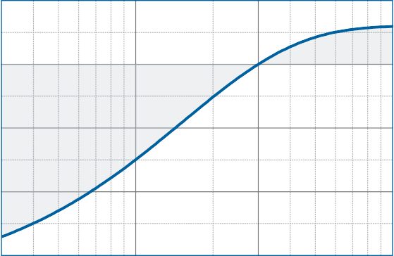
0
Variation of the natural frequency [%]

-5

-10

-30

0.3

1 3
Form factor

-15
10

0.3

1 3 10
Form factor

DISCLAIMER:
The information provided is intended only as a summary and general overview on matters of interest. The information is not intended to be comprehensive nor does it constitute expert advice. P+S Polyurethan-Elastomere GmbH Co.KG shall not be liable for incidental and/or consequential damages directly or indirectly sustained, nor any loss caused by not complying with relevant industry/product standards and improper use of any Diepolast products. Due to varying construction methods, any other circumstances not stated above should be brought to the attention of P+S Polyurethan-Elastomere GmbH Co.KG for review. For suitability to the prevailing site conditions, it is advised that certified testing should be conducted. It is recommended to seek further advice on your application with our technical staff prior to use.
Version 1.0 from 01/04/2016

The data sheet is not subject to any change service! All information is without guarantee. Latest version of this document available on www.pus-polyurethan.de

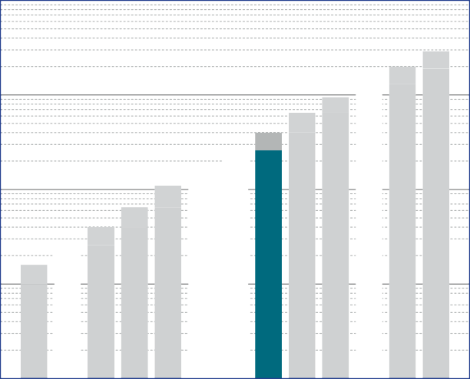10

SD 10
SD SD SD
26 40 65
SD SD SD
260 400 650
SD SD
1300 1900

SD 16

SD 110

SD 170

SD 950

1
specific load [N/mm²]

0.1

0.01

0.001
Diepolast series

Working range

Diepolast type

Recommendations for elastic bearing:

Static load: up to [N/mm²]
0.260
Dynamic load: up to [N/mm²]
0.400
Load peaks: up to [N/mm²]
4.0
Values depending on form factor and apply to form factor q = 3

Material mixed cellular polyether-urethane
Colour petrol
Delivery specifications Thickness: 12.5 mm and 25 mm
Mats: 0.5 m wide, 2.0 m long
Stripes: max. 2.0 m lang
Other dimensions on request (also stamping and moulded parts).

Properties | Value | Test method | Comment
Mechanical loss factor (1) | 0.11 | DIN 53513 (2) | guide value
Static E-modulus (1) | 1.64 N/mm² | DIN 53513 (2)
Dynamic E-modulus (1) | 3.63 N/mm² | DIN 53513 (2)
Resistance to strain | 0.270 N/mm² |  | at 10% deformation
Residual compression set | < 5 % | DIN EN ISO 1856 | 50%, 23°C, 70 h, 30 min after unloading
Tensile strength | > 1.65 N/mm2 | DIN 53455-6-4 | minimum
Elongation at break | > 400 % | DIN 53455-6-4 | minimum
Rebound elasticity | 50 % | DIN EN ISO 8307 | ± 10%
Specific volume resistance | >1011 Ω·cm | DIN IEC 93 | dry
Thermal conductivity | 0.08 W/[m·K] | DIN 52612-1
Operating temperature | -30 bis +70 °C
Temperature peak | +120 °C
Inflammability | Class E / EN 13501-1 | EN ISO 11925-1 | normal flammable

(1) measured at maximum limit of static application range
Version 1.0 from 01/04/2016
(2) test according to DIN 53513
All information and data is based on our current knowledge. The data are subject to typical manufacturing tolerances and are not guaranteed. We reserve the right to amend the data.

Load deflection curve

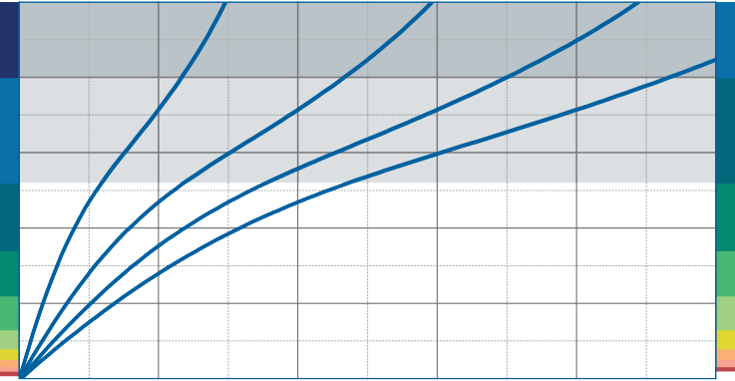
0.5
SD 400

0.4
Specific load [N/mm²]
SD 400
SD 260

0.3

0.2
Static range of use
SD 170 SD 260
SD 170
Dynamic range of use

0.1

Recording of the 3rd loading; testing between steel plates at room temperature measured with a deflection rate of 1% of the thickness per second
Form factor q = 3

0.0
0

2 4 6

Deflection [mm]

8 10

Modulus of elasticity
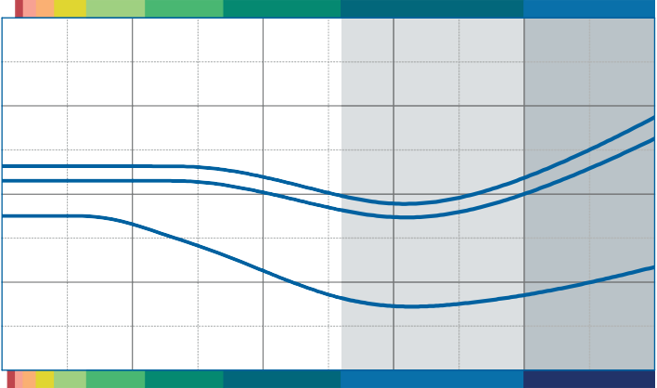Dynamic range of use
SD 170
SD 260
SD 400
SD 170
SD 260
SD 400
8

6
Modulus of elasticity [N/mm²]

4

Dynamic test: sinusoidal excitation with an oscillating range of ± 0.22 mm at 10 Hz and ± 0.08 mm at 30 Hz
Quasistatic modulus of elasticity: tangent modulus taken from the load deflection curve
Test according to DIN 53513 Form factor q = 3

2

0
Static range of use
0.0 0.1 0.2 0.3 0.4 0.5
Specific load [N/mm²]

Natural frequency

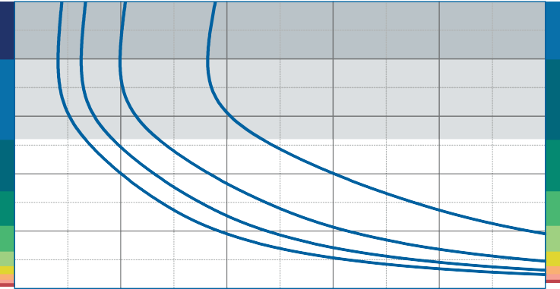
0.5
SD 400

0.4
Specific load [N/mm²]
SD 400
SD 260

0.3

0.2
Static range of use
SD 170 SD 260
SD 170
Dynamic range of use

0.1

Natural frequency of a single-degree-of- freedom system consisting of a fixed mass and an elastic bearing consisting of Diepolast SD 260 on a stiff subgrade.
Form factor q = 3

0.0
5

10 15 20 25 30
Version 1.0 from 01/04/2016

Natural frequency [Hz]

Correction values varying form factors

specific load 0.26 N/mm², form factor q = 3

Static load range Deflection

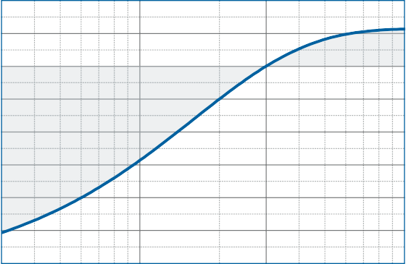
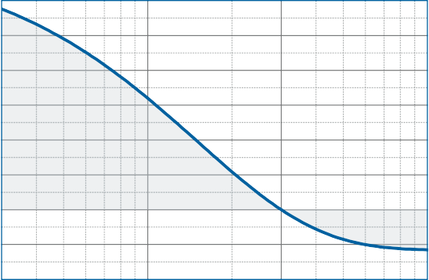
0.30 60

0.28 50

0.26 40
Specific load [N/mm²]
Variation of deflection [%]

0.24 30

0.22 20

0.20 10

0.18 0

0.16 -10

0.14

0.3

1 3
Form factor

-20
10

0.3

1 3 10
Form factor

Dynamic modulus of elasticity at 10 Hz Natural frequency

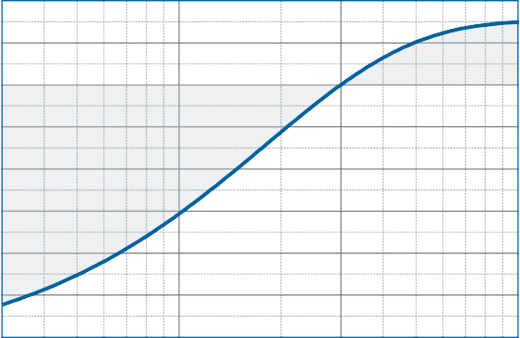
10
Variation of the dynamic modulus of elasticity [%]

5

0

-5

-10

-15

-20

-25

5

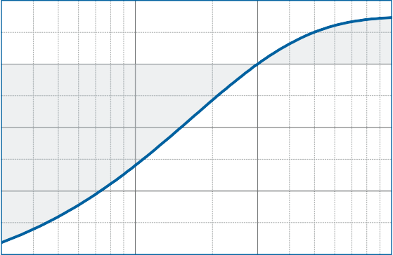
0
Variation of the natural frequency [%]

-5

-10

-30

0.3

1 3
Form factor

-15
10

0.3

1 3 10
Form factor

DISCLAIMER:
The information provided is intended only as a summary and general overview on matters of interest. The information is not intended to be comprehensive nor does it constitute expert advice. P+S Polyurethan-Elastomere GmbH Co.KG shall not be liable for incidental and/or consequential damages directly or indirectly sustained, nor any loss caused by not complying with relevant industry/product standards and improper use of any Diepolast products. Due to varying construction methods, any other circumstances not stated above should be brought to the attention of P+S Polyurethan-Elastomere GmbH Co.KG for review. For suitability to the prevailing site conditions, it is advised that certified testing should be conducted. It is recommended to seek further advice on your application with our technical staff prior to use.
Version 1.0 from 01/04/2016

The data sheet is not subject to any change service! All information is without guarantee. Latest version of this document available on www.pus-polyurethan.de

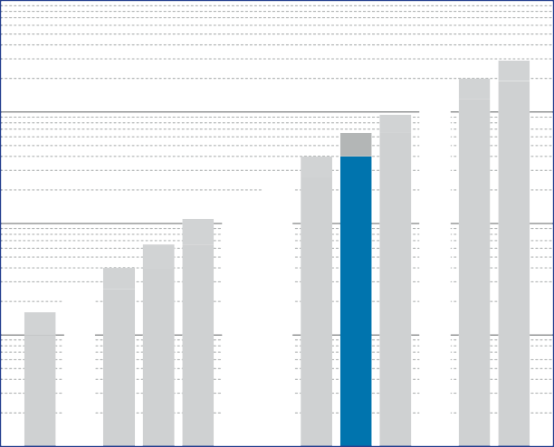10

SD 10
SD SD SD
26 40 65
SD SD SD
260 400 650
SD SD
1300 1900

SD 16

SD 110

SD 170

SD 950

1
specific load [N/mm²]

0.1

0.01

0.001
Diepolast series

Working range

Diepolast type

Recommendations for elastic bearing:

Static load: up to [N/mm²]
0.400
Dynamic load: up to [N/mm²]
0.650
Load peaks: up to [N/mm²]
4.5
Values depending on form factor and apply to form factor q = 3

Material mixed cellular polyether-urethane
Colour blue
Delivery specifications Thickness: 12.5 mm and 25 mm
Mats: 0.5 m wide, 2.0 m long
Stripes: max. 2.0 m lang
Other dimensions on request (also stamping and moulded parts).

Properties | Value | Test method | Comment
Mechanical loss factor (1) | 0.10 | DIN 53513 (2) | guide value
Static E-modulus (1) | 2.72 N/mm² | DIN 53513 (2)
Dynamic E-modulus (1) | 5.27 N/mm² | DIN 53513 (2)
Resistance to strain | 0.370 N/mm² |  | at 10% deformation
Residual compression set | < 5 % | DIN EN ISO 1856 | 50%, 23°C, 70 h, 30 min after unloading
Tensile strength | > 2.25 N/mm2 | DIN 53455-6-4 | minimum
Elongation at break | > 400 % | DIN 53455-6-4 | minimum
Rebound elasticity | 50 % | DIN EN ISO 8307 | ± 10%
Specific volume resistance | >1011 Ω·cm | DIN IEC 93 | dry
Thermal conductivity | 0.10 W/[m·K] | DIN 52612-1
Operating temperature | -30 bis +70 °C
Temperature peak | +120 °C
Inflammability | Class E / EN 13501-1 | EN ISO 11925-1 | normal flammable

(1) measured at maximum limit of static application range
Version 1.0 from 01/04/2016
(2) test according to DIN 53513
All information and data is based on our current knowledge. The data are subject to typical manufacturing tolerances and are not guaranteed. We reserve the right to amend the data.

Load deflection curve

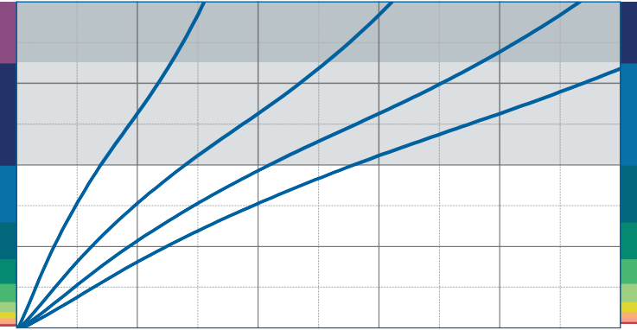
0.8
SD 650

0.6
Specific load [N/mm²]
SD 650
SD 400

0.4
Static range of use
SD 260 SD 400
SD 260
Dynamic range of use

0.2

Recording of the 3rd loading; testing between steel plates at room temperature measured with a deflection rate of 1% of the thickness per second
Form factor q = 3

0.0
0

2 4 6

Deflection [mm]

8 10

Modulus of elasticity
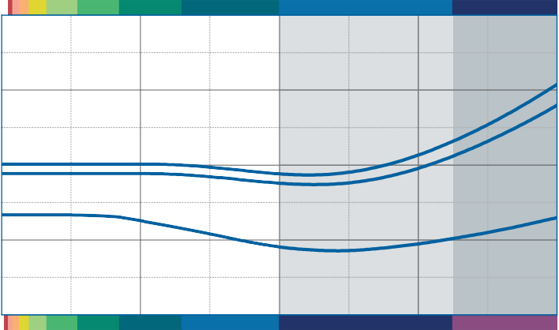Dynamic range of use
SD 260
SD 400
SD 650
SD 260 SD 400
SD 650
12

9
Modulus of elasticity [N/mm²]

6

Dynamic test: sinusoidal excitation with an oscillating range of ± 0.22 mm at 10 Hz and ± 0.08 mm at 30 Hz
Quasistatic modulus of elasticity: tangent modulus taken from the load deflection curve
Test according to DIN 53513 Form factor q = 3

3

0
Static range of use 0.0

0.2

0.4
Specific load [N/mm²]

0.6

0.8

Natural frequency

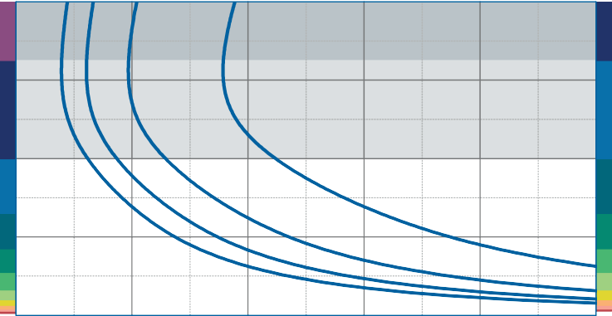
0.8
SD 650

0.6
Specific load [N/mm²]
SD 650
SD 400

0.4
Static range of use
SD 260 SD 400
SD 260
Dynamic range of use

0.2

Natural frequency of a single-degree-of- freedom system consisting of a fixed mass and an elastic bearing consisting of Diepolast SD 400 on a stiff subgrade.
Form factor q = 3

0.0
5

10 15 20 25 30
Version 1.0 from 01/04/2016

Natural frequency [Hz]

Correction values varying form factors

specific load 0.4 N/mm², form factor q = 3

Static load range Deflection

0.48

0.44

0.40
Specific load [N/mm²]

0.36

0.32

0.28

0.24

0.3

1 3
Form factor

70

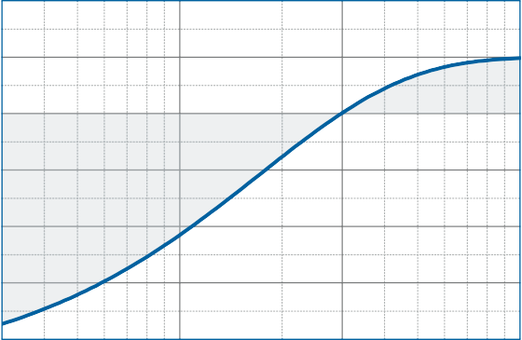
60

50
Variation of deflection [%]

40

30

20

10

0

-10

-20
10

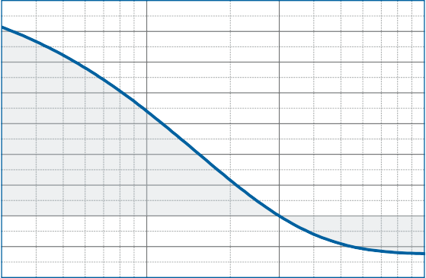
0.3

1 3 10
Form factor

Dynamic modulus of elasticity at 10 Hz Natural frequency

10
Variation of the dynamic modulus of elasticity [%]

5

0

-5

-10

-15

-20

-25

-30

-35

0.3

1 3
Form factor

5

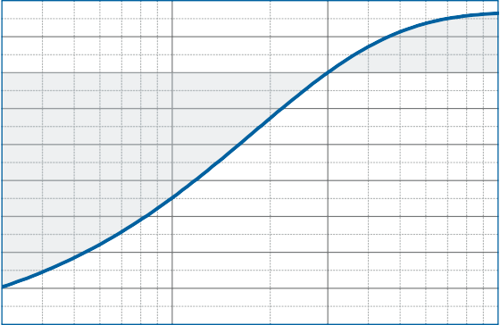
0
Variation of the natural frequency [%]

-5

-10

-15

-20
10

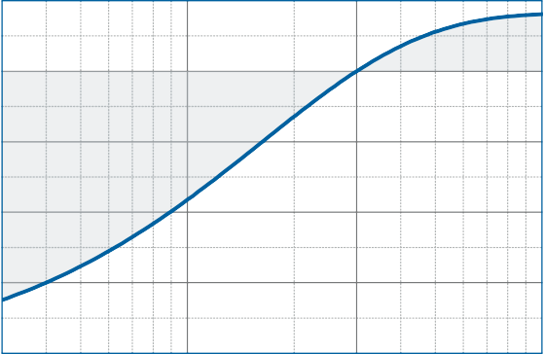
0.3

1 3 10
Form factor

DISCLAIMER:
The information provided is intended only as a summary and general overview on matters of interest. The information is not intended to be comprehensive nor does it constitute expert advice. P+S Polyurethan-Elastomere GmbH Co.KG shall not be liable for incidental and/or consequential damages directly or indirectly sustained, nor any loss caused by not complying with relevant industry/product standards and improper use of any Diepolast products. Due to varying construction methods, any other circumstances not stated above should be brought to the attention of P+S Polyurethan-Elastomere GmbH Co.KG for review. For suitability to the prevailing site conditions, it is advised that certified testing should be conducted. It is recommended to seek further advice on your application with our technical staff prior to use.
Version 1.0 from 01/04/2016

The data sheet is not subject to any change service! All information is without guarantee. Latest version of this document available on www.pus-polyurethan.de

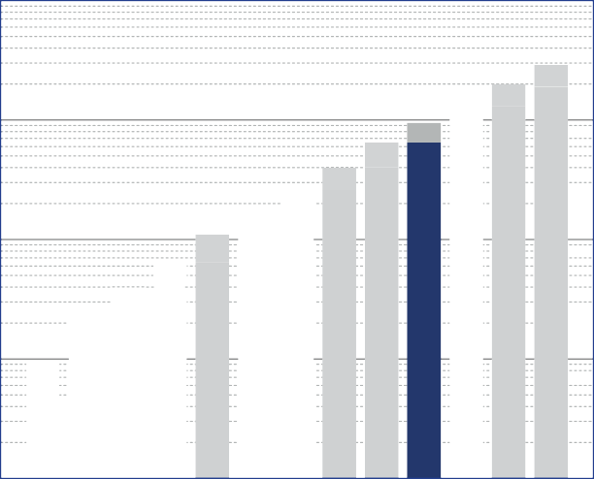10

SD 26

SD 40
SD 65
SD 260
SD 650
SD 400

SD 1300
SD 1900

SD 10

SD 16

SD 110

SD 170

SD 950

1
specific load [N/mm²]

0.1

0.01

0.001
Diepolast series

Working range

Diepolast type

Recommendations for elastic bearing:

Static load: up to [N/mm²]
0.650
Dynamic load: up to [N/mm²]
0.950
Load peaks: up to [N/mm²]
5.5
Values depending on form factor and apply to form factor q = 3

Material mixed cellular polyether-urethane
Colour dark blue
Delivery specifications Thickness: 12.5 mm and 25 mm
Mats: 0.5 m wide, 2.0 m long
Stripes: max. 2.0 m lang
Other dimensions on request (also stamping and moulded parts).

Properties | Value | Test method | Comment
Mechanical loss factor (1) | 0.10 | DIN 53513 (2) | guide value
Static E-modulus (1) | 4.57 N/mm² | DIN 53513 (2)
Dynamic E-modulus (1) | 10.4 N/mm² | DIN 53513 (2)
Resistance to strain | 0.590 N/mm² |  | at 10% deformation
Residual compression set | < 5 % | DIN EN ISO 1856 | 50%, 23°C, 70 h, 30 min after unloading
Tensile strength | > 3.00 N/mm2 | DIN 53455-6-4 | minimum
Elongation at break | > 400 % | DIN 53455-6-4 | minimum
Rebound elasticity | 50 % | DIN EN ISO 8307 | ± 10%
Specific volume resistance | >1011 Ω·cm | DIN IEC 93 | dry
Thermal conductivity | 0.10 W/[m·K] | DIN 52612-1
Operating temperature | -30 bis +70 °C
Temperature peak | +120 °C
Inflammability | Class E / EN 13501-1 | EN ISO 11925-1 | normal flammable

(1) measured at maximum limit of static application range
Version 1.0 from 01/04/2016
(2) test according to DIN 53513
All information and data is based on our current knowledge. The data are subject to typical manufacturing tolerances and are not guaranteed. We reserve the right to amend the data.

Load deflection curve

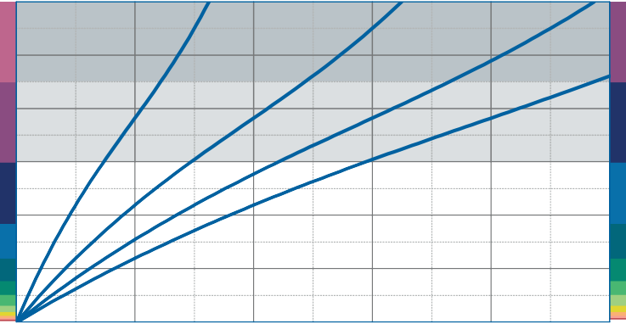
1.2
SD 950

1.0

0.8
Specific load [N/mm²]
SD 950
SD 650

0.6
Static range of use
SD 400 SD 650
SD 400
Dynamic range of use

0.4

0.2

Recording of the 3rd loading; testing between steel plates at room temperature measured with a deflection rate of 1% of the thickness per second
Form factor q = 2

0.0
0

2 4 6

Deflection [mm]

8 10

Modulus of elasticity
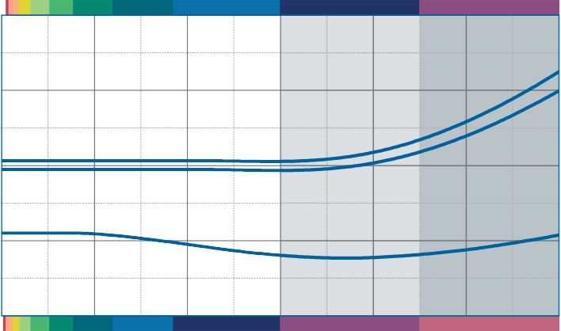Dynamic range of use
SD 400
SD 650
SD 950
SD 400
SD 650
SD 950
20

15
Modulus of elasticity [N/mm²]

10

Dynamic test: sinusoidal excitation with an oscillating range of ± 0.22 mm at 10 Hz and ± 0.08 mm at 30 Hz
Quasistatic modulus of elasticity: tangent modulus taken from the load deflection curve
Test according to DIN 53513 Form factor q = 2

5

0
Static range of use
0.0 0.2 0.4 0.6 0.8 1.0 1.2
Specific load [N/mm²]

Natural frequency

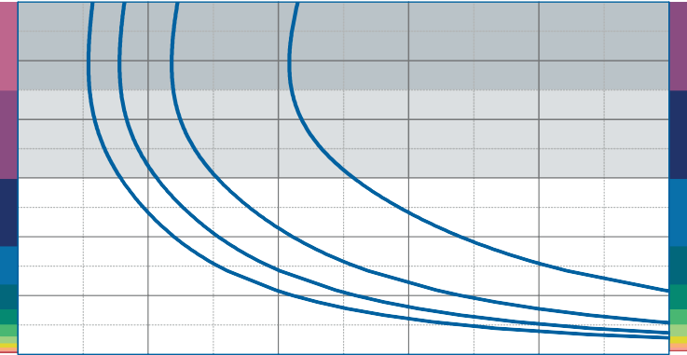
1.2
SD 950

1.0

0.8
Specific load [N/mm²]
SD 950
SD 650

0.6
Static range of use
SD 400 SD 650
SD 400
Dynamic range of use

0.4

0.2

Natural frequency of a single-degree-of- freedom system consisting of a fixed mass and an elastic bearing consisting of Diepolast SD 650 on a stiff subgrade.
Form factor q = 2

0.0
5

10 15 20 25 30
Version 1.0 from 01/04/2016

Natural frequency [Hz]

Correction values varying form factors

specific load 0.6 N/mm², form factor q = 2

Static load range Deflection

0.75

0.70

0.65
Specific load [N/mm²]

0.60

0.55

0.50

0.45

0.40

0.35

0.3

1 2
Form factor

50
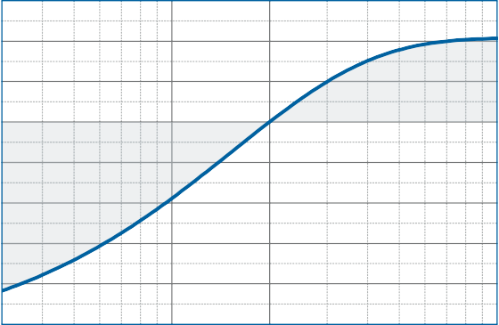
40

30
Variation of deflection [%]
20

10

0
-10

-20
-30

-40
-50
10

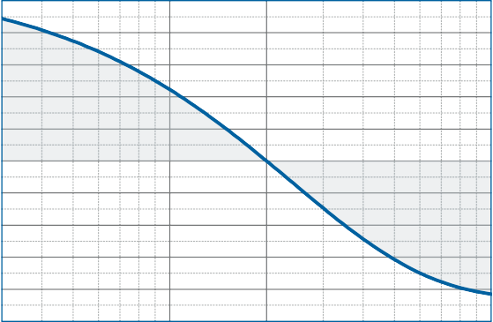
0.3

1 2 10
Form factor

Dynamic modulus of elasticity at 10 Hz Natural frequency

15
Variation of the dynamic modulus of elasticity [%]
10

5

0

-5

-10
-15

-20
-25

-30
-35

0.3

1 2
Form factor

10

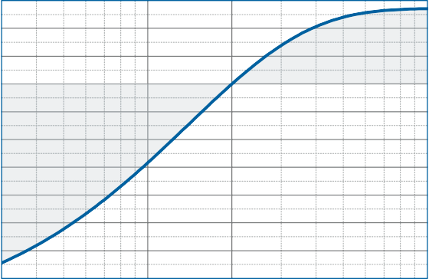
5
Variation of the natural frequency [%]

0

-5

-10

-15

-20
10

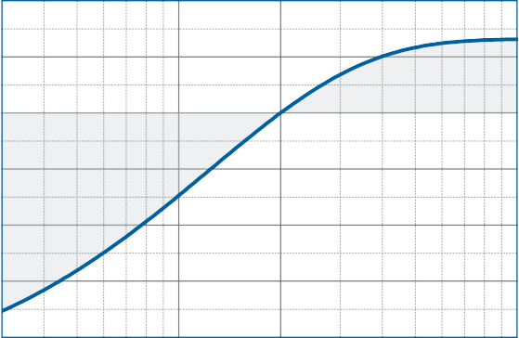
0.3

1 2 10
Form factor

DISCLAIMER:
The information provided is intended only as a summary and general overview on matters of interest. The information is not intended to be comprehensive nor does it constitute expert advice. P+S Polyurethan-Elastomere GmbH Co.KG shall not be liable for incidental and/or consequential damages directly or indirectly sustained, nor any loss caused by not complying with relevant industry/product standards and improper use of any Diepolast products. Due to varying construction methods, any other circumstances not stated above should be brought to the attention of P+S Polyurethan-Elastomere GmbH Co.KG for review. For suitability to the prevailing site conditions, it is advised that certified testing should be conducted. It is recommended to seek further advice on your application with our technical staff prior to use.
Version 1.0 from 01/04/2016

The data sheet is not subject to any change service! All information is without guarantee. Latest version of this document available on www.pus-polyurethan.de

10

 |  |  |  |  |  |  |  |  |  |  |  |  | SD 1900
 |  |  |  |  |  |  |  |  |  |  |  | SD 1300
 |  |  |  |  |  |  |  |  |  | SD 650 | SD 950
 |  |  |  |  |  |  |  |  | SD 400
 |  |  |  |  |  |  |  | SD 260
 |  |  |  |  |  |  | SD 170
 |  |  |  |  |  | SD 110
 |  |  |  |  | SD 65
 |  |  |  | SD 40
 |  |  | SD 26
 |  | SD 16
 | SD 10

1
specific load [N/mm²]

0.1

0.01

0.001
Diepolast series

Working range

Diepolast type

Recommendations for elastic bearing:

Static load: up to [N/mm²]
0.950
Dynamic load: up to [N/mm²]
1.450
Load peaks: up to [N/mm²]
6.0
Values depending on form factor and apply to form factor q = 3

Material mixed cellular polyether-urethane
Colour dark violet
Delivery specifications Thickness: 12.5 mm and 25 mm
Mats: 0.5 m wide, 2.0 m long
Stripes: max. 2.0 m lang
Other dimensions on request (also stamping and moulded parts).

Properties | Value | Test method | Comment
Mechanical loss factor (1) | 0.10 | DIN 53513 (2) | guide value
Static E-modulus (1) | 8.16 N/mm² | DIN 53513 (2)
Dynamic E-modulus (1) | 21.5 N/mm² | DIN 53513 (2)
Resistance to strain | 0.930 N/mm² |  | at 10% deformation
Residual compression set | < 9 % | DIN EN ISO 1856 | 50%, 23°C, 70 h, 30 min after unloading
Tensile strength | > 3.80 N/mm2 | DIN 53455-6-4 | minimum
Elongation at break | > 400 % | DIN 53455-6-4 | minimum
Rebound elasticity | 50 % | DIN EN ISO 8307 | ± 10%
Specific volume resistance | >1011 Ω·cm | DIN IEC 93 | dry
Thermal conductivity | 0.11 W/[m·K] | DIN 52612-1
Operating temperature | -30 bis +70 °C
Temperature peak | +120 °C
Inflammability | Class E / EN 13501-1 | EN ISO 11925-1 | normal flammable

(1) measured at maximum limit of static application range
Version 1.0 from 01/04/2016
(2) test according to DIN 53513
All information and data is based on our current knowledge. The data are subject to typical manufacturing tolerances and are not guaranteed. We reserve the right to amend the data.

Load deflection curve

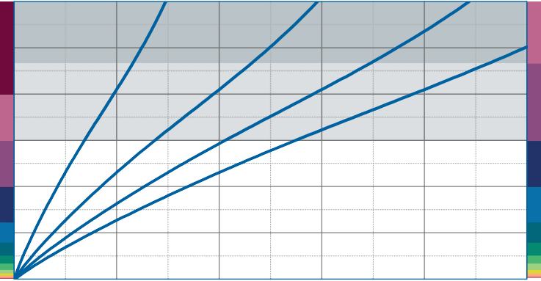
1.8
SD 1300

1.5

1.2
Specific load [N/mm²]
Static range of use
SD 650 SD 950 SD 1300
SD 950

0.9
SD 650
Dynamic range of use

0.6

0.3

Recording of the 3rd loading; testing between steel plates at room temperature measured with a deflection rate of 1% of the thickness per second
Form factor q = 2

0.0
0

2 4 6

Deflection [mm]

8 10

Modulus of elasticity
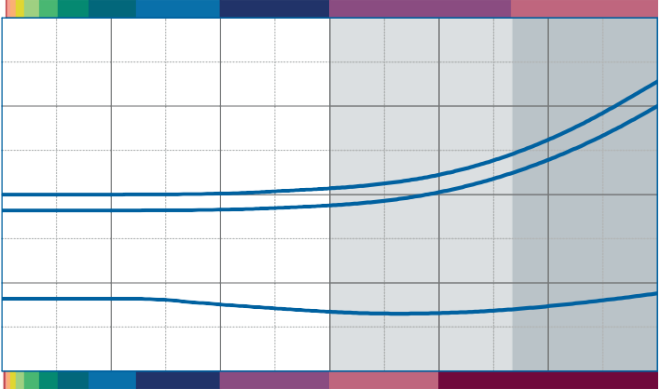Dynamic range of use
SD 650
SD 950
SD 1300
SD 650
SD 950
SD 1300
40

30
Modulus of elasticity [N/mm²]

20

Dynamic test: sinusoidal excitation with an oscillating range of ± 0.22 mm at 10 Hz and ± 0.08 mm at 30 Hz
Quasistatic modulus of elasticity: tangent modulus taken from the load deflection curve
Test according to DIN 53513 Form factor q = 2

10

0
Static range of use
0.0 0.3 0.6 0.9 1.2 1.5 1.8
Specific load [N/mm²]

Natural frequency

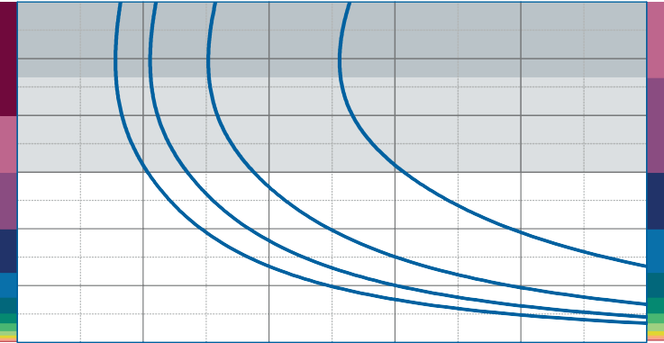
1.8
SD 1300

1.5

1.2
Specific load [N/mm²]
Static range of use
SD 650 SD 950 SD 1300
SD 650 SD 950
Dynamic range of use

0.9

0.6

0.3

Natural frequency of a single-degree-of- freedom system consisting of a fixed mass and an elastic bearing consisting of Diepolast SD 950 on a stiff subgrade.
Form factor q = 2

0.0
5

10 15 20 25 30
Version 1.0 from 01/04/2016

Natural frequency [Hz]

Correction values varying form factors

specific load 0.9 N/mm², form factor q = 2

Static load range Deflection

1.05

1.00

0.95

0.90
Specific load [N/mm²]

0.85

0.80

0.75

0.70

0.65

0.60

0.3

1 2
Form factor

50
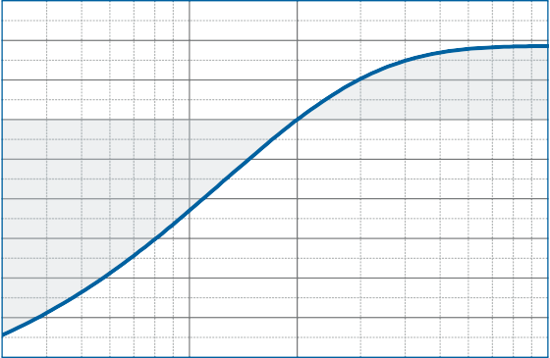
40

30
Variation of deflection [%]
20

10

0
-10

-20
-30

-40
-50
10

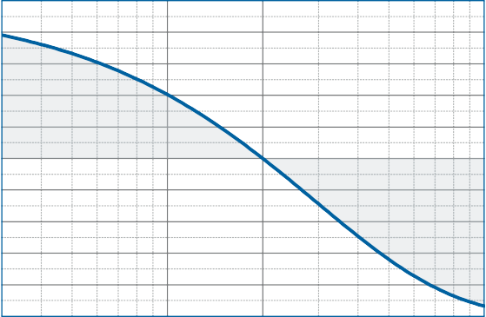
0.3

1 2 10
Form factor

Dynamic modulus of elasticity at 10 Hz Natural frequency

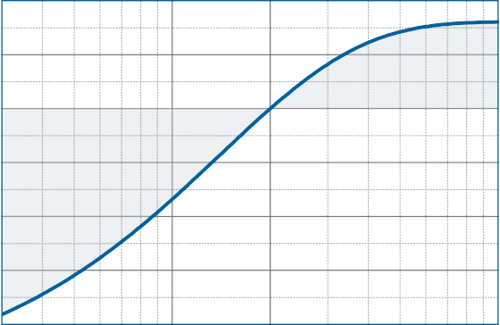
20
Variation of the dynamic modulus of elasticity [%]

10

0

-10

-20

-30

10

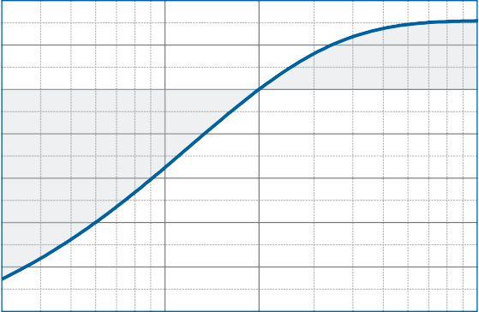
5
Variation of the natural frequency [%]

0

-5

-10

-15

-20

-40

0.3

1 2
Form factor
-25
10

0.3

1 2 10
Form factor

DISCLAIMER:
The information provided is intended only as a summary and general overview on matters of interest. The information is not intended to be comprehensive nor does it constitute expert advice. P+S Polyurethan-Elastomere GmbH Co.KG shall not be liable for incidental and/or consequential damages directly or indirectly sustained, nor any loss caused by not complying with relevant industry/product standards and improper use of any Diepolast products. Due to varying construction methods, any other circumstances not stated above should be brought to the attention of P+S Polyurethan-Elastomere GmbH Co.KG for review. For suitability to the prevailing site conditions, it is advised that certified testing should be conducted. It is recommended to seek further advice on your application with our technical staff prior to use.
Version 1.0 from 01/04/2016

The data sheet is not subject to any change service! All information is without guarantee. Latest version of this document available on www.pus-polyurethan.de

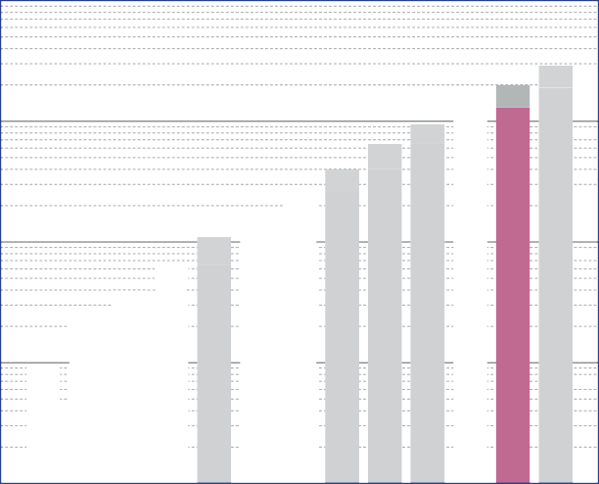10

SD 26

SD 40
SD 65
SD 260
SD 400
SD 650
SD 1300
SD 1900

SD 10

SD 16

SD 110

SD 170

SD 950

1
specific load [N/mm²]

0,1

0,01

0,001
Diepolast series

Working range

Diepolast type

Recommendations for elastic bearing:

Static load: up to [N/mm²]
1.300
Dynamic load: up to [N/mm²]
2.000
Load peaks: up to [N/mm²]
6.5
Values depending on form factor and apply to form factor q = 3

Material mixed cellular polyether-urethane
Colour violet
Delivery specifications Thickness: 12.5 mm and 25 mm
Mats: 0.5 m wide, 2.0 m long
Stripes: max. 2.0 m lang
Other dimensions on request (also stamping and moulded parts).

Properties | Value | Test method | Comment
Mechanical loss factor (1) | 0.09 | DIN 53513 (2) | guide value
Static E-modulus (1) | 12.0 N/mm² | DIN 53513 (2)
Dynamic E-modulus (1) | 35.2 N/mm² | DIN 53513 (2)
Resistance to strain | 1.340 N/mm² |  | at 10% deformation
Residual compression set | < 9 % | DIN EN ISO 1856 | 50%, 23°C, 70 h, 30 min after unloading
Tensile strength | > 4.40 N/mm2 | DIN 53455-6-4 | minimum
Elongation at break | > 400 % | DIN 53455-6-4 | minimum
Rebound elasticity | 50 % | DIN EN ISO 8307 | ± 10%
Specific volume resistance | >1011 Ω·cm | DIN IEC 93 | dry
Thermal conductivity | 0.11 W/[m·K] | DIN 52612-1
Operating temperature | -30 bis +70 °C
Temperature peak | +120 °C
Inflammability | Class E / EN 13501-1 | EN ISO 11925-1 | normal flammable

(1) measured at maximum limit of static application range
Version 1.0 from 01/04/2016
(2) test according to DIN 53513
All information and data is based on our current knowledge. The data are subject to typical manufacturing tolerances and are not guaranteed. We reserve the right to amend the data.

Load deflection curve

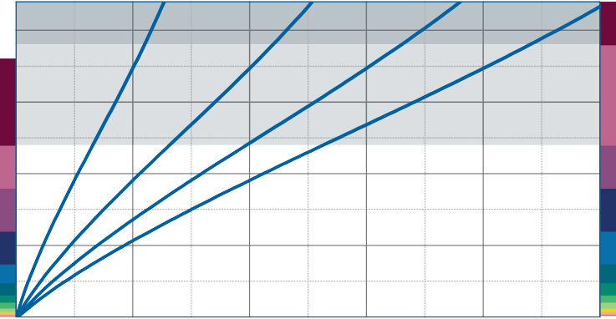
2.2
SD 1900
2.0

1.5
Specific load [N/mm²]
SD 1900
SD 1300

1.0
Static range of use
SD 950 SD 1300
SD 950
Dynamic range of use

0.5

Recording of the 3rd loading; testing between steel plates at room temperature measured with a deflection rate of 1% of the thickness per second
Form factor q = 2

0.0
0

2 4 6

Deflection [mm]

8 10

Modulus of elasticity
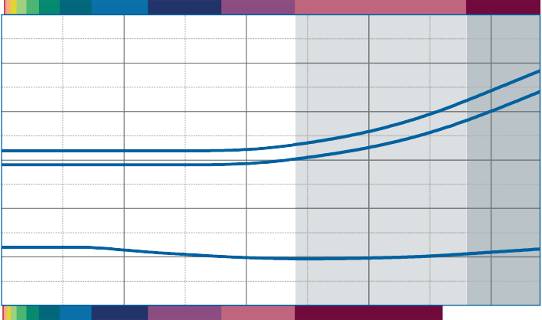Dynamic range of use
SD 950
SD 1300
SD 1900
SD 950 SD 1300
SD 1900
60

50
Modulus of elasticity [N/mm²]

40

30

Dynamic test: sinusoidal excitation with an oscillating range of ± 0.22 mm at 10 Hz and ± 0.08 mm at 30 Hz
Quasistatic modulus of elasticity: tangent modulus taken from the load deflection curve
Test according to DIN 53513 Form factor q = 2

20

10

0
Static range of use 0.0

0.5

1.0
Specific load [N/mm²]

1.5

2.0 2.2

Natural frequency

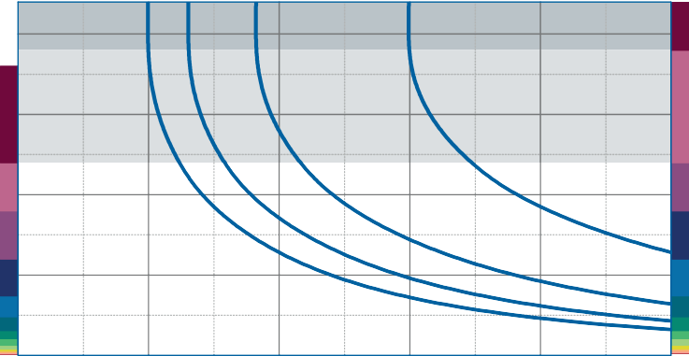
2.2
50 mm
37.5 mm
25 mm
12.5 mm
SD 1900
2.0

1.5
Specific load [N/mm²]
SD 1900
SD 1300

1.0
Static range of use
SD 950 SD 1300
SD 950
Dynamic range of use

0.5

Natural frequency of a single-degree-of- freedom system consisting of a fixed mass and an elastic bearing consisting of Diepolast SD 1300 on a stiff subgrade.
Form factor q = 2

0.0
5

10 15 20 25 30
Version 1.0 from 01/04/2016

Natural frequency [Hz]

Correction values varying form factors

specific load 1.2 N/mm², form factor q = 2

Static load range Deflection

1.5
1.4

1.3
1.2
Specific load [N/mm²]

1.1

1.0
0.9

0.8
0.7

0.6

0.5

0.3

1 2
Form factor

60

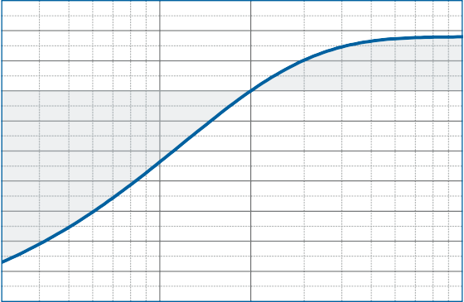
40

20
Variation of deflection [%]

0

-20

-40

-60

-80
10

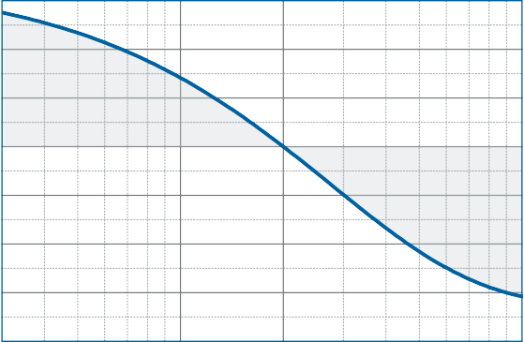
0.3

1 2 10
Form factor

Dynamic modulus of elasticity at 10 Hz Natural frequency

40
Variation of the dynamic modulus of elasticity [%]

20

0

-20

-40

-60

0.3

1 2
Form factor

20
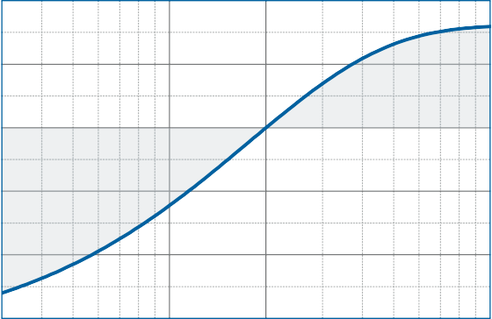
15
Variation of the natural frequency [%]
10
5
0
-5
-10
-15
-20
-25
-30
-35
10

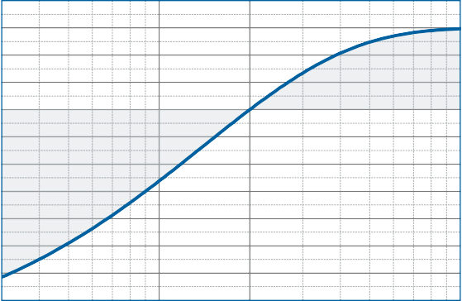
0.3

1 2 10
Form factor

DISCLAIMER:
The information provided is intended only as a summary and general overview on matters of interest. The information is not intended to be comprehensive nor does it constitute expert advice. P+S Polyurethan-Elastomere GmbH Co.KG shall not be liable for incidental and/or consequential damages directly or indirectly sustained, nor any loss caused by not complying with relevant industry/product standards and improper use of any Diepolast products. Due to varying construction methods, any other circumstances not stated above should be brought to the attention of P+S Polyurethan-Elastomere GmbH Co.KG for review. For suitability to the prevailing site conditions, it is advised that certified testing should be conducted. It is recommended to seek further advice on your application with our technical staff prior to use.
Version 1.0 from 01/04/2016

The data sheet is not subject to any change service! All information is without guarantee. Latest version of this document available on www.pus-polyurethan.de

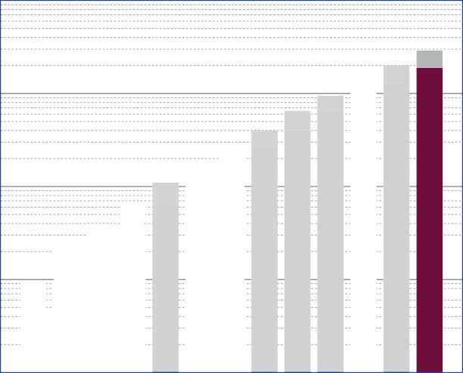10

SD 26

SD 40
SD 65
SD 260
SD 400
SD 650
SD 1900
SD 1300

SD 10

SD 16

SD 110

SD 170

SD 950

1
specific load [N/mm²]

0,1

0,01

0,001
Diepolast series

Working range

Diepolast type

Recommendations for elastic bearing:

Static load: up to [N/mm²]
1.900
Dynamic load: up to [N/mm²]
2.800
Load peaks: up to [N/mm²]
7.0
Values depending on form factor and apply to form factor q = 3

Material mixed cellular polyether-urethane
Colour bordeaux red
Delivery specifications Thickness: 12.5 mm and 25 mm
Mats: 0.5 m wide, 2.0 m long
Stripes: max. 2.0 m lang
Other dimensions on request (also stamping and moulded parts).

Properties | Value | Test method | Comment
Mechanical loss factor (1) | 0.09 | DIN 53513 (2) | guide value
Static E-modulus (1) | 20.4 N/mm² | DIN 53513 (2)
Dynamic E-modulus (1) | 78.2 N/mm² | DIN 53513 (2)
Resistance to strain | 1.840 N/mm² |  | at 10% deformation
Residual compression set | < 8 % | DIN EN ISO 1856 | 50%, 23°C, 70 h, 30 min after unloading
Tensile strength | > 5.00 N/mm2 | DIN 53455-6-4 | minimum
Elongation at break | > 400 % | DIN 53455-6-4 | minimum
Rebound elasticity | 50 % | DIN EN ISO 8307 | ± 10%
Specific volume resistance | >1011 Ω·cm | DIN IEC 93 | dry
Thermal conductivity | 0.11 W/[m·K] | DIN 52612-1
Operating temperature | -30 bis +70 °C
Temperature peak | +120 °C
Inflammability | Class E / EN 13501-1 | EN ISO 11925-1 | normal flammable

(1) measured at maximum limit of static application range
Version 1.0 from 01/04/2016
(2) test according to DIN 53513
All information and data is based on our current knowledge. The data are subject to typical manufacturing tolerances and are not guaranteed. We reserve the right to amend the data.

Load deflection curve

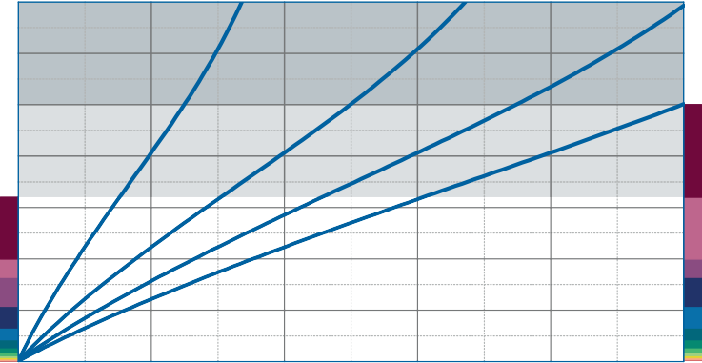
3.5

3.0

2.5
Specific load [N/mm²]
SD 1900

2.0

1.5
Static range of use
SD 1900
Dynamic range of use

1.0

0.5

Recording of the 3rd loading; testing between steel plates at room temperature measured with a deflection rate of 1% of the thickness per second
Form factor q = 1.25

0.0
0

2 4 6

Deflection [mm]

8 10

Modulus of elasticity
Dynamic range of use
 |  |  |  |  |  |  |  |  |  | SD | 1900
 |  |  |  |  |  | SD | 1900

120

100
Modulus of elasticity [N/mm²]

80

60

40

20

Dynamic test: sinusoidal excitation with an oscillating range of ± 0.22 mm at 10 Hz and ± 0.08 mm at 30 Hz
Quasistatic modulus of elasticity: tangent modulus taken from the load deflection curve
Test according to DIN 53513 Form factor q = 1.25

0
Static range of use
0.0 0.5 1.0 1.5 2.0 2.5 3.0 3.5
Specific load [N/mm²]

Natural frequency

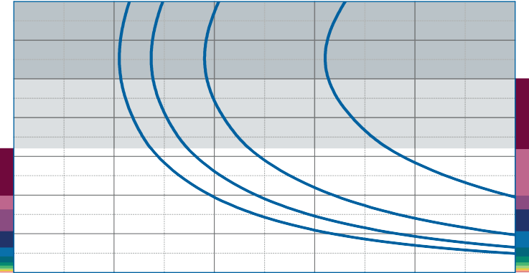
3.5

3.0

2.5
Specific load [N/mm²]
SD 1900

2.0

1.5
Static range of use
SD 1900
Dynamic range of use

1.0

0.5

Natural frequency of a single-degree-of- freedom system consisting of a fixed mass and an elastic bearing consisting of Diepolast SD 1900 on a stiff subgrade.
Form factor q = 1.25

0.0
5

10 15 20 25 30
Version 1.0 from 01/04/2016

Natural frequency [Hz]

Correction values varying form factors

specific load 1.6 N/mm², form factor q = 1.25

Static load range Deflection

2.1
2.0
1.9
1.8
Specific load [N/mm²]
1.7
1.6
1.5
1.4
1.3
1.2
1.1
1.0
0.9

0.3

1 1.25
Form factor

40

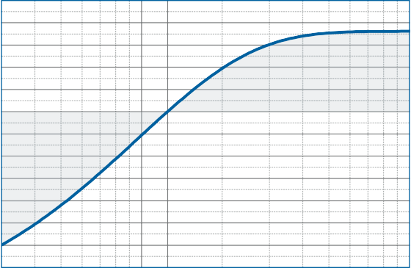
20

0
Variation of deflection [%]

-20

-40

-60

-80

-100
10

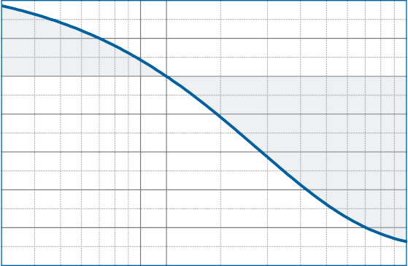
0.3

1 1.25 10
Form factor

Dynamic modulus of elasticity at 10 Hz Natural frequency

160
Variation of the dynamic modulus of elasticity [%]
140
120
100
80
60
40
20
0
-20
-40
-60

0.3

1 1.25
Form factor

60

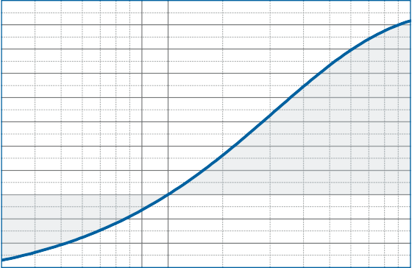
40
Variation of the natural frequency [%]

20

0

-20

-40
10

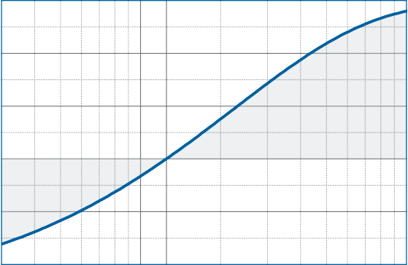
0.3

1 1.25 10
Form factor

DISCLAIMER:
The information provided is intended only as a summary and general overview on matters of interest. The information is not intended to be comprehensive nor does it constitute expert advice. P+S Polyurethan-Elastomere GmbH Co.KG shall not be liable for incidental and/or consequential damages directly or indirectly sustained, nor any loss caused by not complying with relevant industry/product standards and improper use of any Diepolast products. Due to varying construction methods, any other circumstances not stated above should be brought to the attention of P+S Polyurethan-Elastomere GmbH Co.KG for review. For suitability to the prevailing site conditions, it is advised that certified testing should be conducted. It is recommended to seek further advice on your application with our technical staff prior to use.
Version 1.0 from 01/04/2016

The data sheet is not subject to any change service! All information is without guarantee. Latest version of this document available on www.pus-polyurethan.de

